- Funding Status – FY 2019 and FY 2018
- Updates on USAC’s E-Rate Productivity Center and Legacy System
  - EPC Entity Profiles Unlocked
  - EPC Funding Request Report
  - Forwarding Pending PIA Inquiries within EPC
- E-Rate Updates and Reminders
  - Upcoming E-Rate Dates
  - USAC Responds to Commissioner O’Rielly’s E-Rate Overbuilding Concerns
- USAC News Brief Dated April 19 – Webinar and Website

Funding Status – FY 2019 and FY 2018

FY 2019:

The FY 2019 Form 471 application window closed Wednesday, March 27, 2019. On April 1st, USAC released a preliminary demand estimate for the coming year showing a 5% increase to $2.90 billion from FY 2018. This is well within the $4.15 billion funding cap for the year (DA 19-170). Issuance of the preliminary demand estimate, combined with the FCC’s approval (DA 19-218) of the PIA procedures the preceding week, positions USAC to begin FY 2019 funding waves later this month.

FY 2018:

USAC issued Wave 54 for FY 2018 on Thursday, April 18th, for $630 thousand. Cumulative funding as of Wave 54 is $2.19 billion.

Updates on USAC’s E-Rate Productivity Center and Legacy System

EPC Entity Profiles Unlocked:

Effective last Monday, April 15th, USAC unlocked EPC entity profiles to allow applicant updates. Correct entity profiles — particularly those linking school districts and library systems to their associated schools, branches, or NIFs — will be particularly important beginning later this summer and fall as applicants begin filing Form 470s for FY 2020.

It is important to note that any changes applicants make in their EPC entity profiles now will not automatically carry through to their FY 2019 applications. To make entity changes that apply to pending applications, applicants must submit RAL modifications (see USAC’s Schools and Libraries News Brief of March 22, 2019).

EPC Funding Request Report:

An applicant’s EPC Landing Page now includes a link to a Funding Request Report.

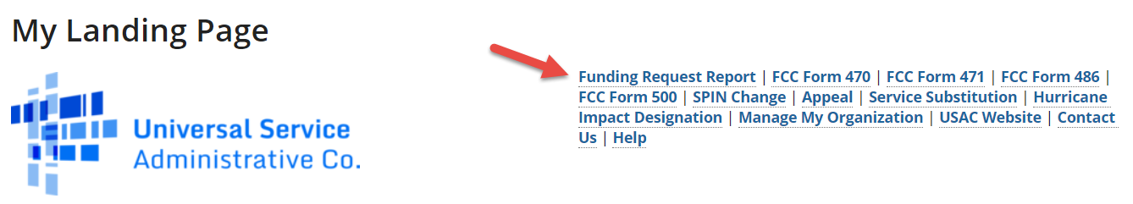

The Funding Request Report lets you search for funding data within a given date range of Form 471 certifications from FY 2016 forward and by BEN, SPIN, and/or application number.

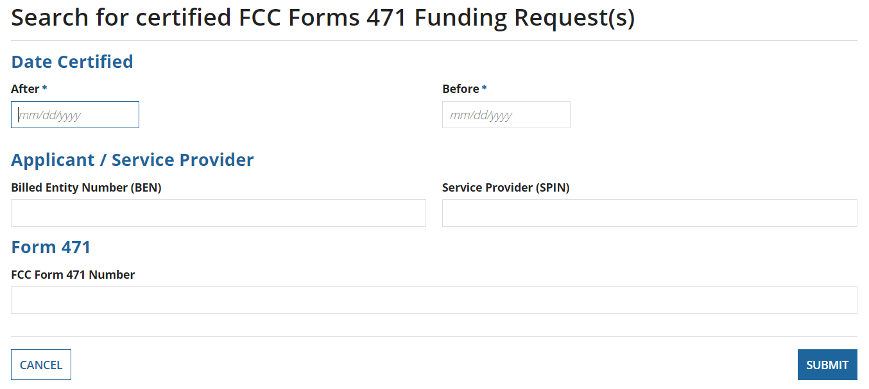

Search results display the following information:
- Funding Request Number
- Entity Number of Applicant — linked to the applicant’s basic EPC page
- SPIN (Service Provider Identification Number) — linked to the service provider’s basic EPC page (unfortunately not including SPAC information)
- 471 Application Number — linked to the Form 471
- Establishing FCC Form 470 — linked to the Form 470
- Applicant Name
- Application State Code
- Main Contact Person — linked to contact information
- Service Ordered
- Funding Commitment Pre-Discount Annual Cost
- Discount Percentage
- Funding Commitment Request Amount
- Service Start Date
- Contract Expiration
- FCC Form 471 Certification Date
- Consulting Firm(s) — link not currently working

Several practical points on using this tool should be noted.
- The starting and ending Form 471 certification dates are required search fields. This is a little less convenient than searching for a specific funding year, but it is manageable. Recognize, for example, that the range 01/01/2018 to 12/31/2018, for example, easily includes any Form 471 certified for FY 2018. Setting the “After” date as 01/01/2016 and accepting today’s default date in the “Before” field will pull down all associated data back to FY 2016.
- Searches by BEN are not restricted to the BEN(s) associated with a specific EPC Landing Page. You can search for data for any BEN — or leave the BEN field blank.
- Searches can generate a large number of FRN records. For example, a search for Verizon Wireless (SPIN 143000677) since FY 2016 generated a list of 12,227 FRNs displayed ten to a page.
- The search results page includes a button at the bottom to “Export Search Results.” That feature creates a Task to download the resulting file. The download indicates “CSV” in the filename but is actually a pipe-delimited “.rsp” file. Converted to Excel, the file includes 35 unlabeled data columns.

Readers of this newsletter are reminded that an easier way to obtain E-rate funding histories by BEN or SPIN from year one of the program (FY 1998) is to use the “Funding History Search” on the homepage of the E-Rate Central website.

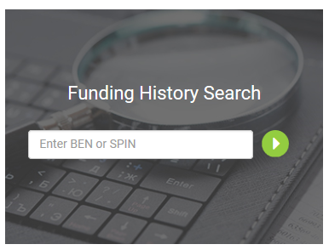

Forwarding Pending PIA Inquiries within EPC:

When PIA initiates an inquiry on a Form 471, an email is sent to the applicant contact listed on that application. The request for information is also posted in EPC under the list of Pending Inquiries for that application. The inquiry can then be viewed by any user with access to that EPC account. As shown below, the Pending Inquiries display for full rights users includes a field allowing that user to forward the inquiry notice to another user of that EPC account.

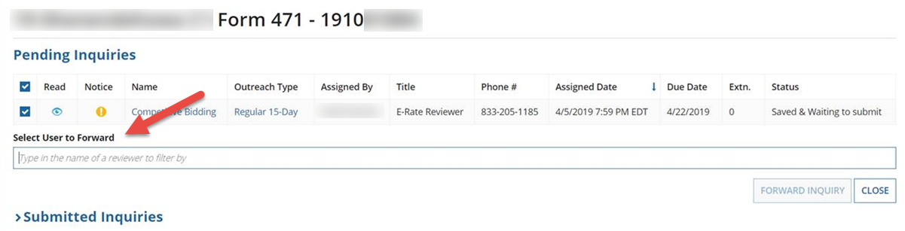

Forwarding is a potentially useful feature if the inquiry is to be best answered by someone other than the applicant’s primary contact, the person who received the initial PIA email. Unfortunately, forwarding an inquiry merely moves a notice to the top of that user’s EPC News Feed. It does not generate a new email notification to the designated user nor does it create an EPC Task for that user. Most likely this means that the new user will learn of the forwarded inquiry only if alerted via phone or email by the original contact.

Two small points should be noted regarding the Pending Inquiries format shown above.
- The instructional text within the forwarding field references the name of the “reviewer.” Normally, when dealing with application inquiries, “reviewer” refers to the PIA representative shown in the inquiry line as the E-Rate Reviewer. In the forwarding context, the “reviewer” is another of the applicant’s EPC users.
- The “Phone #” field on each pending inquiry line is formatted to show only 833-205-1185. A ten-digit telephone number was fine last year when each Solix reviewer had a unique number. This year every Maximus reviewer uses the same toll-free number. To reach a specific reviewer you need the reviewer’s five-digit extension (usually provided in the initial email). For assistance in telephoning reviewers see the Maximus PIA Telephone Directory we have been compiling since the FY 2019 application reviews began.

E-Rate Updates and Reminders

Upcoming E-Rate Dates:

April 26 Form 486 deadline for FY 2018 funding committed in Wave 38. More generally, the Form 486 deadline is 120 days from the FCDL date or the service start date (typically July 1st), whichever is later. Other upcoming Form 486 deadlines are:

Wave 39 05/03/2019

Wave 40 05/13/2019

Wave 41 05/16/2019

Wave 42 05/27/2019

Wave 43 05/31/2019

Note: Applicants missing any Form 486 deadline should watch carefully for “Form 486 Urgent Reminder Letters” in their EPC News Feed. These Reminder Letters afford applicants 15-day extensions to submit their Form 486s without penalty.

May 15 USAC webinar on the Form 486.

USAC Responds to Commissioner O’Rielly’s E-Rate Overbuilding Concerns:

A month ago, FCC Commissioner Michael O’Rielly sent a letter to USAC reiterating his longstanding concerns over the use of USF funds — particularly E-rate — to overbuild existing carrier networks. The letter asks USAC for data on consortium-wide WAN applications that would result in the overbuilding of other fiber provider networks funded in part by the USF High Cost or Rural Health Care programs.

USAC’s response was submitted to the FCC last week. USAC noted the difficulty of extracting detailed WAN data from consortium applications but did provide aggregate funding data on special construction project requests, commitments, and denials. More generally, USAC stressed that all broadband applications were reviewed in full compliance with the FCC’s existing E-rate program rules.

Specifically, with regard to Commissioner O’Rielly’s overbuilding concerns, USAC stressed its commitment to ensuring that special construction projects meet the following requirements: “(1) demonstrate that the self-constructed high speed broadband service is the most cost-effective alternative; (2) the bidder was selected based on a fair and open competitive bid process; (3) build and use the self-constructed services within the same funding year.” More generally, USAC also indicated adherence to the FCC’s rules to prohibit duplicative services.

Early indications are that Commissioner O’Rielly is unimpressed with USAC’s response and that he will continue to resist funding for the construction of new networks wherever existing carrier plant is available — apparently regardless of the cost to schools and libraries. Fortunately, even though Commissioner O’Rielly is one of the three-member Republican majority of FCC Commissioners, his view does not appear to be broadly accepted.
USAC News Brief Dated April 19 – Webinar and Website

USAC’s Schools and Libraries News Brief of April 19, 2019, includes a reminder of USAC’s May 15th webinar on the Form 486. It also alerts website users of changes to the web addresses for the four following legacy tools:
- FCC Form 470 Download Tool
- FCC Form 471 Status Tool
- Search for BEN Information Tool
- SPIN Search Tool

--------------------------------------------------------------------------------------------------------------------- Newsletter information and disclaimer: This newsletter may contain unofficial information on prospective E-rate developments and/or may reflect E-Rate Central’s own interpretations of E-rate practices and regulations. Such information is provided for planning and guidance purposes only. It is not meant, in any way, to supplant official announcements and instructions provided by the SLD, FCC, or state education departments.

For further information on E-rate, follow us on Twitter, Facebook, and LinkedIn.

To convert the file to Excel: 1) Download and save the .rsp file. 2) Open a blank Excel file. 3) In the “Data” tab, click "From Text/CSV." 4) Change the file extension filter to "All Files (*.*)," select the .rsp file, and click the “Import” button. 5) Excel should analyze the file and see that it's pipe-delimited. 6) Click the “Load” button and Excel will create a new worksheet with the data.
The PIA inquiry email is also copied to the applicant’s State E-rate Coordinator(s).

