- Funding Status – FY 2019 and FY 2018
  - Wave 1 Released for FY 2019
- E-Rate Updates and Reminders
  - Upcoming E-Rate Dates
  - Early Form 486s for FY 2019
- USAC News Brief Dated April 26 – Selective Reviews

Funding Status – FY 2019 and FY 2018

FY 2019:

USAC announced and released the first funding wave for FY 2019. Funding totaled $530 million for 18,515 applications — roughly half of all submitted applications (although under 20% of the dollar value of all funding requests).

By applicant type, Wave 1 funding was as follows:

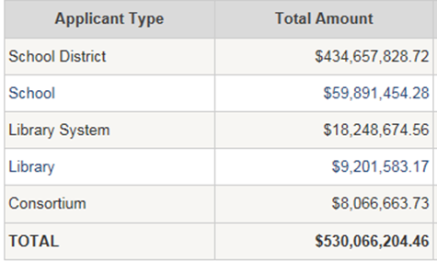

By category type — heavily weighted towards the relatively easier Category 1 applications —Wave 1 funding was as follows:

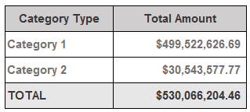

FY 2019’s first wave funding is slightly better than last year when two waves totaling $503 million were released on successive days (April 20-21, 2018).

FY 2018:

USAC did not issue a funding wave for FY 2018 last week. The last few funding waves have been very small suggesting that FY 2018 reviews are virtually complete. Unless we see unusual activity, our plan is to discontinue weekly updates on this funding year. Cumulative funding as of Wave 54 is $2.19 billion.

E-Rate Updates and Reminders

Upcoming E-Rate Dates:

May 3 Form 486 deadline for FY 2018 funding committed in Wave 39. More generally, the Form 486 deadline is 120 days from the FCDL date or the service start date (typically July 1st), whichever is later. Other upcoming Form 486 deadlines are:

Wave 40 05/13/2019

Wave 41 05/16/2019

Wave 42 05/27/2019

Wave 43 05/31/2019

Note: Applicants missing any Form 486 deadline should watch carefully for “Form 486 Urgent Reminder Letters” in their EPC News Feed. These Reminder Letters afford applicants 15-day extensions to submit their Form 486s without penalty.

May 15 USAC webinar on the Form 486.

Early Form 486s for FY 2019:

Any applicant funded in Wave 1 (or subsequent funding waves issued before July 1st) may want to file an early Form 486. An early filing is particularly attractive for an applicant wishing to have its invoices for recurring services discounted by its service provider(s) as of the start of the funding year.

The Form 486, which is normally filed once service begins, has a special early filing certification that may be used if the applicant is confident that services will start in July. To file an early Form 486, be sure to check the following certification:

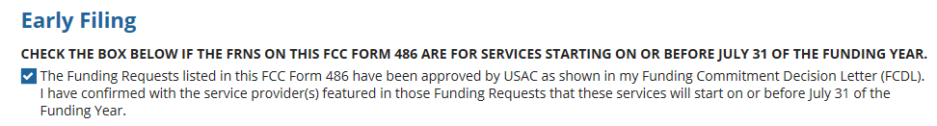

USAC News Brief Dated April 26 – Selective Reviews

USAC’s Schools and Libraries News Brief of April 26, 2019, provides an overview of the selective review process. A selective review, focused on an applicant’s competitive bidding and bid analysis, applies only to some applications. It is considerably more detailed than found in a more typical PIA review. The process is as follows:
- USAC issues selective review questions, notifying the applicant that a Selective Review Information Request (“SRIR”) is available in EPC.
- The applicant confirms receipt of the SRIR.
- The applicant responds to the SRIR through EPC uploading any necessary documents as appropriate.
- As with other reviews, an applicant may request an extension of time to respond.

As discussed in our newsletter of April 22nd, USAC’s News Brief also notes that applicant profiles in EPC have been unlocked.

--------------------------------------------------------------------------------------------------------------------- Newsletter information and disclaimer: This newsletter may contain unofficial information on prospective E-rate developments and/or may reflect E-Rate Central’s own interpretations of E-rate practices and regulations. Such information is provided for planning and guidance purposes only. It is not meant, in any way, to supplant official announcements and instructions provided by the SLD, FCC, or state education departments.

For further information on E-rate, follow us on Twitter, Facebook, and LinkedIn.

