- Funding Status – FY 2019
- Updates on USAC’s E-Rate Productivity Center and Legacy System
  - New Form 498 Status Tool
- E-Rate Updates and Reminders
  - Upcoming E-Rate Dates
  - Ancient COMADs
- USAC News Brief Dated May 10 – Filing a Form 486

Funding Status – FY 2019

USAC released Wave 3 for FY 2019 on Thursday, May 9th. Funding totaled $70.3 million. Cumulative funding as of Wave 3 is $670 million.

Updates on USAC’s E-Rate Productivity Center and Legacy System

New Form 498 Status Tool:

An applicant new to the Form 472 (“BEAR”) reimbursement filing process will need to have filed a Form 498 through EPC and to have made sure that their form has been approved by USAC. The Form 498 provides USAC with the critical banking information (bank routing and applicant account numbers) to enable electronic BEAR payments. Once a Form 498 has been filed/certified, USAC’s approval process requires the applicant to submit additional documentation (typically a copy of a voided check) to confirm the accuracy of the bank routing information.

Last Friday’s USAC News Brief (referenced below) briefly describes a new non-EPC USAC tool to check on the status of any filed Form 498. To use the Search for 498 ID Status tool the applicant must know the associated “498 ID” number from the Form 498 certification process. Unfortunately, the applicant’s BEN is not one of the search criteria.

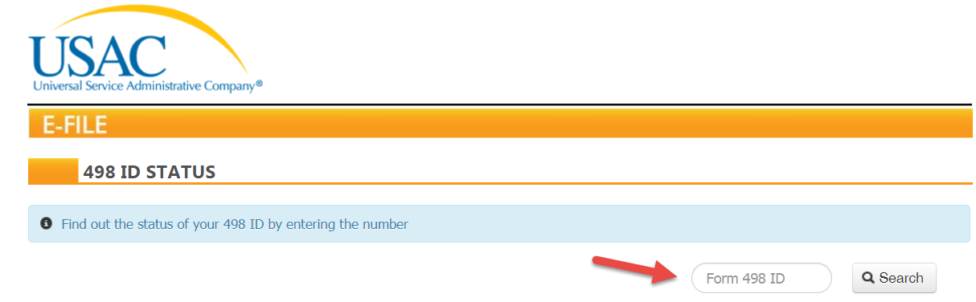

The search result (which includes the BEN) indicates whether the Form 498 has been “Certified,” “Approved,” or “Deactivated.”

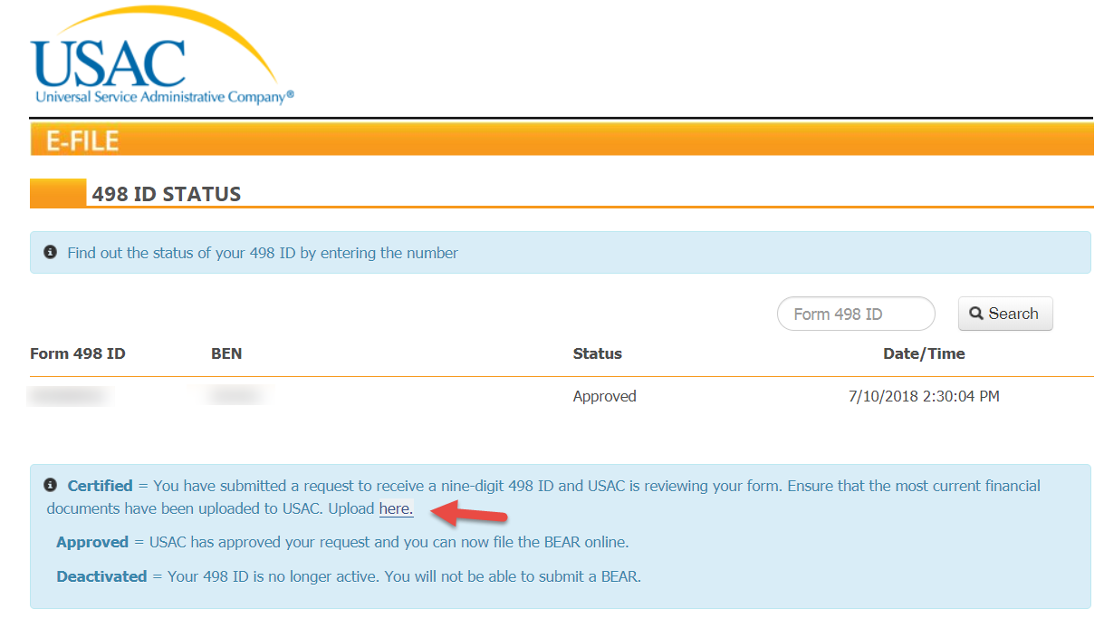

Note that the search results for a certified Form 498 include a link to the following screen allowing the applicant to upload the necessary banking information. For a fuller discussion of USAC’s Form 498 review process, see the USAC News Brief of August 18, 2017.

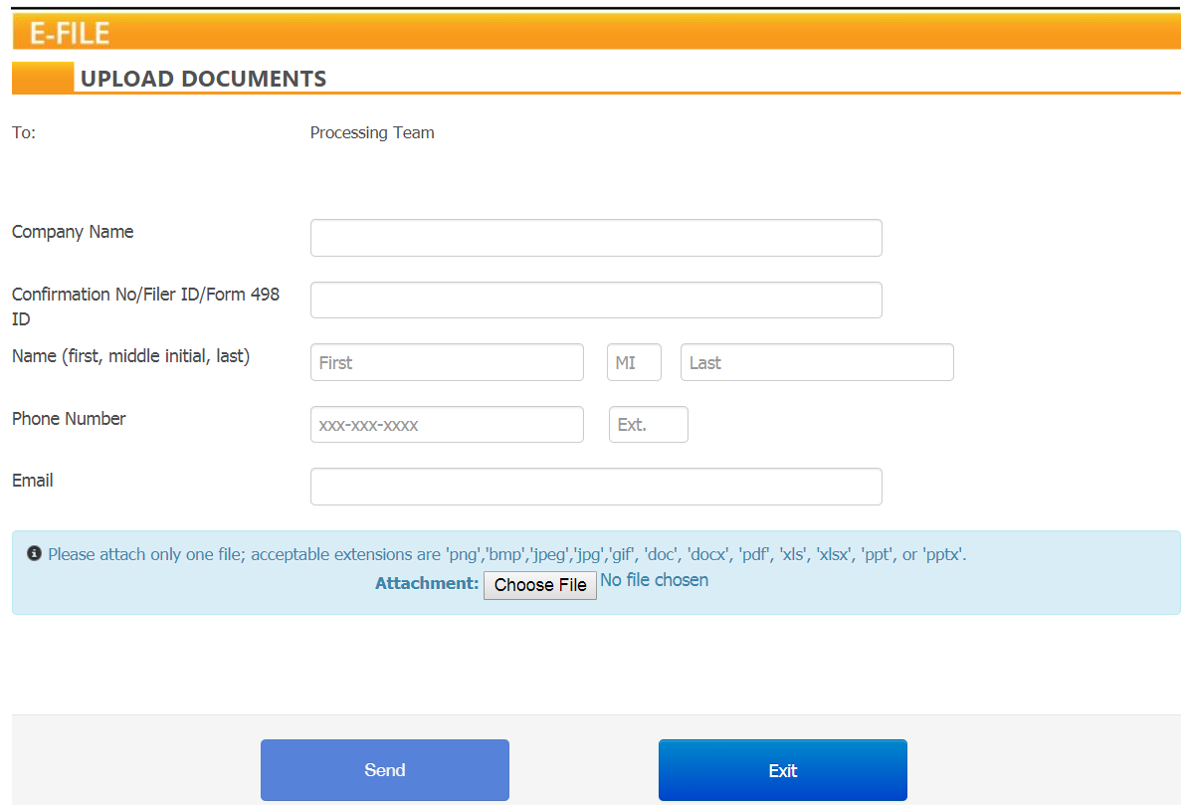

E-Rate Updates and Reminders

Upcoming E-Rate Dates:

May 13 Form 486 deadline for FY 2018 funding committed in Wave 40. More generally, the Form 486 deadline is 120 days from the FCDL date or the service start date (typically July 1st), whichever is later. Other upcoming Form 486 deadlines are:

Wave 41 05/16/2019

Wave 42 05/27/2019

Wave 43 05/31/2019

Note: Applicants missing any Form 486 deadline should watch carefully for “Form 486 Urgent Reminder Letters” in their EPC News Feed. These Reminder Letters afford applicants 15-day extensions to submit their Form 486s without penalty.

May 15 USAC webinar on Starting Services: The Form 486.

Ancient COMADs:

Roughly two years ago, USAC began sending Commitment Adjustment (“COMAD”) — alternatively, Recovery of Improperly Disbursed Funds (“RIDF”) — letters seeking to recover funds from applicants for alleged E-rate rule violations attributed to funding years as far back as FY 1998, the first year of the E-rate program. As discussed in our newsletter of June 19, 2017, the basis for these old COMADs and highly retroactive actions was a 2017 FCC Memorandum Opinion and Order (FCC 17-1). This order rejected an argument by Net56, Inc., that funding recovery efforts on older cases were “time-barred by the Commission’s Policy directive that USAC finish its investigations…within five years…” At the time — and there has been no change since — the FCC indicated that five years was merely a “policy preference” and that it had a statutory obligation to recover any improperly disbursed funds. Effectively, E-rate has no statute of limitations.

Since the FCC’s Net56 decision, we have seen USAC release periodic batches of what we’re calling “Ancient COMADs.” The latest batch was released in April; we suspect there are more to come.

At this stage, one typical problem facing affected applicants needing to respond is the absence of documentation for the funding periods in question — years well beyond even the current 10-year document retention period. Often the personnel who handled earlier applications for the applicant are no longer available. To provide at least some guidance in these situations, USAC has provided a set of FAQs on COMADs and RIDFs addressing the following questions:
- Why am I receiving a letter for recovery of funds on an old funding year?
- How does USAC identify a COMAD or RIDF?
- What is the reason for a COMAD or RIDF letter?
- What do I do if I no longer have documentation?
- When do I appeal to USAC and when do I appeal to the FCC?
- What if I want to file an appeal with USAC or an appeal and/or waiver with the FCC and USAC does not provide documentation to me in time?
- Is there a payment plan option if I do not have enough money to repay the debt right now?
- What is a COMAD?
- What is a RIDF?
- What is the difference between a COMAD and RIDF?

This is a sorry situation. Although ancient COMADs are an exception rather than a rule, their presence at any level represents a real black-eye for the E-rate program. Without a change in the FCC’s position, a legislative solution may be required.

USAC News Brief Dated May 10 – Filing a Form 486

USAC’s Schools and Libraries News Brief of May 10, 2019, provides the following tips for filing a Form 486 in EPC:
- Check the Early Filing box if you are filing early (see also our newsletter of April 29th).
- Choose the correct CIPA certification based on your situation.
- Do not check the “CIPA Waiver” box unless you are eligible for a CIPA waiver (most established applicants are not).
- Choose the Funding Request Numbers (“FRNs”) for services that will be starting.
- Modify the service start date(s) if necessary (the default is July 1, 2019).
- Review your form carefully before you certify it.

Friday’s News Brief also references the new Form 498 ID status tool discussed in greater detail above.

--------------------------------------------------------------------------------------------------------------------- Newsletter information and disclaimer: This newsletter may contain unofficial information on prospective E-rate developments and/or may reflect E-Rate Central’s own interpretations of E-rate practices and regulations. Such information is provided for planning and guidance purposes only. It is not meant, in any way, to supplant official announcements and instructions provided by the SLD, FCC, or state education departments.

For further information on E-rate, follow us on Twitter, Facebook, and LinkedIn.

