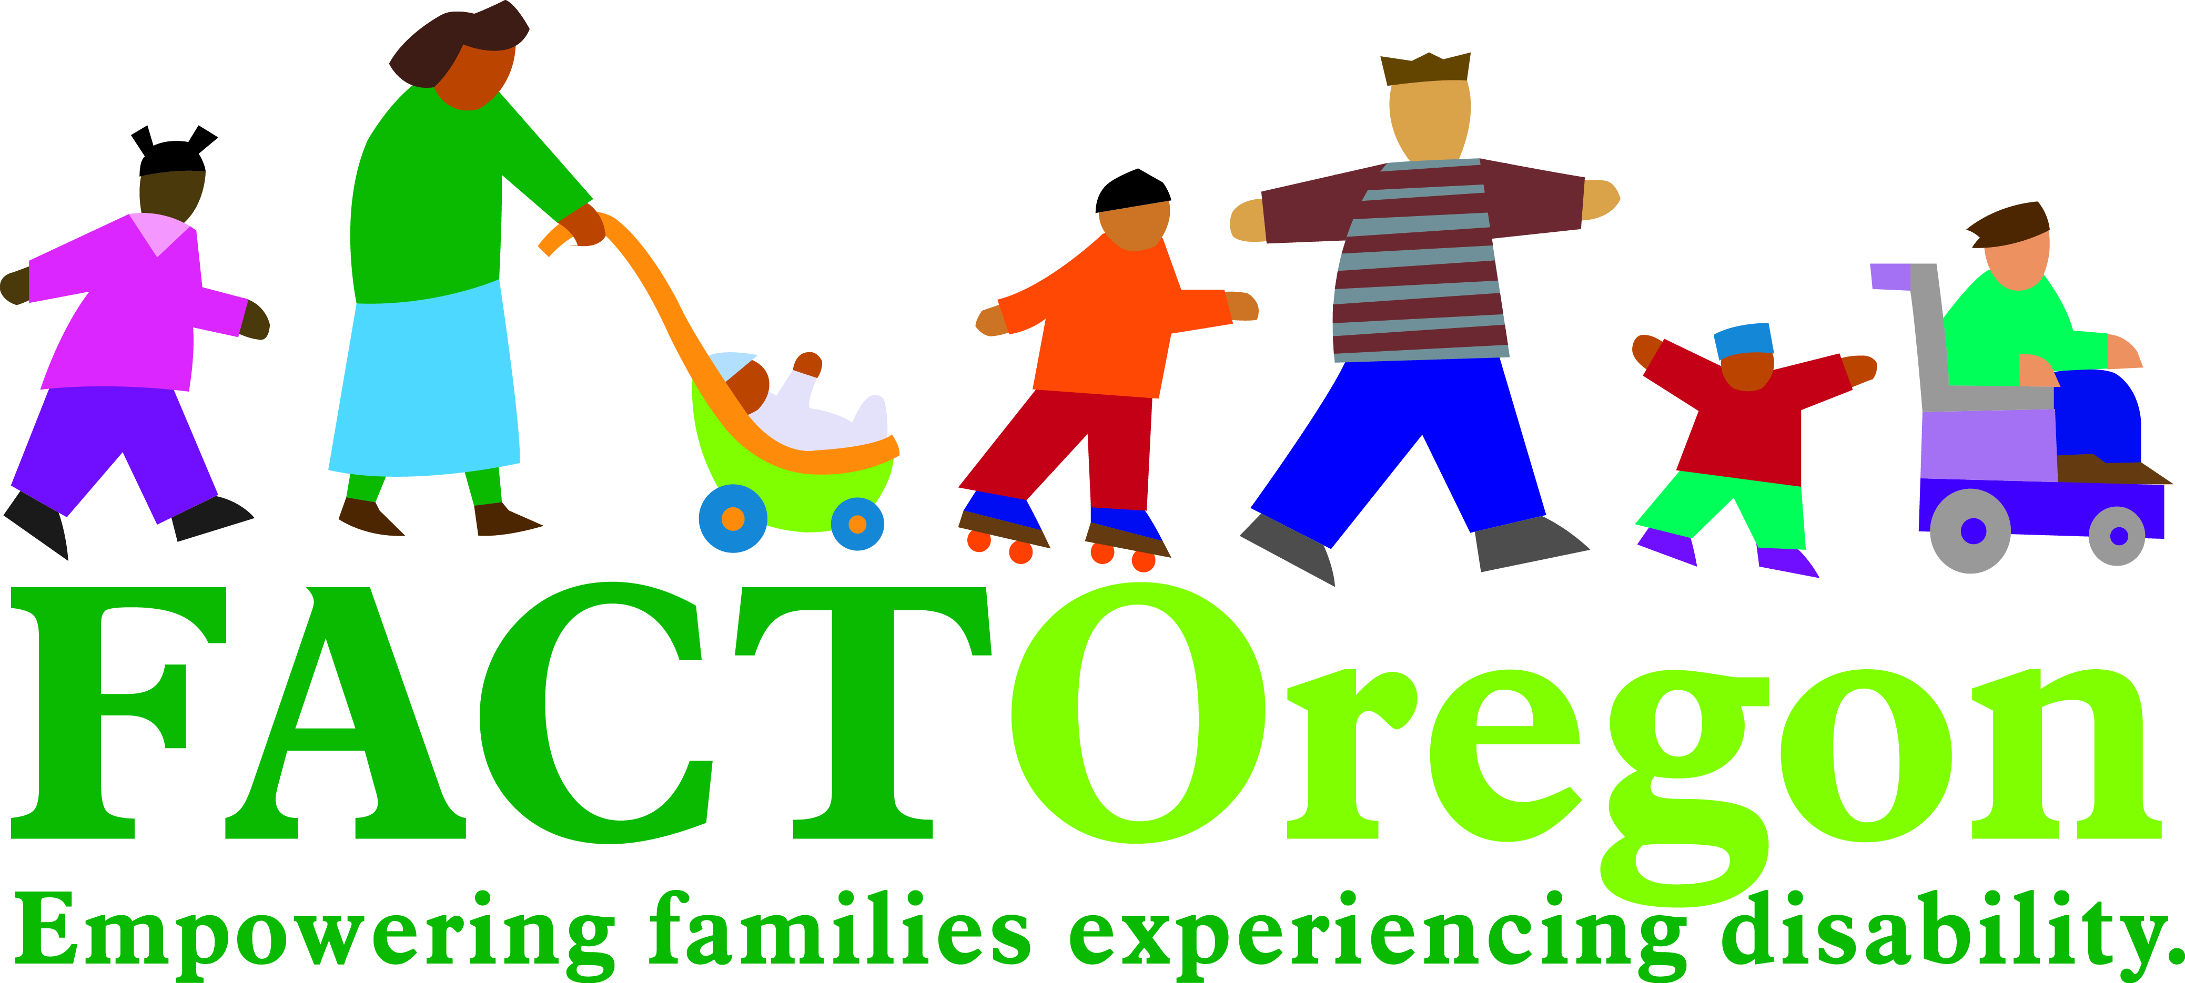

WE VALUE YOUR OPINION!

The Oregon Department of Education (ODE) will soon be asking families living in [insert] School District with children receiving special education services to respond to the 2016-2017 Family Involvement Survey.

If your family is selected, we ask that you take a few minutes to complete and return the survey in the self-addressed, stamped envelope or complete the online version by going to the stated web address.
You are an important member of our team. Your participation in this survey will help us plan improvements in our special education system.
If you have questions regarding the survey, please contact Brad Lenhardt at brad.lenhardt@state.or.us or at 503-947-5755.

