Register Now for the National Center’s Webinar:

Building Relationships Between Fatality Review Teams and Schools

Tuesday, August 24, 2021
2:00 pm—3:00 pm, EST
SPEAKERS

Diane Pilkey, RN, MPH—Health Resources and Services Administration
Frank Miller, MS—U.S. Department of Education
Deepa Joshi, MD, MPH—Health Resources and Services and Administration

Click here to register: https://bit.ly/3iuRecW

Questions?
Contact the National Center for Fatality Review and Prevention: 800-656-2434 info@ncfrp.org A limit of 500 attendees are permitted. Webinars are archived and posted on our website: https://www.ncfrp.org

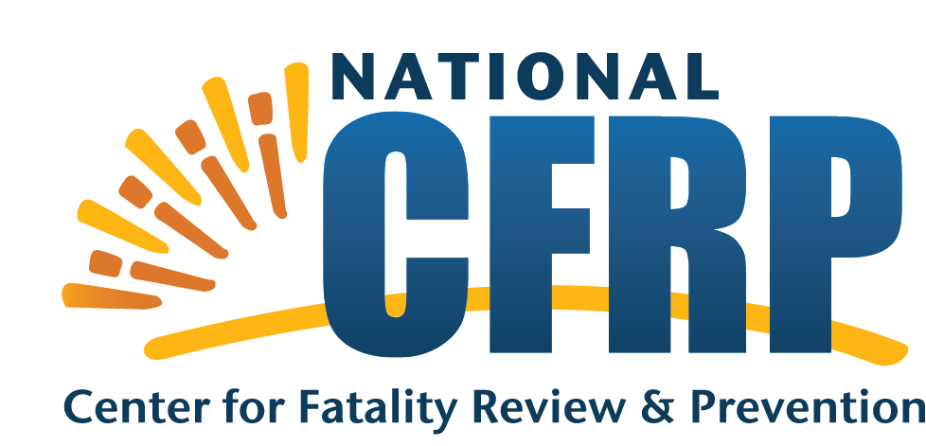
This presentation will provide an overview of collaboration opportunities between fatality review teams and schools. The presentation will provide an overview of FERPA and describe current collaborations between schools and fatality review. Additionally, a written guidance on the topic will be released.

Speaker Biographies

Welcome and Opening Remarks
Diane Pilkey, RN, MPHI


Ms. Pilkey is a Senior Nurse Consultant at the Maternal and Child Health Bureau/Health Resources and Services Administration (HRSA) and the federal project officer for the National Center for Fatality Review and Prevention cooperative agreement. Ms. Pilkey has more than 20 years of experience in public health at the local, state, and federal level, including with the Washington State Department of Health, where she worked as an epidemiologist and the Child Death Review Assessment Coordinator. Ms. Pilkey is a registered nurse who has practiced in both clinical and public health settings in both urban and rural contexts. Her work has focused on children and adolescents, injury and violence, infant mortality, and early childhood. Ms. Pilkey has a master’s in public health from the Maternal and Child Health program at the University of Washington Public Health School, a bachelor’s in nursing from the University of North Carolina, and a bachelor’s in Cultural Anthropology from Duke University.

Guest Speakers
Deepa Joshi, MD, MPH

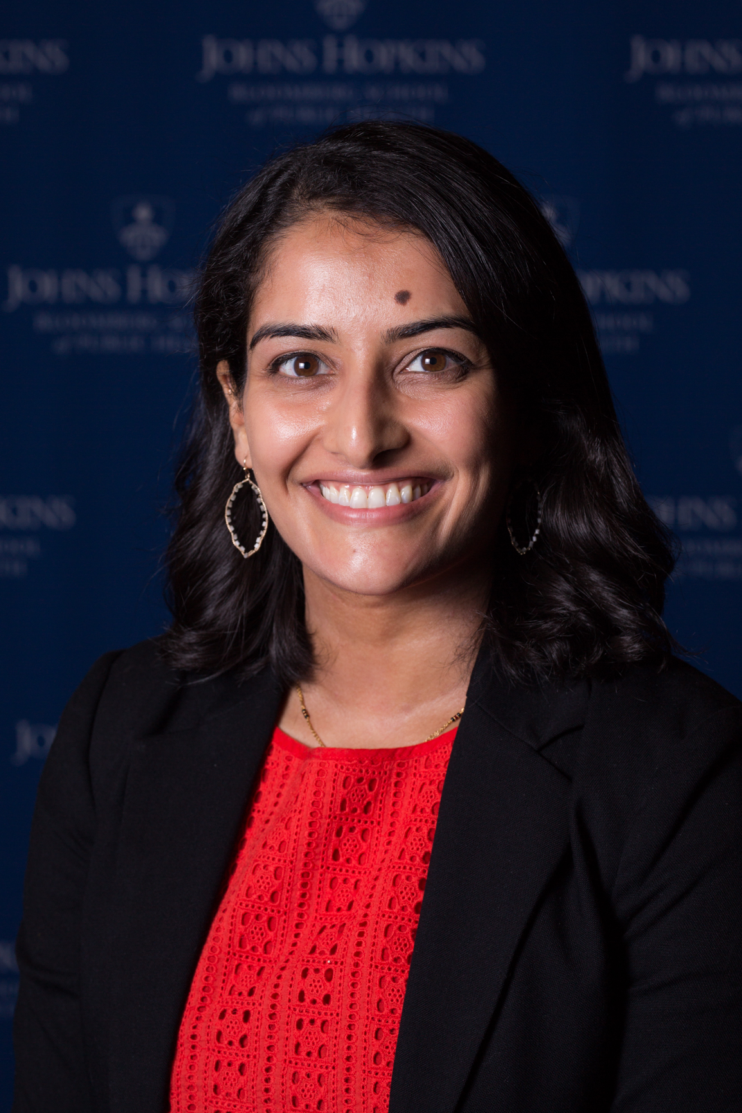
Deepa Joshi is a public health pediatrician who is currently a social scientist with the Maternal and Child Health Bureau’s Office of Epidemiology and Research at HRSA. As a general pediatrician, Deepa aimed to partner with services and sectors beyond healthcare to provide families the best care possible. As a public health practitioner, this interest has translated into a desire to promote cross-sector collaboration from the local to federal levels. She initially became interested in improving the collaboration between the public health and education sectors while pursuing her master’s in public health. Namely, she has been working to understand how to better facilitate Child Death Review Teams collaborating with school systems and is excited to share what she has learned with all of you today.

Frank Miller, MS

Frank Miller is the Deputy Director of the Student Privacy Policy Office (SPPO), focusing on the administration of the Family Educational Rights and Privacy Act (FERPA), and the Protections of Pupil Rights Amendment (PPRA). Prior to joining SPPO in 2013, he was an education program specialist in the Office of Special Education Programs. Before beginning his federal career in 2011, Frank had several years of state-level experience, including 6 years as Division Chief in the Pennsylvania Office of Child Development and Early Learning where he had fiscal, operations and monitoring, and data management responsibilities for the Individuals with Disabilities Education Act (IDEA) Part C and Part B/619 programming and 9 years in regulatory administration and program compliance with the PA Department of Health. In addition to federal and state level experience, he also worked at the local level as a children and youth caseworker and program manager of community living arrangements for individuals with disabilities. Frank has a bachelor’s degree in health policy and administration from the Pennsylvania State University and a master’s degree in computer information systems from the University of Phoenix.

Webinar Host Organization

The National Center for Fatality Review and Prevention

The National Center for Fatality Review and Prevention (National Center), a program of Michigan Public Health Institute (MPHI), is funded by the U.S. HRSA Maternal and Child Health Bureau to provide training, technical assistance, and data support to Child Death Review (CDR) and Fetal & Infant Mortality Review (FIMR) programs across the country.

