# Technical Announcement

|  |  |  |  |
| --- | --- | --- | --- |
| February 9, 2016  **For Immediate Release** | Rob Dollison  Mark Newell | 703-648-5724  573-308-3850 | [drollision@usgs.gov](mailto:drollision@usgs.gov)  [mnewell@usgs.gov](mailto:mnewell@usgs.gov) |

# The National Map Data Download Enhancements

The USGS National Map program is transitioning all of its GIS data download capabilities to its new [TNM Download client](http://viewer.nationalmap.gov/basic/?basemap=b5&category=nhd&q=&zoom=4&bbox=-128.93554688,13.06877673,-65.03906250,54.82600800&preview=&avail=&refpoly=8-digit%20HU%20(Subbasin)) during the week of February 15, 2016. The [new launch page](http://viewer.nationalmap.gov/launch/) will help users easily find the variety of resources available to get National Map data, download GIS data, visualize and analyze data on the web, or access developer tools such as APIs and map services.

This is not a replacement for all the visualization capabilities in the current National Map Viewer, but rather an application and API to improve and simplify the data download experience. The National Map Viewer will remain available for web-based visualization and analysis of National Map data.

Usage of TNM Download Client combined with staged product files will provide faster, more reliable and larger quantities of data to the geospatial community. The Download Client has an associated API available to developers to take advantage in their own applications.

The National Map released several recent enhancements to the delivery of its data products and map services to include:

* Updated [launch page](http://viewer.nationalmap.gov/launch/) to help navigate to the many data resources available from The National Map, including data, maps, applications, and ‘how to’ videos;
* New [TNM Download Client](http://viewer.nationalmap.gov/basic/?basemap=b5&category=nhd&q=&zoom=4&bbox=-128.93554688,13.06877673,-65.03906250,54.82600800&preview=&avail=&refpoly=8-digit%20HU%20(Subbasin));
* Java-based [Download Manager](http://viewer.nationalmap.gov/apps/download_manager/);
* 24K large scale [contours map service](http://services.nationalmap.gov/arcgis/rest/services/Contours/MapServer); and
* Modified dynamic layer control on all its [vector web services](http://viewer.nationalmap.gov/services/).

**TNM Download Client**

The new [TNM Download Client](http://viewer.nationalmap.gov/basic/?basemap=b5&category=nhd&q=&zoom=4&bbox=-128.93554688,13.06877673,-65.03906250,54.82600800&preview=&avail=&refpoly=8-digit%20HU%20(Subbasin)) will replace the data download function in the older legacy TNM Viewer. It allows the user to easily filter by product, file format, and search for data over their area of interest. Product specific workflows have also been developed such as selecting a particular hydrologic unit and to give users more appropriate results. Several ‘[How to Download Data](http://training.usgs.gov/TEL/TheNationalMap/TNM-TEL-Index.html)’ tutorial videos (lessons 4a-4d) have been created to take advantage of the new capabilities.

**Basic download steps**

1) Zoom to your area of interest

2) Select the desired product and file formats

3) Click on the “Find Product’ button to get search results

4) You will then be presented with a .CSV file to directly download or add to a cart if you want additional products.

5) You can order multiple National Map products from this client but it is easiest to go through the steps for each product line you want to order, one product at a time.

**Download Manager**

[Download Manager](http://viewer.nationalmap.gov/apps/download_manager/) is a Java-based application that runs on your local computer and enables download of multiple products without requiring the user to click each individual download link. If you require lots of data, export all the search results into a .CSV file and use the ‘Download Manager’ application for fast behind the scenes data retrieval while working on other activities.

**Large Scale Contours are available**

The contours created from The National Map US Topo program are now included in a dynamic [contours map service](http://services.nationalmap.gov/arcgis/rest/services/Contours/MapServer). This new service has dynamic layers enabled to allow user-defined custom styling to be applied in Esri® clients.

**Dynamic Style Control is enabled on vector map services**

Users can take advantage of dynamic style control on The National Map [vector web services](http://viewer.nationalmap.gov/services/). This feature enables users to change the color and line weight of our vectors to best meet their mapping and visualization needs, without having to download the actual dataset.

**File GeoDatabase 9.3.1 format retired**

In addition to these new enhancements, some of the existing file formats and capabilities will be retired over the next few months. File GeoDatabase 9.3.1 format will be retired in mid-February 2016 and the download function in The National Map (TNM) legacy viewer will be removed. Users will be directed to the new TNM Download Client.

To keep current with The National Map downloadable products and map services, visit [The National Map Viewer launch page](http://viewer.nationalmap.gov/launch/).

Questions or feedback regarding any of these changes can be submitted to [tnm_help@usgs.gov](mailto:tnm_help@usgs.gov).

**GRAPHICS:**

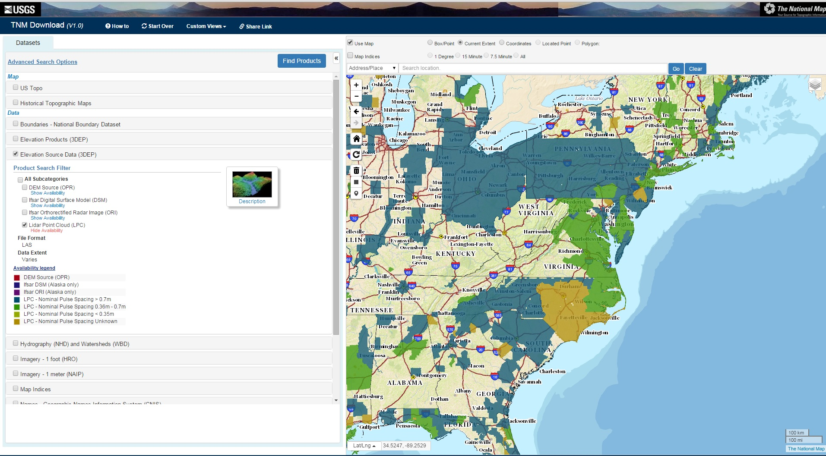

Caption:

**Screen shot of download enhancements to lidar data availability visualization and file downloads**

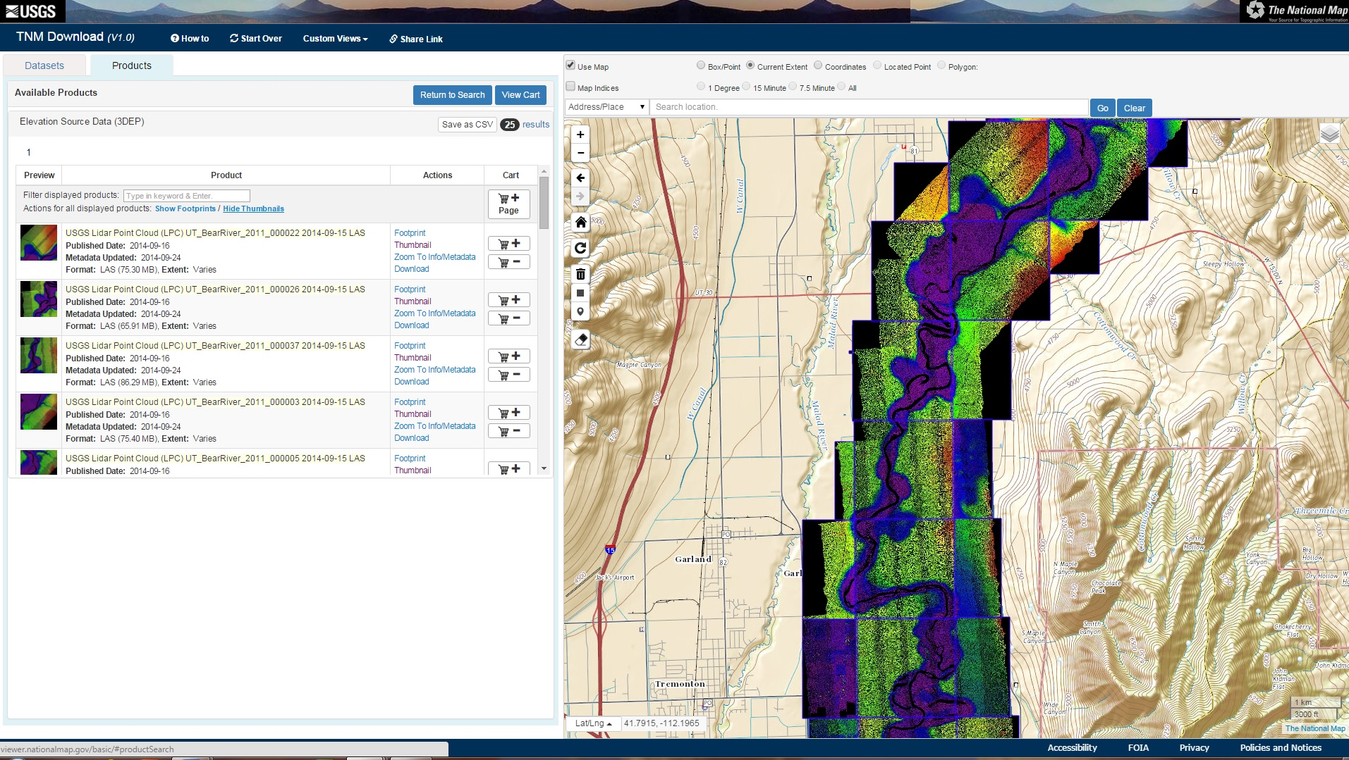

Caption:

**Screen shot of lidar data downloads**