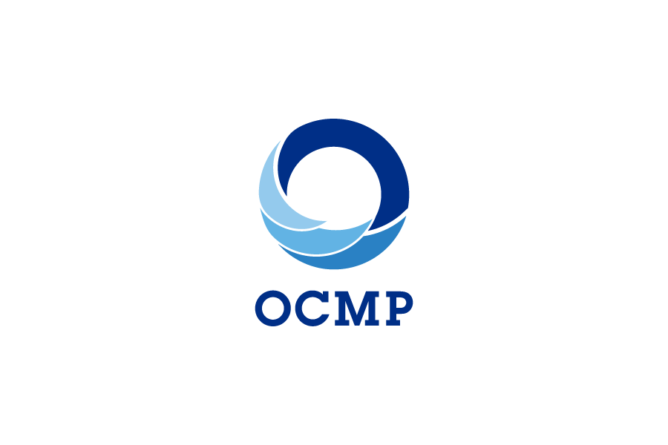**Coastal Resilience Grant Application**

**OREGON COASTAL MANAGEMENT PROGRAM**

***Please type or print clearly***

**Date:**

**Applicant:**

**Address:** **City:** **Zip:**

**Phone:** **Fax:**

**Contact Person, Title:**

**E-mail address(es):**

**Amount Requested from DLCD:**

**Project Title**:

**BRIEF** description of the project, 50 words or so. Be sure to state the expected results

**Keywords**

(Check those that apply to the project)

_____ Information technology _____ Coastal hazards _____ Stormwater management

_____ Economic development _____ Wetland & riparian _____ Resource and land inventories

_____ Estuarine resources _____ Marine resources _____ Special Area Planning

_____ Transportation _____ Public involvement _____ Capital improvements planning

**SUBMITTAL**

Please submit all application information by e-mail to:

Meg Reed, Coastal Shores Specialist

[Meg.reed@state.or.us](mailto:Meg.reed@state.or.us)

**309-1 Coastal Hazards and Resilience Grant Application**

**Project Narrative**

**Please provide the information requested under each item. Although extensive, detailed information is not necessary, you need to provide enough information to help OCMP understand the project and make grant funding decisions.**

**1. Goals and Objectives:**

**State the goal(s) or overall purpose of the project. What is the problem, need, or opportunity the project will address? Describe planning, technical, or information objectives that will help achieve the goal(s).**

**2. Scope of Work, Products, and Budget (attach additional pages if necessary):**

**a. Describe the scope of work to be performed. If the project is in phases, please note.**

**b. Schedule (e.g. when will work begin, project milestones, project end):**

**c. Total Budget**

**Please use the Budget Summary form below, and any additional information as indicated in the footnotes.**

**3. Project Partners**

**List any partners such as other local governments, special districts, state agencies, or other entities; briefly describe the role of each (e.g., will perform work under the grant; will advise; will contribute information or services, etc).**

**5. Will work be performed by a consultant/contractor for all or part of this project?**

__ **Yes**  ___**No**

**If yes, please describe the work to be performed by the consultant, list the anticipated amount of**

**the contract, and provide name of prospective firm/consultant(s), if known, including address**

**and telephone number.**

**Grant Budget Summary**

**NOTE: Please use the format in this table when developing a more detailed budget.**

|  |  |  |  |  |  |  |
| --- | --- | --- | --- | --- | --- | --- |
|  |  | **Grant Request**  **(from DLCD)** |  | **Grantee Match**  **(Optional)** |  | **Total Budget** |
| **Personal Services1** |  |  |  |  |  |  |
| **Supplies (if any)** |  |  |  |  |  |  |
| **Contract Services2** |  |  |  |  |  |  |
| **Other3** |  |  |  |  |  |  |
|  |  |  |  |  |  |  |
| **TOTAL4** |  |  |  |  |  |  |

*Budget notes*:

1. List all personnel who will work on the project. Compute costs on the basis of the number of expected person-hours, hourly rate, and related payroll expenses for each.
2. Total Contract Services. Provide additional information on expected contract services under Item 5, above.
3. List Other expenses (e.g. printing, publishing, travel). NOTE: all travel supported by this grant must conform to state travel rates (e.g. mileage, meals, etc.).