Authoritative Data

The term Authoritative Data has not been well defined by the geospatial community. As the technical advisory group to the Oregon Geographic Information Council (OGIC), the GIS Program Leaders (GPL) provide the following on the use of the term ‘authoritative data’ and other terminology as they relate to GIS data designed, created, and distributed by the GIS community in Oregon.

Authoritative Data has many implied meanings. If data are considered authoritative, does that mean the data are: accurate; valid; from the original source/creator; the best available for a particular data type; regulatory for enforcement purposes; licensed, vetted or approved by an identified authority; appropriate for a specific use; complete or consistent? It is also important to define Authoritative Data Source, as well as other equally relevant terms that often arise when discussing authoritative data.

Definitions:

Authoritative Data – Data that can be officially certified and are provided by an authoritative source.

Authoritative Source – An entity that is authorized by an authority to develop or manage data for a specific business purpose. The data this entity creates are authoritative data. An organization or department within an authoritative source is typically charged with the collection and maintenance of the data (custodial steward).

Authority – In the context of public agencies, it is the legal responsibility provided by a legislative body to conduct business for the public good. This type of authority is referred to as Rational Authority. Example: The Natural Resources Conservation Service (NRCS) creates the STATSGO soils dataset.

Additionally, Expert Authority refers to scientific methodology, technical standards, and expertise required to generate an authoritative dataset. Example: Studies/research conducted by recognized
‘think tanks’ or academia.

Authorization – The result of an act by a legislative or executive body that declares or identifies an agency or organization as an authoritative source.

Data Steward and Trusted Data – A service provider or agency that publishes data from a number of authoritative sources. These publications can be compilations and subsets of the data from more than one authoritative source. These data are “trusted” because there is an “official process” for compiling the data from authoritative sources, and the limitations, currency and attributes are known and documented. Metadata are provided; the data are often formatted into a standardized form; and linkages to the originating source are provided with the data. This data steward is recognized by the authoritative source as an official publisher of the data.

Authoritative Data and Authoritative Data Sources in Oregon
Many Oregon local and state agencies create geospatial data to support their mission, legislative mandates, and day-to-day operational needs. The following statements provide some clarity on authoritative data classifications often used in Oregon.

1) Oregon’s GIS Framework Data: Many state and local agencies participate in Oregon’s GIS Framework program, which is an OGIC endorsed process that organizes data based on a set of 15 data themes, creates data standards, and promotes data stewardship. For the purposes of this authoritative data and authoritative data sources discussion, the Oregon Framework structure and approval processes are a mechanism for agencies to certify data as authoritative data.

Figure 1

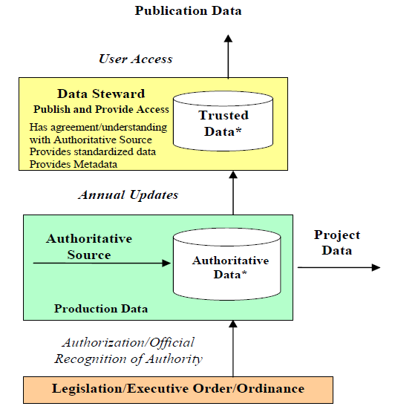
Figure 1 is an illustration of the relationships between the defined terms.

**Definitions and Illustration have been modified from the original source documents. (FGDC Subcommittee for Cadastral Data, 2008, pp. 1-2),
(U.S. Department of Homeland Security) and (Stage, 2009).

2) Rational Authoritative Data: Many state and local agencies, and even non-governmental organizations, create data sets due to regulatory or statutory mandates. They may not participate in the Framework program review and approval process, but may also be considered authoritative data. For example, licensed land surveyors create geospatial data in the form of surveys. According to ORS 672.005, licensed land surveyors, engineers, and photogrammetrists are the authoritative sources for the creation of maps and geo-referenced databases representing the legal locations for property boundaries, the location of fixed works, or topography.

3) Expert Authoritative Data: Some state and local agencies and educational institutions employ staff considered to be scientific or technical experts. In these cases, the data may be certified as authoritative based on the expertise utilized. In many cases, these data are incorporated into the Framework program, but may not traverse the entire Framework process or the data may be published prior to the Framework process completion.

Data Stewards in Oregon
It is important to note that most authoritative data that has been reviewed and approved as part of the Oregon GIS Framework program is stored and served to the public via the Oregon Explorer and the Oregon Spatial Data Library. These trusted sources are the result of a partnership between the State CIO’s Geospatial Enterprise Office and Oregon State University’s (OSU) Institute for Natural Resources. However, not all Framework data have an assigned Steward. Much work remains to be done to complete the governance aspect of data management for authoritative data.

Conclusion
The Oregon GIS Framework Data Program has established a means to identify foundational data elements needed to support effective and efficient government in Oregon, a process for determining that the data is authoritative through the Framework Standards Process, and means for discovering and accessing the data through the Oregon Spatial Data Library and Oregon Explorer. Together, these systems aim to increase access to authoritative data, reduce redundancy in data development, and to elevate the overall quality and quantity of data available to the GIS Community in Oregon.

References
FGDC Subcommittee for Cadastral Data. (2008). Authority and Authoritative Sources: Clarification of Terms and Concepts for
Cadastral Data. Reston, VA: Federal Geographic Data Committee.

Stage, D. (2009). Authority and Authoritative Data: A Clarification of Terms and Concepts. Fair & Equitable, 13-16.

U.S. Department of Homeland Security. (n.d.). Geospatial Concept of Operations. Washington D.C. Retrieved November 2015, from https://www.geoplatform.gov/geoconops-home

