GPL Minutes for Tuesday, Sept 13, 2016

Time: 1:30 PM to 3:30 PM
Location: DSL
775 Summer Street NE
Suite 100
Salem, OR 97301

Intro:
Announcements/jobs/Amendment
- Discussion of agency project portfolios was brought up and how it might relate to shared services. Item is couched again and could be discussed at the Oct 2016 meeting.

- Framework conference – Sept 30, 10:00 – 3:00 pm in Bend. If planning to attend please register so we know how many meals to provide. Here is the link. conference registration website

- Additional item to add to agenda: MS 2012 SQL work at GEO - Dave Mather , Oregon Coordinate System and Imagery – Brady Callahan

Review Aug 2016 Minutes:
- No feedback.

Geo Update:
Cy Smith – Address point are now an FGDC nationally Data Theme. Data Sharing Legislative Concept (LC), workgroup has been working on the language of to be to take to legislative council; Sean McSpaden will provide presentation at OGIC on Wed, Sept 14. Doc can be viewed at GEO’s web site. Briefly the updates includes the addition/definition of Data Steward to match with Data custodian, and also made sharing of Critical Infrastructure information voluntary as it is in law. Section four of the Bill which discusses the mandate for sharing data among public bodies which won’t take place until Jan 1 2020, because we wanted more time to allow OGIC to get back to the legislature in the 2019 session with a funding model for data development, maintenance, and access.
Comments: Brady Callahan – Noticed in Section (2) the representation only allows for 1 representative for the 12 Natural Resource Agencies. Rachel Smith – regarding Critical Infrastructures, does the LC list/define datasets that are deemed Critical Infrastructures? No but the LC does direct the reader to statutes (ORS 192.502) already in place which do offer definitions.
Imagery Procurement:
Brady Callahan – we would like to establish an RFP for one foot imagery statewide for 2017 and then repeat on a 2-3 year cycle. Other component might include 6 inch imagery for urban areas, hosting of data, and including some elevation data and possible some oblique’s. Currently putting the scope together and hope to have out on street on Nov 1, 2016. CY has to create a Business Case as per DAS requirements to show that the RFP is a viable request.
Comments: R. Sounhein – how will funding be approached and will it include the Feds and how might this affect the current NAIP program? Would like to see the Feds get involved with the state much like we did in 2005. CY Smith - Would like to have feds get involved with us, but it look like right now were going to need to use the “passing of the hat approach,” however farther on down the road this project would be nice to roll into the future funding model for Data Sharing, however the RFP has to get out first before we get funding from local governments. The total cyclical funding per year will be approximately $300-500 Thousand for year with products delivered every two years.

Shared services:
Cy Smith – We have had two pilot/proof of concept projects (Lead Testing, Mapping the Oregon Economy) in the works. The later project helps legislatures to make determinations or target areas in the state where investing state funding might provide the most impact. Help OHA, DEQ to provide online tools to provide info on lead testing in public facilities state wide.
Also drafting legislative concept on Shared Services, to help consolidate GIS efforts in a more directed way. State is already working on the unification/consolidation of IT security and so the concept has since been modified to focus more (mandating) on working on better coordination of enterprise based projects to reduce duplication efforts, as opposed to unifying GIS staff under the CIO office. Sept 26, 2016 is the date to when the LC is being turned over to legislative council and so that would be the time when we could get something like a FAQ or public update on where we are with the Shared Service concept.

Framework Update:
T. Burcsu - We are planning to have a follow up meeting in July 2016. The next Framework Forum will be sometime in September 30, 2016 and located in Bend, OR.
Working on Metadata STD update to clarify roles and point of contacts. Working with FIT leads on prioritization of data elements. A couple of GPL meetings back we talked about Foundational Themes and so now were looking at creating some determination as to what the foundational layer will be.

Oregon Coordinate Reference system
Brady Callahan - Currently belong to the Oregon Coordinate reference system policy update committee, want all to know that ODOT has added multiple low distortion coordinate systems to the existing state plan coordinate system and should show up in early 2017. Secondly, the committee is looking to add the Oregon lambert Coordinate System into state statute, and wanted to know is GPL would agree that we should add this to rule/law? Yes all GPL members recommend further review of item at the next GPL meeting in Oct 2016. Brady will follow up by sending out related links on GPL.

MS SQL 2012 environment at GEO
Dave Mather - Need to create a simple easy to follow failover component, within their SQL environment. Overall goal was wanted more resilience and have a need to eliminate single points of failures, within a VM environment. With the new environment features an Anti-Affinity Cluster Node which basically is a virtual machines the function as a physical server. Thus multiple nodes (two) can be active at the same time, so we can run any and all SQL instances on any resource node thereby allowing us to balance the instance across the resource nodes. In the event of a failure (ArcGIS Server etc.) would be transparent to the end user. See picture below and for more info please contact Dave over at GEO: David.Mather@oreogn.gov

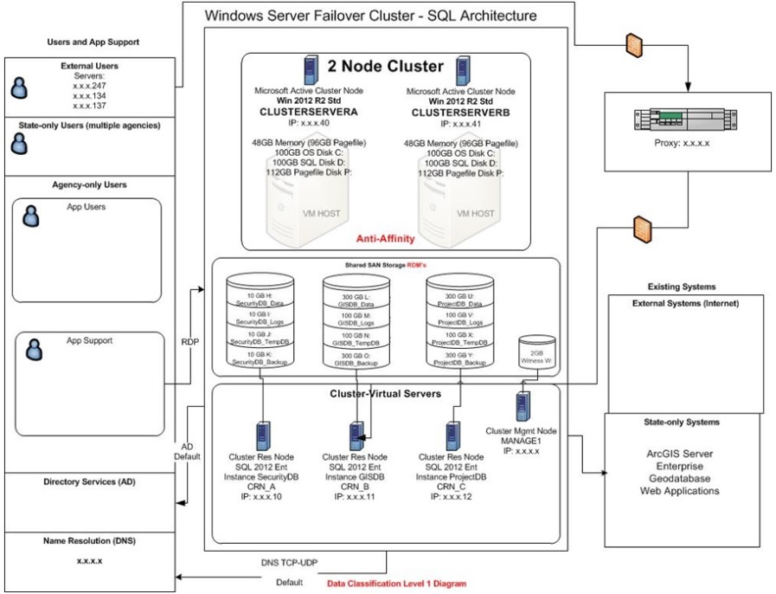

Agency Roundtable:
ODOT- S. Mead. Agency finally made it through our 10.2 migration.
DSL - R. Sounhein. Nothing to report at this time.
DHS – L. Haider. Nothing to report at this time.
ODA – D. Walker. Water Quantity project just about complete. Noxious Weed Group has been using Collector successfully. Still having issues with Cyrix and ESRI will pay a visit to help out. Food safety will stand up a Web site to host info on tracking the posting of Oyster and Clam harvesting.
ODP – B. Callahan. We have migrated our LIDAR storage over from ArcSDE to File Geodatabases for the purpose of easier backend maintenance/management. Been comparing the differences with LIDAR versus Phodar
ODRev – J. Prichard. More staff will be added to help with managing the change with Marijuana.
ODWR - B. Harmon. Recent requests on data related to water rights point of diversion, and so have been working on tools to reformat the diversion data so others can use our data for easier analysis.
OWEB – T. Wirth. Updating online water restoration tools and OWEB investment tracking tools which are set up in a GEOCortex environment over at OSU.
DLCD – R. Smith We also have a few apps over at OSU. INR is upgrading some tools for more stakeholder outreach. We have been working with the Sage Grouse efforts along with the USGS and BLM who have developed the new Surface Disturbance Analysis and Reclamation Tracking Tool (SDARTT). This new tool is a national repository for and analysis tool of disturbance data pertaining to public land operations for the BLM https://blm.sciencebase.gov/sdarttinfo/ .
OEM/911 – M. Gurlery migrating off of Shapefiles to Geodatabase. We will be using Airbus DS Telephony software which is already used in the PSEP’s and the dispatchers are happy with the new tools which replaces Map Star.

Meeting Adjourned

