National Geospatial Advisory Committee

Geospatial Technology and Infrastructure Use Case:


NY STATE CULTURAL RESOURCE INFORMATION SYSTEM

To improve the permit application process and reduce paper, New York State Historic Preservation Office (NY SHPO), created the New York Cultural Resource Information System (NYCRIS), an advanced Geographic Information System that provides streamlined access to New York State's vast historic and cultural resource databases and digitized paper records. The improved access to critical information makes informed decision making easier, more consistent, and faster. NYCRIS provides users with access to more than 1.5 million pages of digital images, including National Register documents, building and archaeological inventory forms and survey reports, and a wide variety of additional legacy data. The system has organized data access and resulted in significant time savings and increased efficiency.

Benefits of Geospatial Technology
The system has been a tremendous success, embraced by the external users, as well as internally within the State Historic Preservation Office. Since the inception of the NYCRIS application, the NY SHPO has experienced the following increases in efficiency:
- 20% increase in the number of projects processed
- average number of days responding to a submission reduced from 23 days to 12 days
- reduction in annual paper usage from 70 linear feet to 15 linear feet
Description
The NY SHPO’s main objective was twofold; reduce or eliminate paper submissions; and simplify and streamline the internal review and processing of applications and projects. To achieve this objective, the project involved complete requirements analysis, design, and development of the Cultural Resource Information System. The resulting system is an enterprise application developed to record and manage data concerning the cultural resources within New York State, and an application to facilitate a workflow for submitting, reviewing and processing a variety of project types, including:
- Environmental Review (in accordance with Section 106 of the National Historic Preservation Act);
- Nominations for the National Register of Historic Places;
- Building and Archeological Surveys;
- Evaluations of Eligibility; and,
- Federal and State Tax Credits.
Before the workflow application could be implemented, the project required organizing, and in some cases digitizing from paper, a diverse set of data resources required for the proper evaluation of project applications. The NYCRIS database includes:
- 320,000+ above ground cultural resources (buildings, structures, objects) and 20,000 archaeological sites, all of which are stored as point features in the geodatabase;
- 1,000+ historic districts stored as polygon features;
- 6,000 National Register listings, over 13,000 surveys, and 130,000 consultation projects; and,
- Over 1 million pages scanned from hardcopy and now on-line as attached documents and photos
Complementing this rich and diverse data resource is the cornerstone of NYCRIS, the application that manages and simplifies the digital submission, review and response process. The application leverages custom wizards and on-line forms to facilitate digital submissions and reviews, dashboards to monitor and notify progress, and automated emails for timely communications.
In addition to providing powerful search capabilities to access the vast data resources, the NYCRIS application guides the systematic workflow through the necessary steps of the process from digital submission to final decision. Key steps in the process:
- Digital Submission: External users are provided a series of wizards to digitally submit new projects to NY SHPO.
- Review: Once the submission has been imported into NYCRIS, one or more reviewers are added to review the project based on their expertise (buildings, archaeology, etc.). The reviewers then determine the eligibility of all resources within the project area and conduct their review of the project.
- Request Additional Info: If they do not have enough details on which to base a decision, they can digitally request more information from the external user (submitter) via NYCRIS. The reviewer can request photos, documents (e.g., site plans), surveys (building or archaeological), geographic data (e.g., a more detailed area of potential effect), or updated data on one or more cultural resources in the project area.
- Supplemental Information: The external user receives the request digitally via email, as well as in their NYCRIS dashboard, and can respond to the request digitally via a custom wizard to upload the requested information or completing an on-line form.
- Rendering / Communicating Decision: When the NY SHPO reviewers have enough information to complete their reviews, they can render their decision for the project. All key decision points are formally communicated with digital letters sent as PDF documents to the submitters.
NYCRIS is a state of the art, web-based application with powerful search capabilities and secure web services that consume data stored in a centralized SQL Server database and enterprise Geodatabase. GIS functionality is integrated throughout the process, and NYCRIS is based on a robust security and privileges model to protect sensitive data, such as archeological sites.
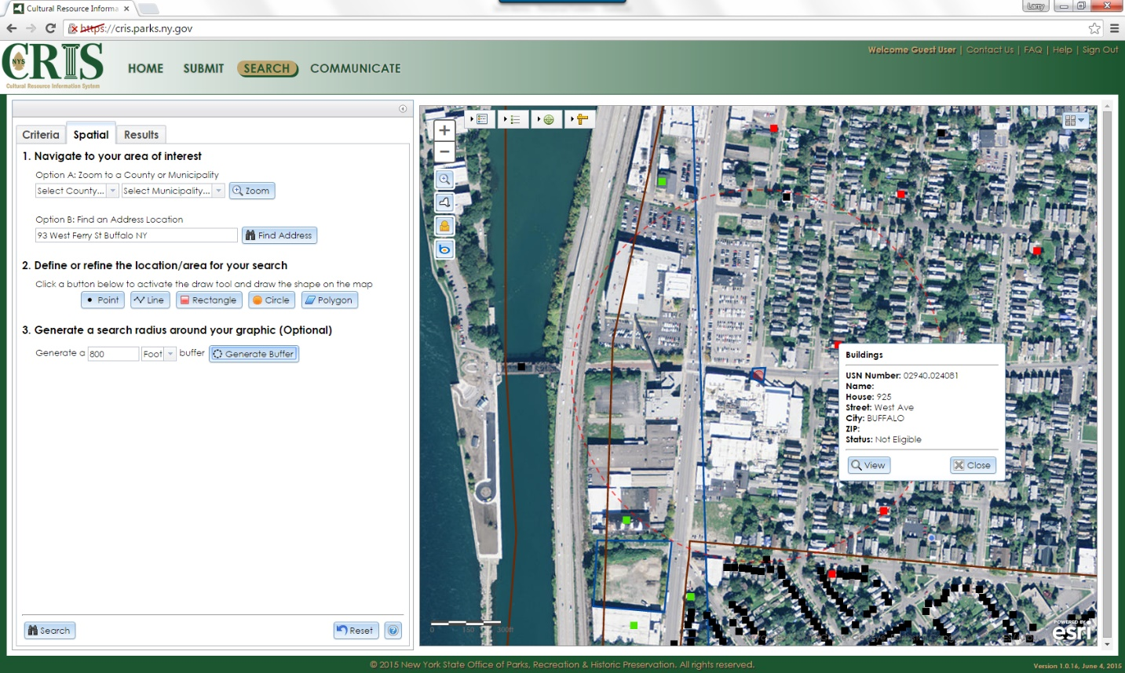
Challenges
As with any system, data quality matters and the data must be kept up to date. For NYCRIS to remain effective and valuable, responsible agencies must continue to add new data to the system as it becomes available. To achieve this, each agency must incorporate submissions of new data into standard operational workflows, leveraging automated tools to minimize the burden.

Tip
This project focuses on reviewing proposed project impacts on historical and cultural resources, however the same process and procedures could be applied to other permit reviews and the application code could potentially be repurposed. NYCRIS can be accessed at the following URL: https://CRIS.parks.ny.gov

