National Geospatial Advisory Committee

Geospatial Technology and Infrastructure Use Case:


PERMIT STREAMLINING

Infrastructure development and renewal must go through a permit approval process. That process is often time-consuming and expensive, increasing the cost of infrastructure development significantly, if not stymieing it entirely. Geospatial technology and data can help streamline the permitting process.
Description
Sage grouse habitat stretches across the Pacific Northwest and Northern Rockies, in Oregon, Idaho, Montana, Nevada and Wyoming, and into Washington, Utah and California. Sage grouse conservation is shorthand for a host of complex issues related to public lands, roles of various levels of government, rural community sustainability, energy and economic development, wildfire, outdoor recreation, and vast ecosystems supporting unique and important wildlife. Sage grouse habitat covers some 175 million acres in that part of the country.
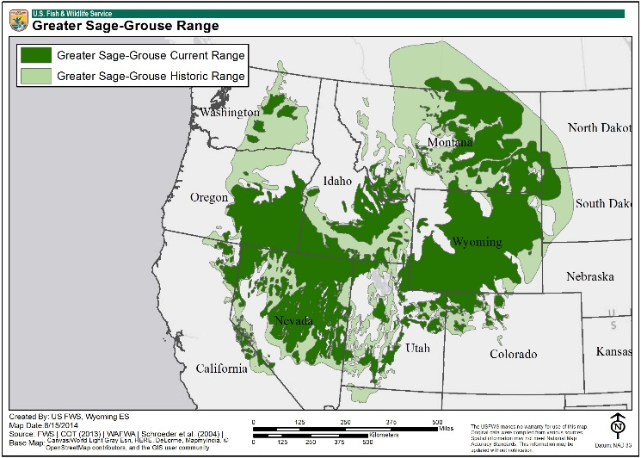
Habitat protection measures have been developed collaboratively across the region, focusing on core areas that are high priorities for the majority of the bird’s population. Strengthening land use rules limits and controls development in core areas and requires compensation for impacts on sage grouse habitat through conservation investments. The stronger land use rules combine habitat protection with greater flexibility to accommodate needed development. Local governments retain responsibility for permit evaluation and approval, with standards set at the state level.
US Fish & Wildlife – August 2014
Energy development, including oil/gas and mining operations, major electrical transmission lines, and renewable energy projects, as well as new or upgraded roads for such development, are infrastructure projects that must be evaluated for permits. The collaborative effort pursued by a group of ranchers, farmers, developers, utilities, environmental groups and government agencies for permitting development in ecologically sensitive areas has streamlined the process, significantly shortened the time for permit approval, and halted the listing of sage grouse as a threatened and endangered species, which would have further complicated the permitting process.
Benefits of Geospatial Technology
The benefits of using geospatial data and technology related to permit streamlining can be summarized as:
- Improved planning for habitat mitigation from human development
- Improved process for establishment of habitat protection areas
- Support for establishment of land use rules to guide the permitting process
- Streamlining the permitting process while protecting critical habitat
Maps and geospatial data provide a tool for planning and identifying appropriate mitigation in the event of human development in sage grouse habitat. Large-scale infrastructure development and renewal is potentially some of the most disruptive for sage grouse habitat.
The collection, modeling and mapping of biological data using geospatial technology allows government agencies to determine species densities, calculate age ratios, sex ratios, peak hatch dates and proportion of successful hens. Blood samples from harvested birds has enabled tracking and research on West Nile virus.
Breeding density data, combined with legal and administrative boundary lines, and overlaid on National Agricultural Imagery Program (NAIP) aerial imagery enabled the collaborative stakeholders to evaluate habitat and topography in establishing the initial core areas for protection. A series of other maps and geospatial analyses of the core areas, including oil/gas development sites, mining permit boundaries, permitted wind development, sage grouse breeding areas, and base data (roads, surface water, land ownership, etc.), provided the necessary understanding to hone the core area boundaries and establish the initial land use rules to guide the permitting process.
The land use rules and associated permitting processes were further refined and streamlined with the use of sagebrush habitat maps, sage grouse observation data, human footprint data, updated sage grouse breeding density data and many other supplemental geospatial datasets and geospatial analyses.
In addition to the creation and refinement of the core areas, geospatial technology and data were also used to identify “connectivity” habitat corridors to support sage grouse movement and genetic connectivity between populations in the various states.
Challenges
The hurdles to permit streamlining are not primarily related to geospatial technology and data. The collaboration necessary to achieve such streamlining is exceedingly difficult and requires far-sighted leadership at all levels and among all stakeholder communities. There are more than just environmental issues at play in the permit process, of course, and each issue presents its own set of challenges that take significant leadership and collaboration to overcome.
The challenges related to geospatial technology and data are funding of data collection, and acquisition and sharing of appropriate data. Technology and data require significant short term funding for development at the required levels, and long term funding to continue to support the permitting process. Even with sufficient funding, challenges related to collecting or acquiring data, and with sharing data between jurisdictions can be significant problems that have to be carefully managed over time.
Tips
Collaboration is difficult, even under the best circumstances, and requires a well-developed collaborative governance structure, great leadership, and continuous effort and investment.
Geospatial data and technology provide the visualization tools necessary for decision makers with diverse objectives to find common ground.

