National Geospatial Advisory Committee

Geospatial Technology and Infrastructure Use Case:


PAVEMENT MANAGEMENT

Citizens interact with public infrastructure constantly – with or without realizing it. The importance of public infrastructure is often taken for granted whether it is drinking from the faucet or driving on smooth roadways. When infrastructure becomes dilapidated or broken, it gets noticed and the public clamors for a return to the ordinary.

Crumbling roads are what people seem to notice most. The American Society of Civil Engineer’s gave America’s roads a grade of D in the 2017 Infrastructure Report Card. Addressing road conditions, with both short and long term objectives, is a challenge many municipalities are currently facing.

A Pavement Management Program (PMP) is a geospatial asset management process used to effectively allocate resources to maximize the service life of paved roads. This program includes a systematic process for inspection, evaluation, project planning, and maintenance of the entire street pavement network. The information collected is used to identify appropriate maintenance strategies for each street segment based on the condition, expected service life, and volume of traffic. Such a system also takes into account other infrastructure co-located under the roadways.

Benefits
Geospatial technologies and analytics are integral tools for a successful asset management program. More importantly, geospatial technologies can quickly create a simple narrative for a complex process. Other benefits include:
- Visualize and Analyze:
  - The road network as a system, rather than individual puzzle pieces;
  - Related assets, including utilities, and their relationship with the pavement program;
  - Investment strategies along with their impact on treatment strategies and ultimately the overall condition of the system;
- Communicate:
  - A complex process in a simple manner;
  - A clear representation of options allowing decision makers to confidently set a strategy; and,
- Educate:
  - Policy makers and citizens on the benefits of an asset management program to ensure effective use of limited resources.

Description
In 2006, the City of Topeka, Kansas performed a condition inventory on their roadways. The overall condition of the City’s streets was found to be “fair”. The Governing Body sought to improve the condition, and in 2009 issued a ballot initiative for a ½-cent retailer’s sales tax, expected to bring in $14 million annually for 10 years. The ballot question laid out restrictions: revenues a) could only be spent on existing streets, curbs and gutters, sidewalks, alleys, and street lights; b) could not be spent on building new roads or sidewalks where none existed before; c) could not include repair or replacement of underground utilities.

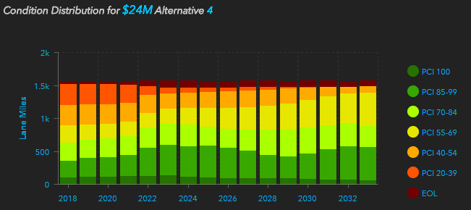
The very specific language was crafted only after citizen input and much discussion by the Governing Body to make clear how the money could be spent. The initiative passed, and work began to identify streets to be fixed. Project selection was not determined through a geospatial analysis. This process limited projects to efforts on rehabilitation and reconstruction strategies for arterials and collector streets, rather than a programmatic and geographically targeted approach.
Figure 1. Condition distribution of streets over time.

In 2016, Topeka reevaluated the condition of their streets. The assessment showed that arterials remained in “fair” condition, but the overall pavement condition dropped to “poor” due to the lack of investment in preventive maintenance and rehabilitation on collector and local streets, which constituted over 2/3 of the City’s inventory. Also, Topeka lacked project coordination to reduce water main breaks occurring under newly laid pavement, or alignment with other infrastructure projects. Without a systematic approach little to no street repairs and resurfacing occurred in neighborhoods. These decisions led to a growing backlog of streets needing more costly repairs and a pothole epidemic.

The facts presented through the 2016 analysis demonstrated that a new pavement management approach was necessary. The Topeka Governing Body set a goal to increase the overall pavement condition index (PCI) to 60, or “fair”, within 10 years. With the sales tax, which accounted for 52% of the annual program budget, scheduled to sunset in 2019, the Topeka Public Works Department embarked on a sophisticated geospatial analysis to achieve 3 objectives: 1) to educate the citizens and Governing Body on the decision process for immediate and long term needs; 2) to cultivate a culture where pavement management is programmatic and not project based; and 3) to optimize treatment strategies to reach the Governing Body’s goal. The Public Works Department performed extensive geospatial and asset management analysis to develop an approach to their objectives. The analysis assumed the sales tax would be extended.
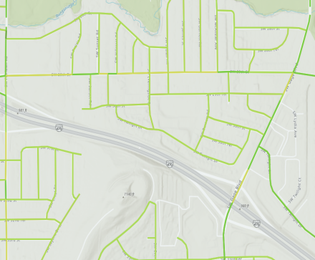
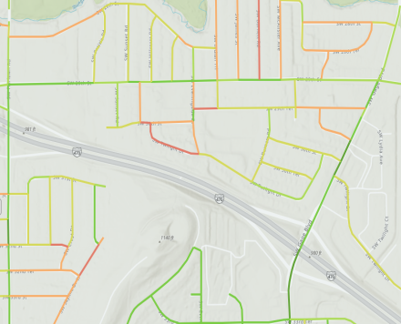
Figure 2. Maps of current (L) and projected (R) pavement condition.
The result was a well-distributed and programmatic system for treatment strategies that optimizes tax dollars and met the condition goal (Figures 1-2).
Treatment strategies were identified for all 1,600 lane miles, including a timeline of when treatments should occur. The analysis estimated less than 5% of roads would be at the end of their service life in 15 years. Another advantage of this approach was that neighboring projects could be combined, along with the coordination of other utility projects, for procurement to take advantage of economies of scale.
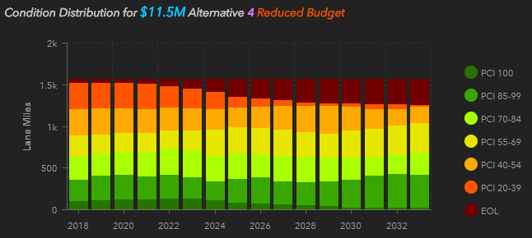
Figure 3. Condition distribution with reduced budget scenario.
An important piece of the narrative was to raise awareness that the PCI of a street reflects the optimal treatment strategy for that segment, not that the street had deteriorated beyond a drivable condition.

Lastly, the Public Works Department wanted to present a reduced budget scenario (Figure 3). Should the sales tax not be renewed, the analysis estimated that nearly 20% of the City’s roadways would be at the end of their service life in 15 years.

Challenges
As with any analysis project, having a complete data inventory is paramount to success. In the case of roads, the inventory included not only city-owned assets, but assets maintained through maintenance agreements.

Tips
While this project was performed with roads data, similar projects can be developed with a broad spectrum of assets, including above ground and underground utilities, alleys, facilities, sidewalks, trees, and more.

