State of Oregon
GIS PROGRAM LEADERS (GPL) COMMITTEE
December 10, 2019 Meeting Minutes
Meeting Host: Dept. of Land Conservation and Development
Scribe: Diana Walker, ODA
Attendees (*via phone): Rachel Smith – Chair (DLCD), Emmor Nile (ODF), Malavika Bishop* (DEQ), Tanya Haddad (DLCD), Bob Harmon (WRD), Diana Walker (ODA), Joe Severson (OSMB), Thom York* (DOR), Phil Smith* (ODOT), Scott Moore (esri), Terri Morganson (esri), Dave Smetana (esri), Chris Marsh (esri), Cy Smith (GEO), Dave Mather (GEO), Jon Bowers (ODFW), Tom Elder (DHS)
Announcements:
- GeoDesign Summit: Feb 24-27 (registration fee applies)
- Federal User Conf: Feb 11-12 (registration fee applies)
- Developer Summit: March 10-13 (1 Advantage Program Credit can be used per registration)
- Public Sector CIO Summit: April 1-2 (2020 website updates pending; registration by invitation and is complimentary)
- GIS In Action: April 21-22, PSU
- Esri User Conf: July 13-17 (12 complimentary registrations via enterprise agreement)
  - ELA registrations are first come first serve.
  - Contact Dave Mather for ELA complimentary seats

ODF will be doing a Lidar re-flight in parts of Clackamas County in 2020 and is looking for partners, contact Emmor Nile.

GEO / OGIC Report, Cy Smith:
Josh will give an AGOL report in January, since he was unable to attend today’s meeting.
Dave Mather
- Significant infrastructure upgrades in the 2019 year:
  - 7 servers decommissioned,
  - 4 new servers provisioned as replacements,
  - and a new SQL upgrade in the planning stages.
GEO/OGIC items - Cy Smith
- GIS Showcase @ Capitol - thought traffic was pretty good. They got an announcement out to all of the leg offices about the event. Had a couple of legislators and leg staff that stopped by.
- We discussed the OGIC Technical Advisory Committee makeup and the # of state agency representatives. Rachel asked for folks to let her and/or Cy know if they are interested in volunteering for the TAC. Goal: make it easier on OGIC members to select state agency representatives.
- OGIC Policy Option Package (POP) was drafted for DAS review. POP details - create GeoHub (infrastructure for data sharing), new staff, and $$ to support three data development/validation projects. Projects selected are: elections administration, wildfire, and workforce development. Cost = $2.8M. There was a very short timeline to get this POP written and to DAS.

Framework Report, Theresa Burcsu via Rachel Smith:
- Address Points Update Project is going very well. Tom Elder did a brief walk through of the outreach progress and database design with the steering committee yesterday. The group provided feedback on the main address table fields as well. Overall everyone seemed to be pleased with the design, which is very thorough and adaptable to future data needs. Tom is also developing a number of scripts to ingest data in the future, but ETL processes aren’t the focus of the project, so more work will be needed in this area in the future.
- Fish Habitat Distribution standard public comment period ends on Friday. Please provide comments to Jon Bowers or Theresa.
- Framework Development Program project contracting is in progress. Delays are attributable to some internal and external budgeting challenges.
- Robert Mansolillo is stepping down from the Administrative Boundaries Theme lead position. Please let Robert and me know if you are interested in stepping into this position.

Jon Bowers commented that Arty Rodriquez from ODFW volunteered to be the BioScience FIT lead.

Esri Presentations
Dave Smetana and Terri Morganson – Advantage Program
- Esri Advantage Program - focused on premium support services, training, consulting, and esri managed services (cloud-based ArcGIS infrastructure)
- Esri is doing planning meetings with several State agencies this week. The top common workplan activities are:
  - System architecture Design Recommendations,
  - Enterprise GIS performance assessment
  - Training
    - A Migrating to ArcGIS Pro class to be held next Spring.

- Quarterly Technology Webcast: https://esriurl.com/insidetrack

- Credit Usage / Equivalents
  - Consulting Support 1 credit = 2 hours
  - Instructor led training 1 person 1 credit = 1 day
  - Onsite instructor led training (up to 15 people) 12 credits = 1 day
  - Dev Summit Reg 1 credit = 1 registration
  - Esri technical certification exam voucher 0.75 credit = 1 voucher

- $560 / per credit

- When Cy buys a block of credits for the ELA, GEO is subsidizing the credits for state agencies. Cy can purchase additional credits for the enterprise at any time. Cy and Dave discussed the amount of credits currently available and those allocated to state agencies.

- Dave Smetana as tech advisor is here for us. Get on the phone, get other esri professionals as needed to provide input on projects, create cost estimates, etc…

- Credits have a 2 year expiration date (once purchased).

Scott Moore – ArcGIS Enterprise Overview

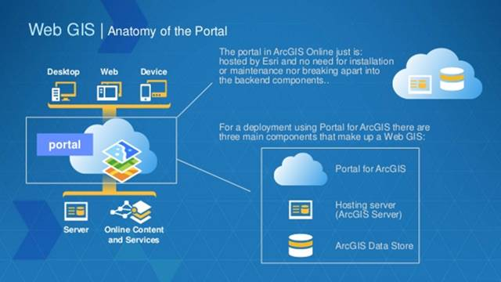
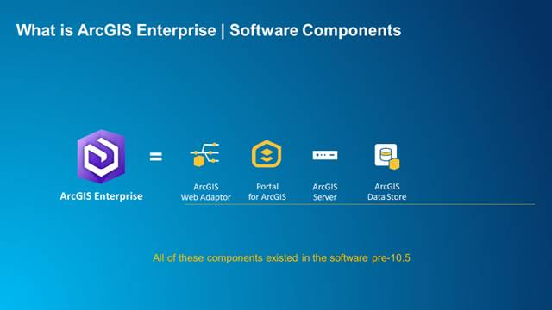
Shared Instances:
https://www.esri.com/arcgis-blog/products/arcgis-enterprise/administration/shared-instances-arcgis-server-107/
Bulk Publishing:
https://enterprise.arcgis.com/en/portal/latest/use/bulk-publish-arcgis-server-feature-layers.htm
Key 10.8 Enterprise capabilities:
* New options for hosted feature layers: Manually update editor tracking to account for changes across your user base and to provide access control, give others context about fields with field descriptions and field types, and publish hosted map image layers from feature layers for server-side rendering and advanced symbology.
* Shared instances updates: At 10.8, all new ArcGIS Server sites will use shared instances by default (this can be updated if needed). Shared instance settings can be chosen when publishing using ArcGIS Pro 2.5. Administrators can search by instance type (shared or dedicated) within Server Manager.
Publishing to a non-federated ArcGIS Server:
https://pro.arcgis.com/en/pro-app/help/sharing/overview/publish-a-map-service.htm

Roundtable:
ODOT – Nothing to report.

DEQ - ArcGIS Pro is priority. New functionality within GeoCortext to create new widgets in the web app builder. Web GIS is a focus

DOR - time to get a planning consultant on site? - 2 weeks to 2 months depending on the topic.
Minimum # of credit usage = none.
Interested in Shared Service for Enterprise Deployment assistance and Portal sharing. Esri does offer managed services.

DLCD – nothing to report.

ODA - trying to gear up for Pro, but Citrix will be a challenge for the ODA deployment. Continue with Desktop and mobile apps. Will be 2 years before ODA can upgrade Citrix.

Marine Board - mainly AGOL usage. Desktop analysis. StoryMaps for legislative concepts and public outreach. Problem area - quarterly survey to boaters. Thinking about leveraging Insights and sharing the results to public - instead of using Tableau.

WRD - emphasis on Desktop and Server. Planning to migrate to the data center in Spring. Trying to know the best route for publishing services and using ArcGIS stuff once they move.
What is the future of Collector - Windows aurora edition?

Forestry - Collector app use. What does it mean to be a normalized geographic database?
Ex. Point feature class with lat/long, but don't need lat/long because it is redundant. Looking at high-level normalization or de-normalization. Have a lot of Pro users.

Final Announcements
- Next Meeting: January 14th Dept. of Forestry, Salem
- Scribe: Rachel S.

Adjourn

