Geospatial Data Management Overview

GENERAL GUIDANCE
Incidents involving state response require data to be collected in various formats and visually displayed to help inform leadership and decision-makers within the established ECC structure, state/local/tribal response partners, and the public. As such, core management of Geographic Information Systems (GIS) data is critical.

GIS MAPPING APPLICATIONS
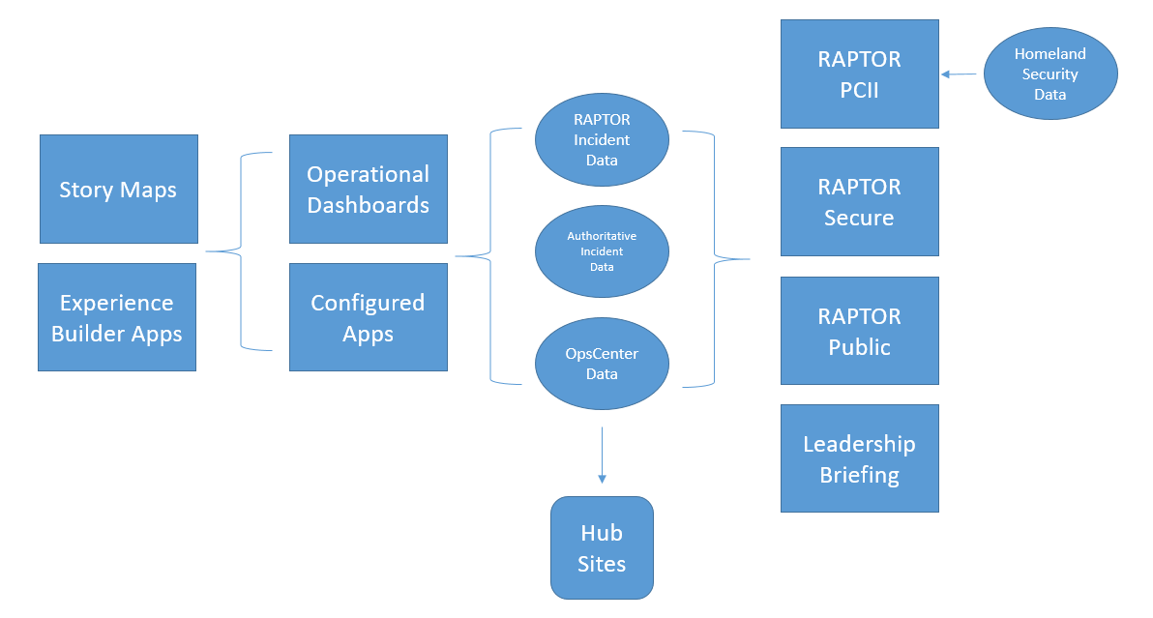

RAPTOR
The State of Oregon adopted the Real-time Assessment and Planning Tool for Oregon (RAPTOR) as a resource for displaying situational data on a single mapping application. This application includes relevant GIS datasets from the authoritative source, including weather watches and warnings from the National Weather Service, earthquake data from the US Geological Survey, and incident data placed in the application by local/tribal/state partners. These applications are physically stored on OEM’s servers at the Anderson Readiness Center.

Operational Dashboards and Configured Apps
During response to any event, miscellaneous mapping products will be created. These include utilizing the ArcGIS Online suite of software, including relevant data stored on that system, derived views of said data, and follow-on applications. These applications include dashboards, experience builder applications, and easily configured application solutions.

Public Facing Applications
To keep the public informed, data feeds that are used on the internal facing RAPTOR application are also consumed by the public version of RAPTOR as well as the Leadership Briefing product, which combines relative datasets by hazard and places them within a map series application to allow for ease of use by the general public. These applications are all hosted on the ArcGIS Online platform.

Hub Sites
During large scale incidents, a hub site for sharing datasets and information may be created. Hub sites feature text, images, videos, and relevant datasets for a specific initiative. Hub sites can be made public or left private.

Depending on the incident, a hub site may not be necessary, subject to the amount of data that is already shared within groups and/or relevant datasets that are available for the disaster.

Story Maps
In the event of a disaster or extended ECC activation, story maps are produced that document the data captured during those events to help describe the impacts to local and tribal communities from the disaster. Story maps are also created for incident overview briefing products for ECC related meetings to help facilitate the discussion and highlight specific issues regarding coordination or any other section involved in response.

A story map is also created to capture the full extent of the impacts of the disaster/event in order to supply Oregon with information to supplement a federal disaster declaration request.

For exercise events, story maps are produced that feature the story map series accordion style template and showcase data relevant to specific incident scenario data.

Experience Builder Apps
This category includes specialized mapping applications using the Experience Builder configurable application. One such example is the Oregon Wildfire Response and Recovery site, which is based upon the Experience Builder Indicators for the Living Atlas template. This includes card-based information about the event, with relevant subpages and topics for each of the key elements of information to communicate to the public.

GIS DATA SHARING
Data utilized during events are shared using the ArcGIS Online and ArcGIS Server platforms. Access to ArcGIS Online groups is coordinated via the assigned GIS staff and the planning section. These groups follow the ESF model for group naming. At the start of any event, a unique incident ESF 5 group is created for storage of data and relevant products. For all events, these groups will be created:
- Incident Name ESF 5 (for all developed products)
- Incident Name Development/Testing (for GIS staff to conduct testing on appropriate solutions, not for final official products)
- Incident Name Leadership Briefing (for official products used for sharing with leadership and incident briefings)
- Incident Name Damage Assessment and Imagery (for sharing damage assessment data and any imagery flown for the response)
  - This group will have categories assigned within it to allow for filtering for damage assessment data or imagery

All groups will be created and maintained by using the OEM agency ArcGIS Online account (Oregon_OEM).

GIS DATA STORAGE
Primary reference data storage for use by the ECC GIS staff can be found on the GIS network drive. This includes snapshot in time datasets from authoritative sources and is ordered in folders by the responsible agency underneath the “GIS_Data” folder on the GIS network drive.

Data that is created as a part of the incident utilize the ArcGIS Online platform and are stored as hosted feature services secured to relevant groups.

All ArcGIS Online content are backed up using a script and are stored in the appropriate data exports folder.

Data from operational periods during ECC activation can be found in the “Data Exports” folder under the “ECC” directory on the GIS network drive. These include map packages (includes GIS data and the symbols for said data in one file) and are date/time-stamped from the time they were created.

Other datasets that are used for RAPTOR incident data can be found on the OEM SDE server, which is located on a SQL server located at OEM and used for visual display of incident data.

GIS DATA SYMBOLOGY
The incident data that is supplied by local/tribal/state partners within the RAPTOR mapping application follow a standard set of symbols created by the National Alliance Public Safety GIS Foundation (NAPSG) and was adopted by Oregon. Details about these symbols can be found in the RAPTOR symbology guide.

Data externally sourced will follow established symbology from that service/data source unless the symbols are conflicting with any internal or other source data.

GIS TOOLS
Data Extracts
In the event of an ECC activation, snapshots of the GIS data are captured by executing the Python programming scripts located underneath the “Scripts” folder under the “ECC” directory on the GIS network drive. These scripts take snapshots of the National Shelter System data, ODOT TripCheck incidents data, statewide fire evacuation layer, and RAPTOR incident features data. The tool will then create a date/time-stamped map package and place it in the “Data Exports” folder under the “ECC” directory on the GIS network drive. These tools are run during each operational period to ensure proper documentation is created during an event.

Situation Report Mapping
GIS and ECC Planning Section staff also have the ability to generate a situation report map using pre-defined templates through the OpsCenter application. The user has the option to “Produce Sitrep Maps” on the left navigation screen. This allows the user to select the appropriate template, enter in the incident number, and enter their abbreviations for their name and generate a situation report map without opening the map document on the GIS network drive. This tool utilizes a script stored on the OEM GIS server and the map documents found in the “SitrepMap_Templates” folder underneath the “ECC” directory on the GIS network drive.

RAPTOR and Other Analysis Tools
The RAPTOR mapping application has the ability to create custom reports using the “Area of Concern” report tool. This will generate an excel spreadsheet that includes tabs of various data points selected within a given geographic region.

Many tools exist within desktop mapping applications, such as Esri’s ArcGIS Desktop and ArcGIS Pro applications. The full toolset of these applications are available for use in analysis of existing datasets and data created during the incident.

While other tools exist for analysis of impacts to a jurisdiction (such as HAZUS), they are not currently implemented in our existing planning/analysis structure. For HAZUS results, the planning section will coordinate with the Department of Geology and Mineral Industries (DOGAMI) to conduct a specific HAZUS analysis.

OTHER ASSOCIATED TRACKING DOCUMENTATION
A master Excel spreadsheet will be created for any new incidents. The spreadsheet will include the details pertaining to the status of the initiative, a brief description, maintenance requirements, and service URLs for derived products.

For long duration events, a Trello board will be created. This board will indicate the status of assigned projects and ongoing repetitive tasks assigned to the GIS position in the response.

GIS COORDINATION
For all major incidents involving an ECC activation, regular coordination calls will be conducted through response and recovery to ensure proper coordination of efforts, allow for agency requests for supplemental staffing, and information sharing with state partners. At a minimum, these calls will occur weekly on Tuesdays at 10AM, utilizing the GoToMeeting software for screen sharing and web-conferencing. The coordination meeting invites will be sent to the GIS Program Leaders (GPL) Listserv (gpl_list@listsmart.osl.state.or.us) so all lead state GIS partners are informed of the conference calls.

The agenda for these coordination calls includes the following information:
- Situation update
- Current initiatives from response/recovery
- Review of Trello status board (current assigned projects)
- Review of where content is stored on AGOL (and groups)
- Federal GIS response overview
- Roundtable:
  - Agency response needs
  - Relevant staffing contacts by agency
  - Initiatives for the next week

For the agency roundtable, the Emergency Support Functions (during response) and State Recovery Functions (during recovery) will be referenced in the agency callout.
All meetings will be recorded (and also sent to the GPL Listserv) so those that are unable to attend are able to watch the recording and provide information via email.

