20210608 GPL
Tuesday, June 8, 2021
1:33 PM

Attendees:
Malavika Bishop – DEQ
Thom Yorke - DOR
Phil McClellan - DOR
Daniel Stoelb – OEM
Carl Anderson – OMD
Cy Smith – GEO
David Mather – GEO
Brent Grimsrud – ODF
Steve Timbrook – ODF
Bob Harmon - OWRD
Ed Buchner - DOGAMI
Brady Callahan – OPRD
Tom Elder – OHA
Laer Haider – OHA
Diana Walker – ODA
Randall Sounhein – DSL
Rachel Smith – DLCD (Scribe)
Tanya Haddad – DLCD
Phil Smith – ODOT
Jon Bowers – ODFW
Myrica McCune – INR
Paula Wills – OWEB
Joe Severson – OSMB

Presenters:
John Laughery – ESRI
Adrian Laufer - DLCD

Announcements
Esri UC next month.
NWGIS User Group - October 26, 2021; virtual conference this year.
No GPL meeting in July as it overlaps with UC. August meeting will include time on the agenda for folks to talk about UC participation, key takeaways, stuff you learned, etc…

DAS GEO Update
Dave Mather - working on elections project (geo-enabling elections) but they are struggling to get data exports. Last year they participated in a pilot to create taxing districts from elections data. Our elections are based on SPLITS - unique combination of addresses for voting. They are using the taxing districts as a proxy. They are updating address data and other data to improve the accuracy of the address geocoding.

Dave also has other data requests in the que. Will be improving their FTP sites and the links to data will change to https.

Cy - esri contract work: was updated to a 4-year duration last year. Cy has been establishing new IGAs with 8 agencies who are now using the Esri EA. Invoices will go out in the next week or so for training taken in the last year. Josh has been collecting software inventory info from agencies. This info will go into invoices for the next year. Invoices will now be sent out on an annual basis. The increase in cost is ~ 6%. The cost of AGOL is going up which is where the majority of the cost increase is at.
21-22 is Year 2 of the 4-year esri agreement.

OGIC - OGIC is considering using some of the FIT grant funding to hire a consultant to put together a financing/funding plan for Framework lifecycle funding. We estimate that it is a $350M investment to be made at every level of government. And a $13M gap in funds per year to maintain the data. OGIC put together its own plan and didn't get the $350M approved by the legislature. OGIC leadership feels like there is more work to be done to move Framework Forward. $500K a biennium is not sufficient. While this is a viable use of Framework funds, it is possible that some $$ from the legislature can be used or available for this purpose instead of taking $ from the $500K.

Will there be a Planet subscription in the Fall? Cy says it was supposed to be part of an imagery portfolio request to the legislature.
A legislature can ask for money at any time. Cy is thinking that the AOC could ask for the funds to support the imagery portfolio. Also - there is some grant money options available. We'll have to wait until the session is over. The conversations should/will happen at the Imagery FIT table.

FIT Report - grant program has been opened. Proposals are due July 9th. Review process will be as usual. Cy needs 1 person from GPL to serve on the Reviewing Team.
Reviewing Team is light duty; meet 2-3 times between now and Sept. They "guide" the evaluation process. They do not evaluate proposals. They make sure everyone follows the process.
FIT leads, GPL, and PAC will evaluate the proposals. GPL must decide how it wants to evaluate the proposals (as a whole or with a smaller workgroup).

The PAC is being formalized now. There are 8 PAC members nominated by OGIC members. Cy expects 2-3 additional nominations in the next couple of weeks.

What about TAC vs. GPL role? The RFP was published before Cy realized that TAC wasn't listed as part of the review process. So TAC was accidentally left out.

We will use Theresa's rubric to review proposals.

GPL Review Team: Cy will have GPL members sign up for 3-4 proposals to ensure that we have multiple GPL reviewers for each proposal. All GPL members will have an opportunity to volunteer/sign-up for proposal review.

Review Team GPL nominee: Phil Smith

Cy will create a training session for these review teams so that everyone knows what the process and procedures are.

Esri UC Update - John Laughery
Esri UC - July 12-15, 2021
100% virtual meeting; everyone can attend for the sessions they are interested in; perhaps specific business units in the agency would align well with specific sessions.
Recommend we review the agenda and curate sessions that align well with business units within the agency.

Registration: use your AGOL account. If folks do not have an AGOL account but they want to attend, they can still attend with a few extra registration steps.

Virtual Map Gallery deadline extended to June 9th.
Call for Images to be used in Plenary has also been extended to June 9th.

Agenda is now posted online. Currently no State/Local Gov't special interest group. But check back regularly for updates to the agenda.

Community Blog - specific industry flyers. (state and local gov't) Provides a list of relevant sessions and workshops for the specific industry. https://community.esri.com/t5/user-conference-documents/tkb-p/user-conference-docs

NWGIS User Group - October 26, 2021; virtual conference this year.

Shoreline Access Project Presentation - Adrian Laufer, DLCD
Workgroup created to support the data stewardship and data standard for new Shoreline Access dataset. Primary task was data inventory. Last inventory was conducted in 2010.
But Adrian created a 5-step process for the project.

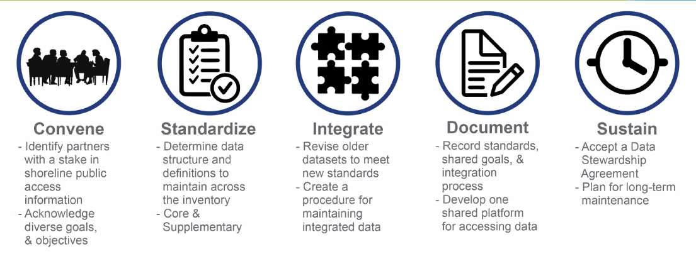

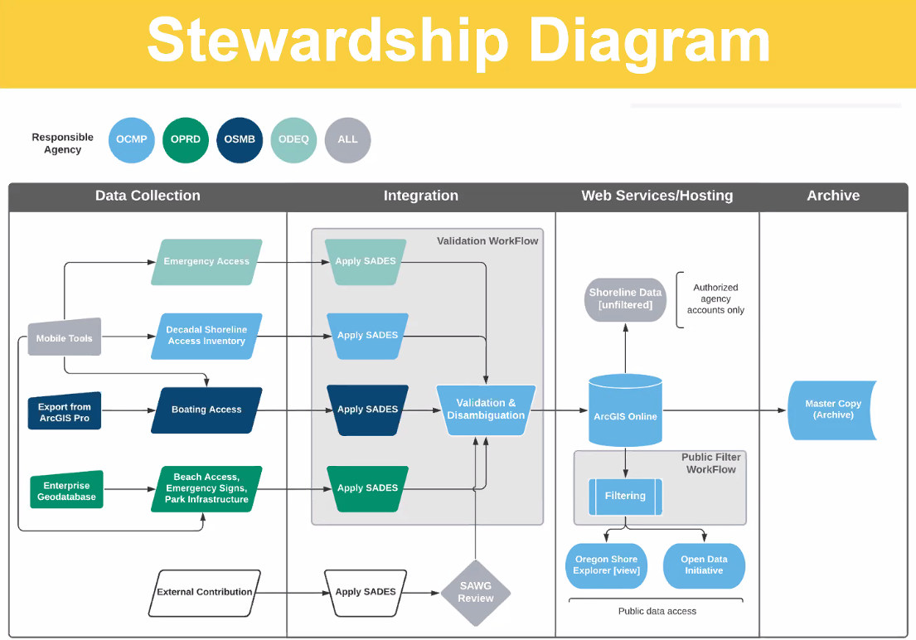

Created a public facing site to display publishable data; created use Experience Builder = Oregon Shore Explorer

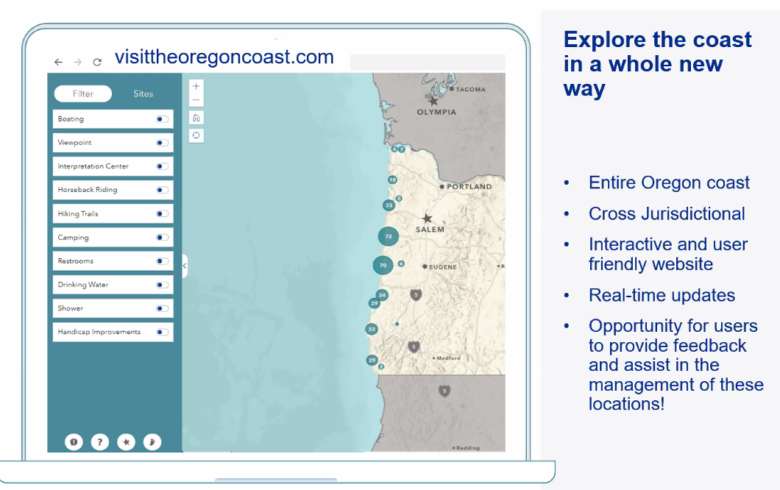

Also an internal data viewer is being created as a web app for all data.

Data Exchange Standard and the Stewardship Plan is set to be approved by OGIC in July.
Cy stated that the data stewardship plan is very robust and a great model for the State.

This project came to the Framework community because of how messy this dataset was with large number of data collectors/contributors. It's now been organized and planned for future stewardship.

Roundtable
DEQ - no report.

DOR - You can download a FGDB of OTDW's work product, this year's statewide Taxing District Layers: https://ormap.exavault.com/share/view/2iymj-6aaewcro
Most of the district layer names are self-evident (by district type). The FGDB also contains the sources for these layers, i.e. the statewide ORMAP TaxCodeAreas layers (buffered and non-buff), and DOR-Research’s latest SAL Match Table that links TaxCodeAreas to Districts.
The layers have some issues that will be worked on in future versions. One layer called “OTD_POLYS_TAXCODE_NOMATCH” shows ORMAP TaxCode polygons whose TaxCode attribute could not find a match in Research’s SAL Match Table. These areas are therefore voids in the district type layers.

OEM - ongoing damage assessment; counties are testing the new tools. Working on the emergency preparedness document; state of the state assessment; planning some table-top exercises for disaster preparedness. Starting a software needs assessment for crisis management app and needed functionality.

Military Dept. - no report

ODF - Steve Timbrook - fire season has started; set up an AGOL collaboration to assist with fire mapping. Just pushed out a HUB site for data catalog. Trying to be better organized internally and sharing content, setting up a governance process, etc… Moving all users to ArcPro. GIS Coordinator recruitment will be posted soon.

WRD - no report.

DOGAMI - Ed Buchner - no report.

OPRD - Planning for OPRD Centennial (100 yrs old in 2022); passage of SB 109 related to regulating drone use in state parks; talking to other agencies about data collection from drones and high accuracy mapping. If interested in conversation about drone data collection, reach out to Brady C.

DHS/OHA - Aaron H. is working on prep for wildfire season; COVID vaccine recipients and providers project. Survey of GIS Profession in Oregon - for OGIC; 267 survey responses to date.
https://survey123.arcgis.com/share/9db5acea2f57431b881a912116fd6ef2?portalUrl=https://geo.maps.arcgis.com
Cy - very small number of responses. Survey is for anyone in the state who is using GIS.
The goal is to build the GIS community list for a variety of reasons. Group discussed ways in improving survey responses; how the list is going to be used, etc…

ODA - no report.

DSL - updating GIS servers for performance improvements; rolling out field maps and the workflows for offline data editing and management.

DLCD - land use Framework project is moving along; workgroup is meeting next week to review a draft data standard and discuss stewardship and data QA. Use of Portland Community College intern is coming to a close; work was focused on creating print templates for Portal.
National Coastal Mapping Program - 5 yr cycle to fly imagery of the coast. Our coast wasn't completed in 2020 as planned. It will be finished in 2021. More detailed info:
JALBTCX = Joint Airborne Lidar Bathymetry Technical Center of Expertise
JALBTCX plans to return in August 2021 and wrap up the collection in OR/WA and also complete collection in CA (which is scheduled for 2021 data collection under the original planning cycle). Last year they were impacted by Hurricane Sally in the Gulf Coast region because they had to divert resources there.
They were also impacted to some degree by wildfires, weather, etc. So, hopefully this hurricane season, and conditions on the West Coast, will be a bit more conducive for data collection.
The JALBTCX processing is always contingent on the hurricane season, as the processing gets stalled if they have to go out for hurricane-related surveys.

ODOT - no report.

ODFW - just completed UW project - web map/app creation done as a proof of concept. Recently concluded biological data asset classification update. Classified fish habitat distribution data; ~ 80 stream-based datasets and ~50 lake-based datasets. Currently recruiting an ISS-4 GIS Analyst, permanent position.

INR - no report.

OWEB - no report.

OSMB - grant data viewer under development; will show some grant history as well as current grants; before/after photos of improvements by grant; will be a public app available at end of month.

