GPL Notes
Jan 11, 2022
R. Sounhein, GISP
GIS Coordinator
Dept. State Lands
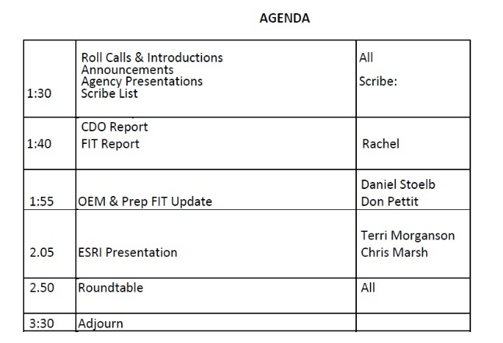

Roll call:
DAS GEO – Rachel Smith, Dave Mather, Tom Elder
Dept Ag – Diana Walker
DEQ – Malavika Bishop
OEM - Daniel Stub
ESRI – Terri Mortenson, Chris Marsh
ODFW - Jon Bowers
Fire Marshall - Melody Wadsworth
ODF – Author Rodrigues
DOGAMI – Rudi WATZIG
DHS – Aron Hereford
DLCD – Tanya Haddad
Revenue – Phil McKellen, Tom York
DSL – Randy Sounhein
ODOT – Phil Smith
USGS – Tom Carlson
OWRD – Bob Harmon

Announcements:
GIS in Action 2022, April 18-21 virtually at Portland State University

DAS/GEO/FIT report
Rachel Smith
Interview with IS8 Data Operations Coordinator (Lead for our Data Team).
All FIT Grants/ Contracts are now out the door
All ESRI amendments have been sent out and still awaiting a few reply’s from a few agencies.
Imagery FIT Funding (statewide NAIP 2022 flight) will cost approximately $800 thousand.
Geospatial Data Management project – we have selected a consultant. This will kick off the secure portal and data hub.
Legislative Districts – working to get compliant metadata for the new dataset.
Helping some agency with the Log4j patches
Just posted the DLCD Land use Framework data element

FIT:
Stood up some FIT lead meetings stating Jan 28, 2022. We will then commence monthly meetings after that.

OEM & Prep FIT update
Daniel Stub. Hel our last Prep FIT meeting in Dec 2021. OEM We have a new 911 GIS Coordinator “Alex” on board. Other new on emergency management - Working with ESRI on a new evacuation layer upload utility, which includes a Survey123 form to attach a JSON files, to update Evacuation layer.
Have been working on reviewing a Crisis Management Software.

ESRI
Talked about all the new functionality of the ArcGIS Platform ranging from Desktop, Enterprise, to online. Here are some brief points. For more information, please contact ESRI:

AGOL
Update with Data Management
New Map Viewer
Dashboards have a new Layout panel
Arcade now has been support for html, and many new features
Field Maps – new built in features map viewer form
Data collection updates – stream line data collection task
Survey123 – can now upload Docs through a smart form
Enterprise
New Cloud Data Warehouse support
Google Cloud now supports SQL
New Dashboard updates
New ArcGIS Knowledge server roles
Faster installation
10.9.* – last to provide any support with ArcMap.
Publishing from Pro - much efficient Runtime environment increases performance with publishing over ArcMap; can now bundle services together which takes up less memory.

ArcGIS Pro
Both Terri and Chris highly recommend the folks migrate from ArcMap over to ArcGIS Pro since starting in 2022 all future releases of Enterprise will not directly support the ArcMap 10.8.*. Ex: Won’t be able to publish share to Portals.
Easy to convert PDF into Tiffs
Cloud Data Warehouse Support
New user interface with Linear Referencing
Use of Knowledge Graphs
Dynamic Feature Clustering
New animated symbols
New Vertex editing mode
New Extension of Image Analyst

ELA and Advantage
Early adopter of ELA in 2000’s, thanks to Cy Smith. Many amendments over the years. Our ELA’s are now set up via 4 year cycle.

Roundtable
DAS/GEO - NA
DOA - D. Walker. Our Pesticide Group getting fund together to start to use Surve123 to deal with Grasshoppers.
Emergency - NA
ESRI - NA
ODFW - J. Bowers; The Fish Habitat Distribution project is set up and running. Working with ODF on a creating a plan for Fish Habitat mapping.
Fire Marshall - M. Wadsworth. Continuing with Fire Apparatus Survey results. Continuing on Looking at Defensible Space workflow. Updates on FIT layer Fire Districts/Station locations and Community Risk Reduction. Looking to get some new position on community risk reduction program.
ODF - A. Rodriquez. Looking into SALO Science Forest Observer software used in California. All about machine learning. Getting settled into the new GIS Coordinator position.

DOGAMI - NA
DHS - NA
DLCD - Coastal Marine FIT updates. Upcoming meeting in near future on Data Standards.
Marine Board - NA
Military - NA
Parks - NA
Revenue - T. York. ORMAP aggradation is now underway for Taxlot datasets. Via Data Sharing agreement, Feb 1st is when Counties need to submit datasets. DOR then has until April 30 to release ORMAP datasets. Looking at updating the Admin Boundaries. Looking at evaluation of and renewal the Pictometry imagery licensing. Will be providing a presentation at the Assessors Winter conference talking about statewide taxing districts layer.

DSL - R. Sounhein. Migrating staff over to ArcGIS Pro as ESRI has advised. Planning to migrate our Production Enterprise over to SDC.
ODOT - P. Smith. Look at our implementation of business plan. Will be developing in near future an Outreach outlook Framework.
USGS - NA
OWEB - NA
OWRD - B. Harmon. Have stood up Enterprise 10.9.1 and then applied patches. Kicking off a meeting working with the HIPAA compliant tracking. D. Mortensen. Looking for info on Cannabis legislation enforcement. Randy will get DSL staff I touch with OWRD and ODA.

DEQ - M. Bishop. Looking at contributing to the 2022 Imagery program. Agency is moving over to ArcGIS Pro. Also looking to update online GEOCORTEX platform.

