State of Oregon
GIS PROGRAM LEADERS (GPL) COMMITTEE
Date: August 9, 2022
Time: 1:30-3:30pm
Microsoft Teams meeting

Roll call and Introductions
Scribe: Tanya Haddad, DLCD
Attendees:
DAS/GEO: Rachel Smith, Tom Elder, Willow Crum, Eric Brewster
ODA: Diana Walker
OEM: Daniel Stoelb
ESRI: Lacey Summers
OSFM: Melanie Wadsworth
ODF: Carl Swanson
DHS/OHA: Eric Main
INR: Myrica McCune
DLCD: Tanya Haddad
OMB: Joe Severson
DSL: Randy Sounhein
ODOT: Phil Smith
OWRD: Bob Harmon, Jordan Beamer
WSDA: Perry Beal
DEQ: Malavika Bishop, Don Pettit, Cesar Villaca

Announcements (All)
- No announcements
ODGT Update (Rachel Smith)
- Geocoding: Tom Elder is in the process of updating the statewide geocoder – please forward any questions to Tom on this topic
- GDMS project: GEO is still working with Timmons on how the project will look to state agencies and non-state agencies. They are working out how publishing workflows will work, and how the OSDL will be integrated. More information will be forthcoming in September.
- ESRI license “true-ups” are in progress, agencies should be returning their reports to Rachel by this coming Friday
- OGIC Summary: the last meeting was July 27th, and Rachel will be posting the PDFs of the presentations. The main topic was the strategic plan update. The next activity will be for FIT leads, where they will be reviewing and editing some draft objectives. Rachel suggests watching the videos that will be posted if interested in this topic. OGIC will also begin to start having work session meetings, to allow the group to make progress between quarterly meetings. Will also allow for presentations from the community and will allow for more opportunities for discussions. These meetings will not be ones where decisions will be made, so no quorums will be necessary. Rachel will send out calendar invites when those OGIC work session meetings are scheduled.
Framework update (Rachel Smith)
- Interviews next week for the new Framework Coordinator
- OGIC endorsed the new Admin Bounds FIT lead (Karen GROSULAK-MCCORD)
- Both Karen and Sephe Fox (Utilities) are new FIT leads and are working to re-boot their respective Framework teams, so please join the listservs for those teams so that you can participate in their work
- Tentative date for Fall framework forum is October 20th, 2022 (planned as in-person)
- Recent Data sets published:
  - 2022 Fish Habitat Data,
  - SLIDO version 4.4,
  - 2022 Enterprise Zones,
  - 2021 gridded soil survey,
  - 2021 City Limits,
  - 2021 ORTRANS,
  - 2020 NAIP, 2021 UGBs
OEM & Prep FIT Update (Daniel Stoelb/Don Pettit)
Daniel sent out survey results last week (https://prepfit-geo.hub.arcgis.com/) so you should have that if you are interested. Some key findings:
- Data being difficult to find, not maintained, etc
- Implies that outreach to broader GIS community might be a good thing to consider
- Data sharing as a general topic (e.g. taxlots)
- GIS planning and staff capacity
- Usefulness of GIS so that people are aware of the options and can take the burden off
Useful Story Map created for briefings related to heat and Fire activation:
https://geo.maps.arcgis.com/apps/MapSeries/index.html?appid=00172d29e0234117948aaf66da6d7139
Also following up on the document “GIS Data Sharing during events”
CONNECT Explorer Project (Megan Reilly, Eagleview)
- Megan (Regional Technical Manager at EagleView) Background in GIS and property appraisal in Idaho
- EagleView is a fixed-wing aerial company operating in Oregon since 2006
- Megan is presenting because DAS GEO has some free user accounts that are available to state agencies. Subscriptions end at the end of November 2023.
- CONNECT Explorer is the Eagleview web portal for viewing and interacting with imagery
- Demo: Mobile & Desktop apps, includes links to training resources
- Ortho mosaic and Oblique imagery viewer with access to historic imagery as available, with options for side-by-side views, and the option to export images as PDF, GeoTIF, etc.
- End users in the state account will not necessarily be those who contracted for the imagery, so there are options for browsing imagery by resolution or acquisition date
- Most Eagleview imagery has been collected in the I-5 corridor area:
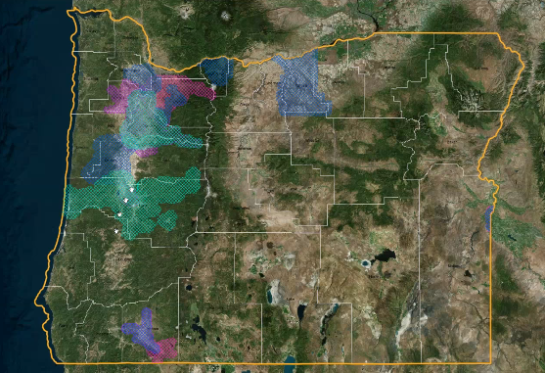
- DAS is the parent organization on the available Eagleview account, with agencies added as “sub-organizations”. Agencies should be able to have their own logins for users, etc.
- GIS data can be added via Shapefile upload, REST or WFS endpoints
- Tools available:
  - Rough elevation and slope calculation tools are available
  - Bearing tool is available for people who work with land records, etc
  - Distance tool measures as the crow flies, while the Ground distance tool measures a distance that follows the actual contour of the terrain
  - Annotation
- There is a workspace for users where they can save their measurements and annotations between work sessions. This also allows the saving of notes for collaborating / sharing with others.
- Eagleview offers Ortho imagery, 4-band imagery (a false color), 9-inch resolution options
- Eagleview imagery can be integrated with other applications as a base map or via a Pictometry web app builder widget (provides some of the same functionality as CONNECT Explorer)
- There is also a 3rd party API integration available to launch a Pictometry view from within a web map
- Rachel encourages any agencies that are interested in testing these services to reach out to her office to obtain one of the free accounts that are available from now to November 2023
OWRD Statewide ET (Evapotranspiration) Project (Bob Harmon, Jordan Beamer)
- Bob Harmon introduced the OWRD
- Water rights in Oregon are “First in Time, First in Right”
- There are 24 districts overall and 5 regions, and approximately 270 employees at OWRD (see: https://www.oregon.gov/owrd/aboutus/contactus/pages/regionalofficesandwatermastersdirectory.aspx)
- Jordan spoke about the Statewide ET project, focusing on the “irrigation for agriculture” use of water
- Paper water use vs actual water use is difficult to track
- Results from a grant to establish statewide baseline products
- OpenET tool : “OpenET uses best available science to provide easily accessible satellite-based estimates of evapotranspiration (ET) for improved water management across the western United States. Using the Data Explorer, users can explore ET data at the field scale for millions of individual fields or at the original quarter-acre resolution of the satellite data.” https://openetdata.org/
- One product of OWRDs work is a comprehensive map of Agricultural fields, with linked information about water rights and irrigation use, along with monthly ET time series
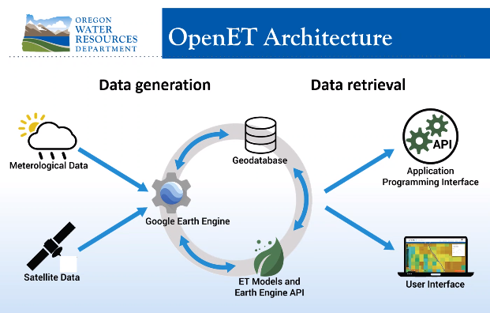
- Model outputs are saved at 30m pixels, and also aggregated to agricultural field boundaries, HUC12 summaries, etc
- Used to estimate total usage per basin (something not possible previously)
- NASA Western water application grant allows OWRD to collaborate across state lines and view the same data (useful for looking at the entire Columbia River basin for example)
- Tentative plan is to launch the Columbia Basin ET tool on Oregon Explorer in November 2022
- All these tools will update how water is used in Oregon, far more efficient than visiting fields individually, and or measuring pump sizes

Roundtable (All)
DAS: reported during meeting
ODA - no report
OEM: nothing to report
ESRI: nothing to report
OSFM- continuing to separate from state police, new CIO and New GIS analyst working through hiring process,
ODF- good progress on private forest accords project (Presented recently at HydroFIT. Keeping up with GIS for fire, big thank you to Willow for all the community accounts.
DOGAMI- Rudie Watzig: A new Lidar Coordinator and new Director have started.
DHS/OHA- Eric Main is the new EJ contact for OHA
INR- Myrica McCune: Wildfire Risk explorer was launched June 30 but has now been rolled back to the 2018 version as ODF is revising the more recent data. See the statement from ODF: https://oregonforestry.wpengine.com/2022/08/04/state-forester-announces-next-steps-for-statewide-wildfire-risk-map/
DLCD- No report
DSL- looking to standardize all the desktops over to ArcPro to get ready for Enterprise 11
ODOT- No update
OWRD- Hydro FIT meeting on Monday the 1st, presentation from NV5, formal identification of elements for submission to OGIC at the end of the year
DEQ- Continuing work on the DEQ online application, also uploading a lot of resources for GIS users on a GIS SharePoint site.

