State of Oregon
GIS Program Leaders (GPL) Joint Meeting with Oregon Geographic Information Council (OGIC) Technical Advisory Committee (TAC) Meeting
Date: Tuesday, March 10th, 2026
Time: 1:30-3:30 pm
Scribe: CJ Kunowski (Dept of State Lands)
GPL MEETING AGENDA
1:30 | Announcements | All (Scribe: CJ Kunowski, DSL)
1:35 | GEO/OGIC Update | Melissa Foltz, GEO
1:40 | Framework Update | Melissa Foltz, GEO
1:50 | Technical Advisory Committee (TAC) Update + Roundtable | Myrica McCune, IR
2:00 | Presentation | Nate Herold, NOAA
2:30 | Roll Call/ Roundtable | All
3:30 | Adjourn

Announcements
- No presentations set yet for April meeting, so reach out if you have something you’d like to share!
Geospatial Enterprise Operations (GEO) / Oregon Geographic Information Council (OGIC) Update
- As of this month, Concurrent licenses now considered deprecated
- RFP in final review, and going to DOJ, expected to be released by end of March/ early April
- Digital registration to the ESRI UC and David Mathers will be sending out more info.
- OGIC
  - Still focusing on membership and recruitment
  - Conducted a membership survey and reviewing feedback which included clarity on priorities and around roles and relationships; also that TAC is underutilized
  - April meeting will include discussions around the building footprint data standard is coming to completion and is coming to endorsement in April’s meeting
Framework Program Update
- FIT leads still actively working and participating
- Framework forum – planning and logistics (date TBD)
  - This forum has traditionally been about geospatial data and framework data, but may look different
    - How? Because we have a few data governance groups that cover similar topics, and we are looking at ways to combine those groups and efforts
- Framework inventory on final internal reviews and will be going out to public comment in the next couple of weeks through listservs
  - Minor updates, mostly dataset cleanups
  - Goal is to have small updates every biennium vs large update every ten years
  - Will be discussed in next GPL
TAC Update + Roundtable – Lead by Myrica McCune
- Steve Timbook will be taking over as new vice chair July 1
- Reviewed building footprints standards and provided recommendations
Other Committee Member Updates:
- Jacob Blair (Lane Council of Governments-LCOG) – null
- Brady Callahan (Oregon Parks and Recreation Dept)
  - NSRS Modernization – NGS looking at beta products roll out this year and FDGC will vote in early 2027
- For Oregon State Projection System (SPS) moderations zones were adopted into rule last Fall, which is early considering no federal adoption yet
  - More info shared in chat:
    - SPCS 2022 information, zones, distortion maps, etc. is available in an AGOL Experience here: https://experience.arcgis.com/experience/dddb7bc0be6f4e56a1c370c8d529d1a0
    - Oregon adopted the 39 local and one statewide SPCS2022 zones into statute/rule late in 2025. This is a bit premature since they haven’t been adopted yet nationally. https://secure.sos.state.or.us/oard/displayDivisionRules.action?selectedDivision=3301
Bob Harmon (Oregon Water Resources - OWR)
- Decoding 2/2 toolbars for ArcPro 3.x
- Concurrent license migration in May
Phillip Smith (Oregon Department of Transportation – ODOT)
- ArcMap -> Pro migration happening
  - Training planned for staff
  - Using this time to evaluate desktop needs vs web GIS needs
  - Enterprise updates from 11.3 to 11.5 this spring

Stacy Schumaker (Tribal Representative for the Confederated Tribes of the Umatilla Indian Reservation)
- Getting contract in place for updating LiDAR and Imagery over the reservations
Tim VanD
- <Null>
Steve Timbrook (Oregon Department of Forestry -ODF)
- <Null>
Myrica Muir McCune – Oregon State University- OSU)
- Translating mapping tools using LibreTranslate
- Enterprise server upgrade
Presentation – Nate Herold (NOAA)
- Office of Coastal Management, and leads Coastal Change Analysis Program (CCAP)
- Title of Presentation: Good Thinks Come in Small Pixels
- CCPA creates regional Products at 30 meter updated every 5 years and high-resolution products at 1-meter, which is historically expensive to use
- Support hydro modeling and flood assessment
- Coos county and Lower Columbia in Oregon part of CCAP part of Phase 1 in April
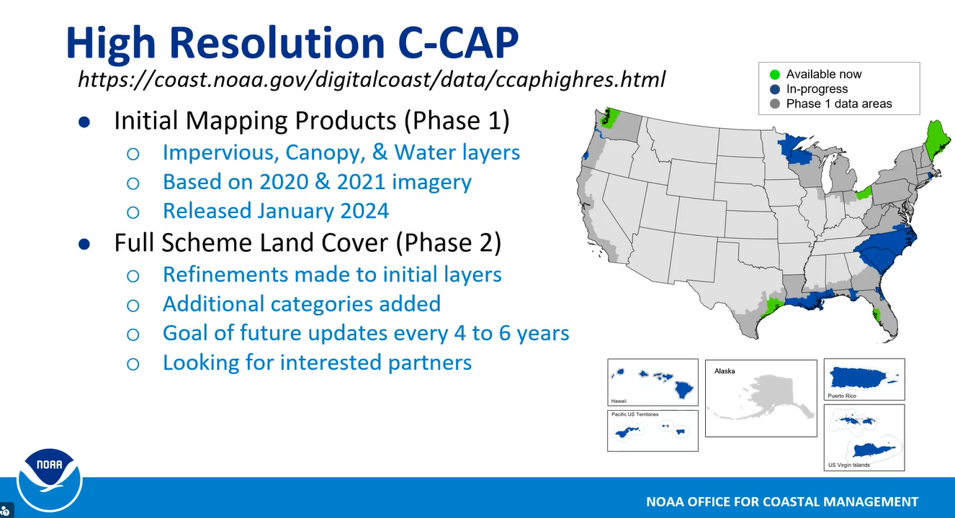
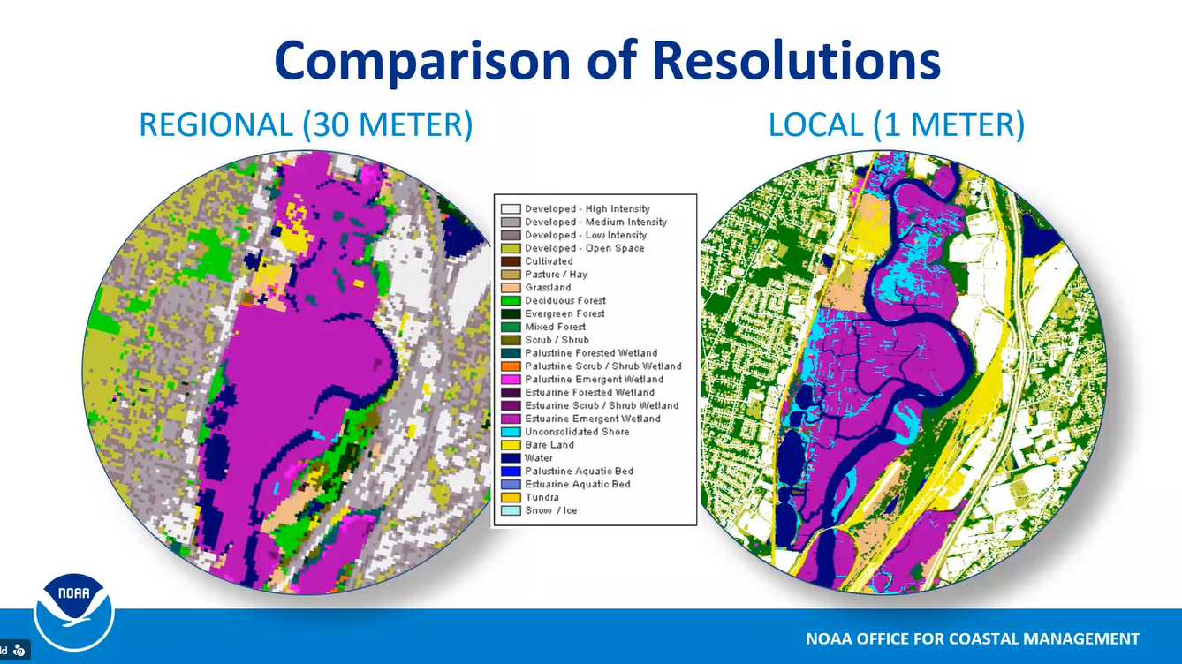
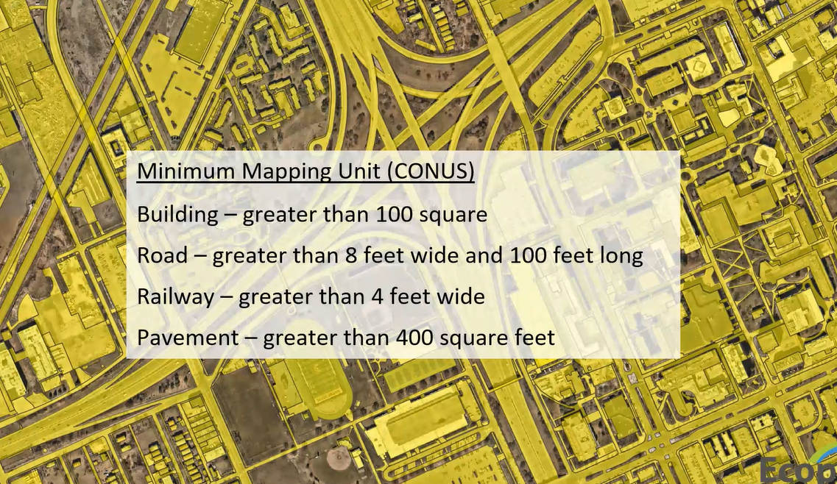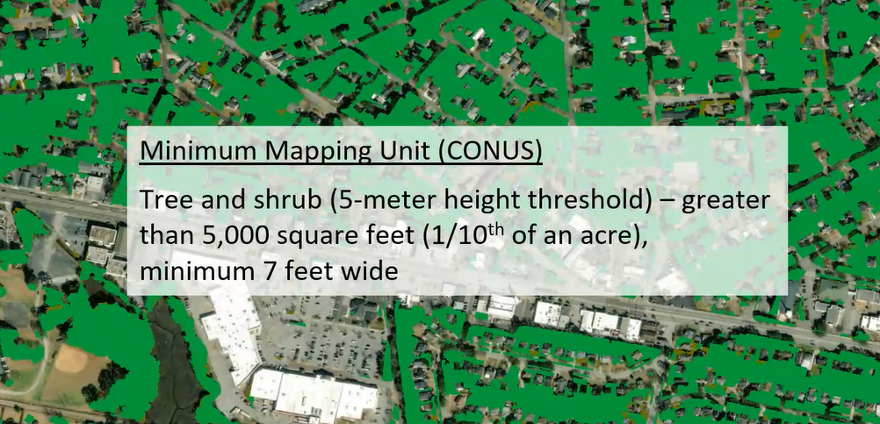
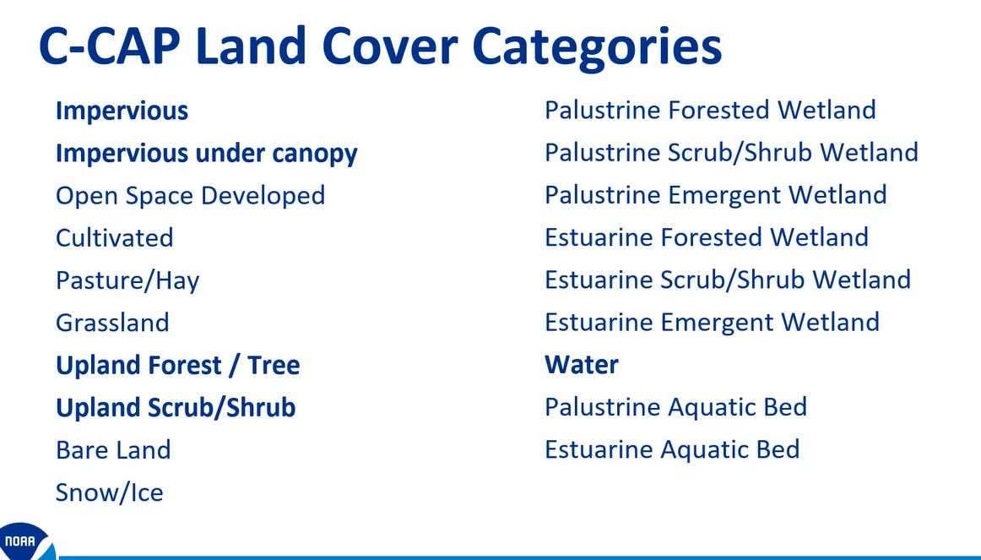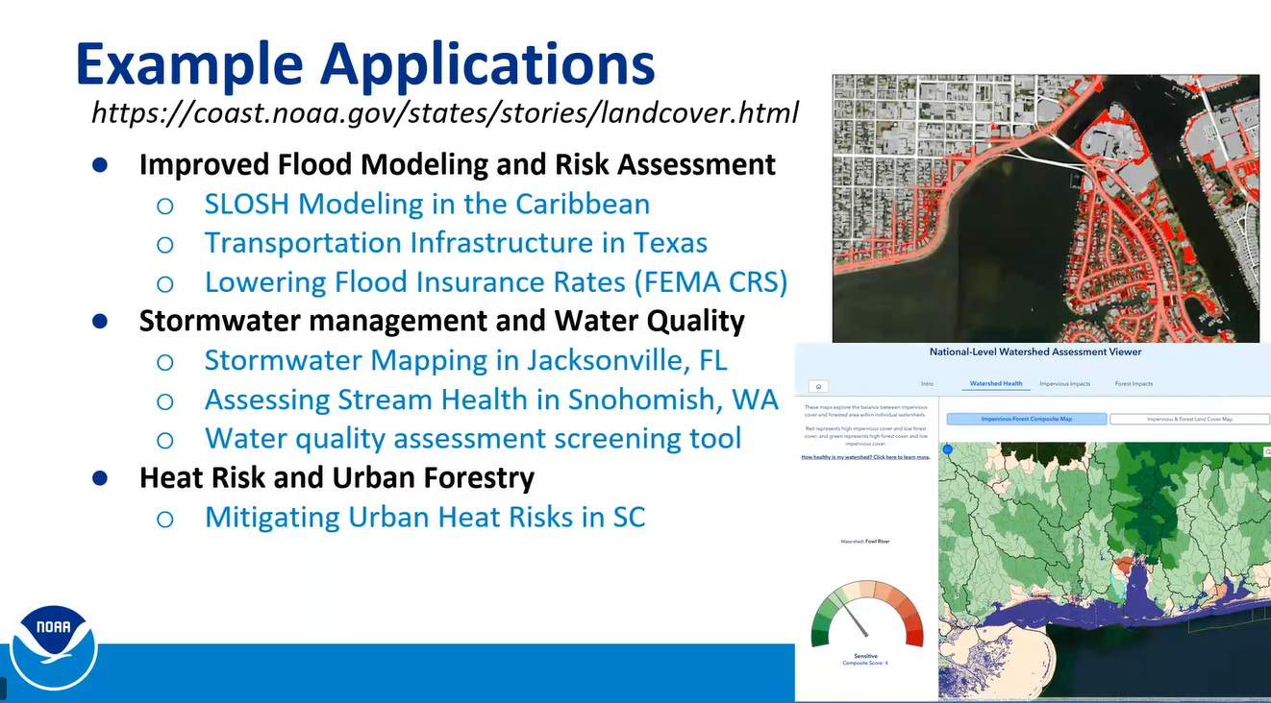
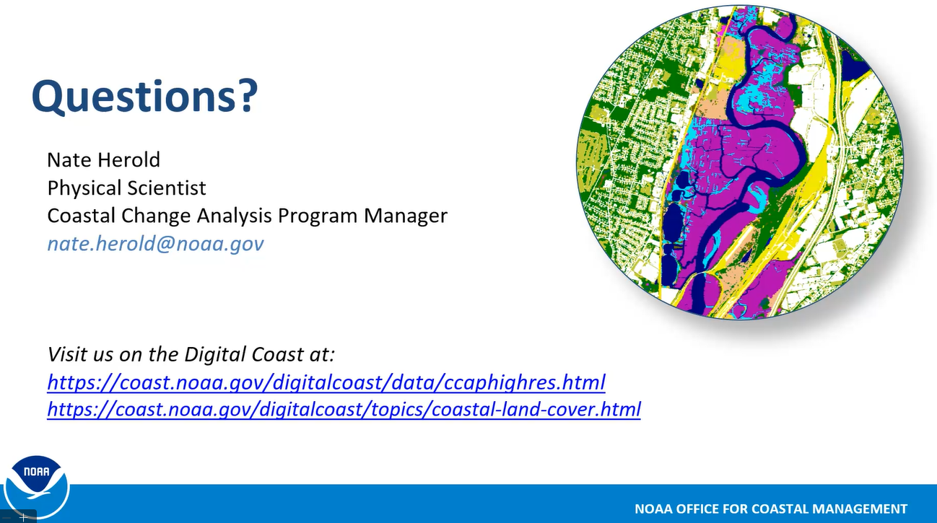

Questions?
- Via Brady Callahan (OPRD): What about error assessment? – Nate answered: Standardized landcover assessment, and most is based on analyst interpretation and referencing other imagery
- Plugged free data leaf on 30 cm resolution imagery from USDA’s NAIP program
- Via Bret Folder (NOAA) in chat: I'm regional representative for this work/data, and all of the rest of NOAA Office for Coastal Management's work through NOAA's Digital Coast. Feel free to email me with questions as well - bret.folger@noaa.gov
- Via Tanya Haddad (DLCD) in chat: Does this work interfaces with fire management – Nate Answered: Yes, especially at the urban boundaries for the higher resolution; Eastern Washington using for what? – Nate Answered: They bought it up and created a vector map of impervious
- Via Bret Folger (NOAA): Additionally, NOAA's Data Access Viewer allows users to clip datasets to specific bounding boxes, making the downloads and processing much faster: https://coast.noaa.gov/dataviewer/#/
- Via Lacy Summers (ESRI) - Esri partners with SkyWatch for ordering specific areas for satellite imagery:https://www.esri.com/about/newsroom/arcuser/access-satellite-imagery-with-arcgis-pro-add-in
Roll Call / Roundtable
Esri: <Null>
Business Oregon - BIZ: Not present
Oregon Department of Administrative Services - DAS: <Null>
Oregon Department of Aviation - DAV: Not present
Oregon Environmental Quality - DEQ: <Null>
Oregon Department of Human Services - DHS: <Null>
Oregon Department of Land Conservation & Development - DLCD: <Null>
Oregon Department of Geology & Mineral Industries - DOGAMI:
- Would like to have conversations with any folks who have recently upgraded their Enterprise in the last six months
Oregon Department of Revenue - DOR:
- Looking for support on making PDF maps ADA compliant to meet April deadline
Oregon Department of State Lands - DSL:
- Updating Enterprise from 11.2 --> 11.5
- Recruiting GIS Data Steward and soon two GIS Specialists
Legislative Commission on Indian Services - LCIS: Not present
Legislative Policy & Research Office - LPRO:
- Trying to load usage for last six months to a year
Oregon Department of Agriculture - ODA: Not present
Oregon Department of Education - ODE: Not present
Oregon Department of Forestry - ODF:
- Upgrading Portal to Enterprise 12
- Test environment up to 12
- Using SAML for authentication for user sign-in
Oregon Department of Fish & Wildlife - ODFW:
- Moving from concurrent to named user licensing
Oregon Department of Energy Management - ODOE:
- Bailey will be leaving and replaced by Jim Gore
Oregon Department of Transportation - ODOT:
- Trying to load usage for last six months to a year, will opening a support ticket
Oregon Department of Emergency Management - OEM:
- March 24th - Holding presentation on Statewide Evacuation Service: How it works and how to gain access
- GIS management interest group: ODF Mission Aircraft presentation
- Working through public facing AGOL content for WCAG
- Getting set up a new ‘Watch Center’ and reviewing integration with other systems
- Working through updates on GIS strategy and hoping to get Director’s signature on it soon
- Kick off meeting for work group on crisis mapping report project, dealing with budget notes that tasked OEM with creating a State of the State to track status of pre-planned data (e.g. indoor mapping information and systems)
Oregon Employment Department - OED:
- Happy to be back attending these meetings
Oregon Geographic Information Council - OGIC: <Null>
Oregon Health Authority - OHA:
- First round of indicator reductions for the statewide index for the environmental justice mapping tool
Oregon Housing & Community Services - OHCS: Not present
Oregon Military Department - OMD: Not present
Oregon State Parks & Recreation - OPRD: <Null>
Oregon State Police - OSP: Not present
Oregon State Fire Marshal - OSFM:
- Fire district boundaries updated and added a new activated district
Oregon State Marine Board - OSMB:
- We recently completed and continued more accessibility reviews and updates to our public ArcGIS Online applications to improve alignment with WCAG guidelines. Updates included improving map symbology, so status information is communicated through both color and symbols, refining popup structure and HTML formatting, adding accessible labels to Experience Builder widgets, and improving visual contrast and layout readability. We also added descriptive text for icons so key information is available in text as well as visually.
- Accessibility testing included NVDA screen reader testing along with WAVE and Silktide scans to help identify and address potential issues. These updates have been documented as part of our ongoing WCAG accessibility review process.
Oregon Watershed Enhancement Board - OWEB: Not present
Public Utilities Commission - PUC: Not present
Water Resource Department - WRD: <Null>
Oregon State University Institute for Natural Resources - INR: <Null>
Adjourn @ 2:37p

