BULLETIN INSERT

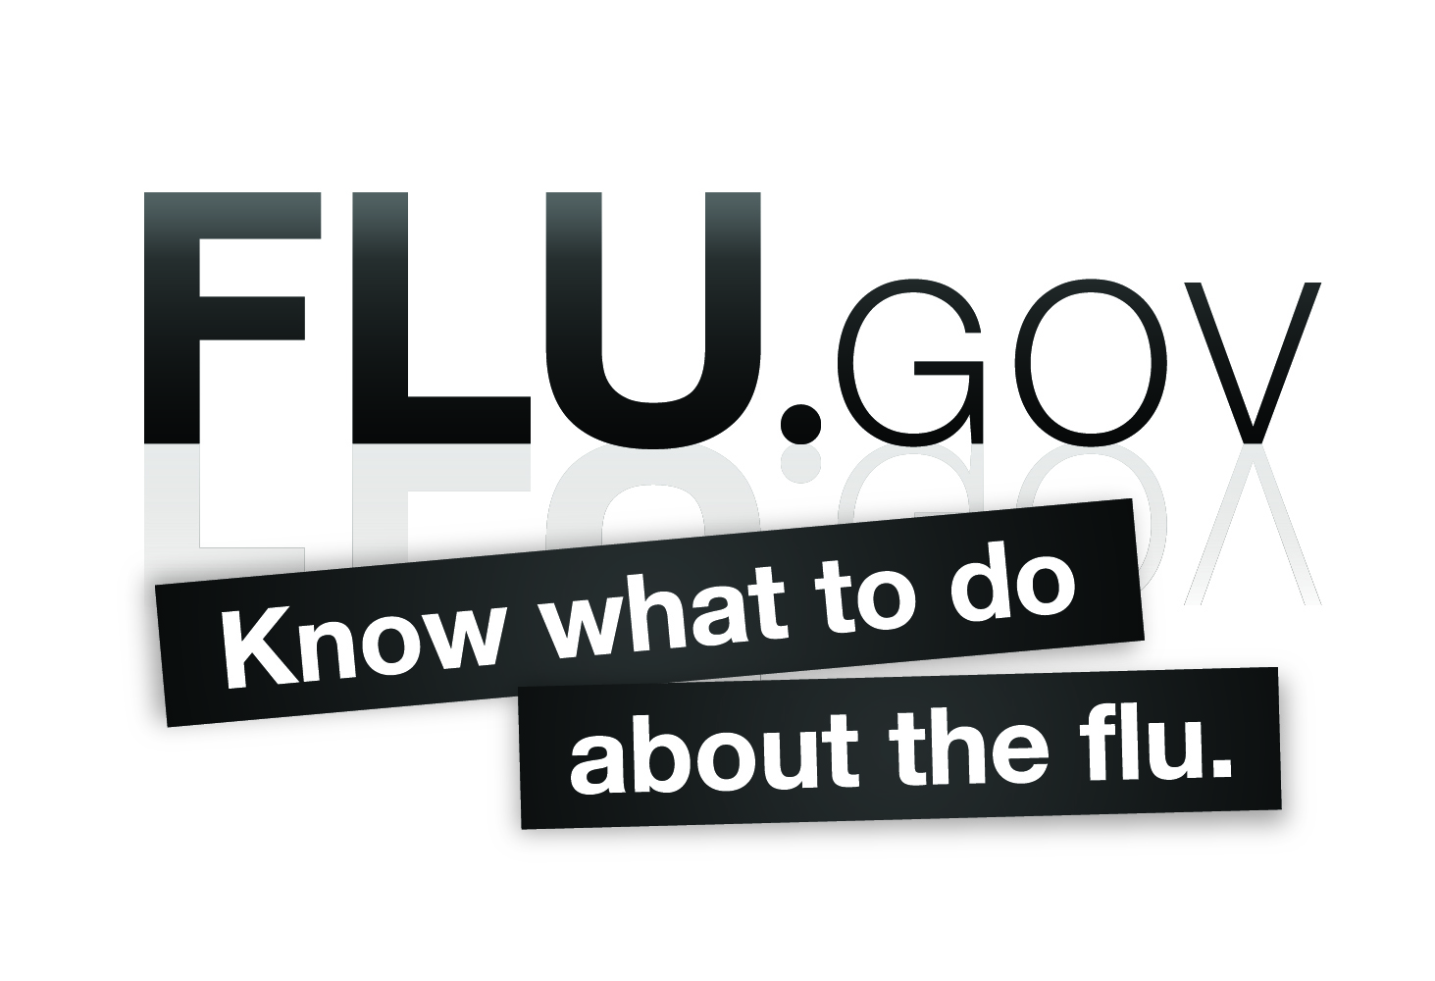
Together, we can fight the flu.
This Sunday marks the beginning of the annual observance of National Influenza Vaccination Week (NIVW). This flu season has presented our community with a unique challenge to fight a new type of influenza -- the 2009 H1N1 influenza virus.

The H1N1 flu is a serious disease. The Centers for Disease Control and Prevention estimates that between mid-April and November 14, 2009, 47 million people in the United States were infected with the 2009 H1N1 flu, more than 200,000 people were hospitalized, and over 9,800 people died.

Influenza is unpredictable and we do not know the likelihood of a future wave of H1N1 flu, but we do know that vaccination is the most important step in protecting against influenza. Protect yourself, your family and your community by getting vaccinated. Visit www.flu.gov to find the closest vaccination clinic and learn more facts about the H1N1 flu. Show your love to your family and our community by keeping yourself and those close to you healthy; get yourself and your family vaccinated.

