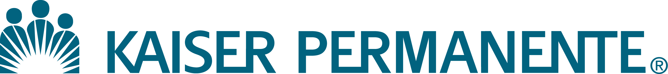
Northwest Region

Oral Health Initiative for Prevention, Advocacy, Care and Education
Letter of Intent (LOI)

Completed LOI should be electronically submitted to community.benefit@kp.org

Organization Name: | Date:
Organization Mailing Address: | Service area covered by project:
Project Director Name: | Anticipated number to be served by this project:
Project Director Title: | Indicate priority area: (please express with %)
Project Director Phone: | Please indicate the priority area of your project:  _____%_Policy/Advocacy ____% Access to Care  _____%_Prevention ____% Education  Must equal 100% - Policy/Advocacy is a required element
Project Director Email:

- A succinct description of the proposed project.
  - Identify the problem and documented community needs, and describe how the proposal will address those needs. Please specify the population you intend to address.

  - Describe all the efforts, programs, and services that will be included, including how the project will increase access to oral health care.

- Estimated project cost and duration.

- Sustainability plan and strength of organization or program to leverage additional resources and funds. Identify your intended community partners.

- Project Outcomes: Describe how you will define and measure the success of your work.

- If appropriate, the LOI may include and extra ½ page to define the ways in which your organization wishes to be recognized as a culturally-specific organization with heightened ability to serve communities of color. See page 10 in RFP for definition.

No more than 2 pages + an additional ½ page if project is culturally specific.
To be completed and returned to community.benefit@kp.org by
5pm Monday March 15, 2011

