Register Now!
Symposium
Social Determinants of Health: Solving Problems in Partnership
April 5th
4:00 – 7:30PM
(Reception with hors d'oeuvres until 8pm)
Lincoln Recital Hall
1620 SW Park Avenue, Portland, Oregon 97201
Register at (https://atrial.qualtrics.com/SE/?SID=SV_etDMExOKzTWyfdy)
Opening Comments: Bruce Goldberg, Oregon Health Authority
Internationally Recognized Scholars:
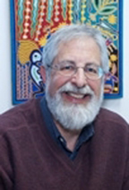
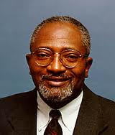
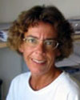

Robert Bullard George Kaplan Catherine Ross
Along with leading PSU researchers, community partners, and government and foundation representatives
Hosted by the School of Social Work-RRI, School of Community Health, Department of Sociology, with lead sponsorship from the PSU Office of Research and Strategic Partnerships. For more information, contact Lindsay Coffey at lncoffey@pdx.edu


