 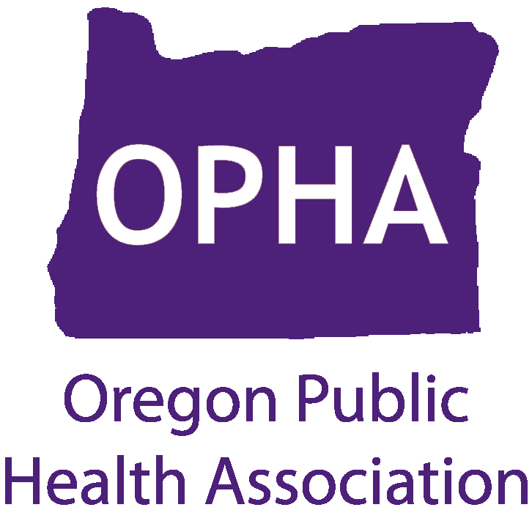

Introduction to Popular Education

Hosted by the OPHA Health Promotion and Education Section

Presented by the Community Capacitation Center

Popular education is a highly effective strategy for building knowledge and skills, developing leadership, and organizing for social justice. Most closely associated with the adult literacy work of Brazilian Paulo Freire, popular education is used around the world in many fields. It is applicable to all areas of educational practice. Popular education is based on the idea that, no matter our occupation and level of formal education, we all know a great deal as a result of our life experience. Therefore educators should start with what people already know and build on it.

In this workshop, you will become familiar with:

• The underlying philosophy of popular education and key popular education methods, such as brainstorming, sociodramas (social skits), cooperative learning, role plays, and dinámicas (educational games)

• How to move through the cycle of praxis (from action to reflection to action) in the course of a class

• How participants can apply what they are learning to their day-to-day work

• How this method can be used to teach any subject

• The history of popular education and how it grew out of the lived experience of people working for social change.

Registration: Space is limited and participants will be registered on a first-come, first served basis.

**Date: May 17th, 2012**

**Time: 1:00-5:00 pm**

Location:

Multnomah Building, Room 280

501 SE Hawthorne St.

Portland 97214

**Cost: OPHA Members: No cost**

**Others: $35**

For more information contact Alissa Leavitt at alissa.leavitt@pcc.edu