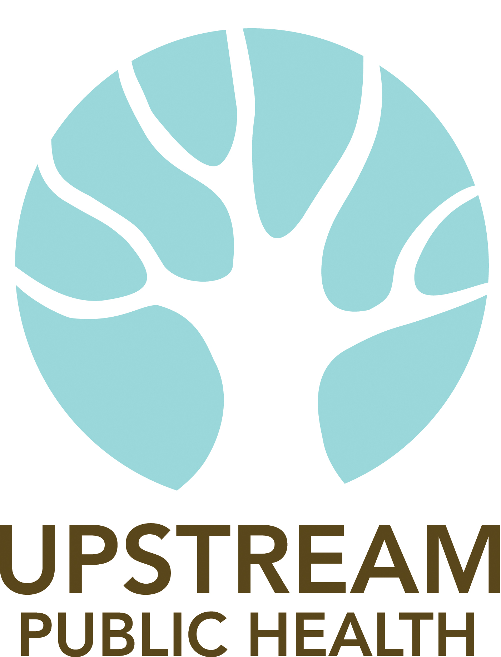
Deputy Director Job Announcement

Upstream Public Health Overview
At Upstream, we believe that smart policies are the best way to create communities that help people lead healthier, fuller lives. We seek out the most innovative broad-based public health solutions that are backed by science and research, move them into the mainstream dialogue, and build momentum for change. Our goal is to address the most pressing health issues and improve people's wellbeing, one policy at a time.

Position Overview
Upstream is seeking a passionate, experienced, and collaborative Deputy Director to manage overall operations of the organization, including budget tracking, program administration, grant writing and human resources. The position reports to the Executive Director and has internal and external facing responsibilities. This position will oversee staff and will support the Executive Director in organizational and project/program planning, providing leadership, and implementation of an emerging strategic direction. This is a full-time position.

Duties
- Support internal management functions including grant writing and contract administration, project/program management, human resources, work planning, budgeting and governance.
- Increase organizational resources through grants, contract negotiations, and foundation relations.
- Develop strategic communications to increase awareness about the organization and its mission among decision-makers, stakeholders and the public.
- Advocate for policies and programs that benefit the health of Oregonians particularly low-income people and communities of color
- Partner with the ED on specific internal leadership activities, including fund development, staff support, staff supervision, budget development, administration, organizational planning, and board development
- Identify best practices and improve internal systems with an eye toward future needs and budget realities.

About You
You are passionate about public health and inspired by Upstream’s work and growth potential. You have experience in at least one of following issues areas: health equity, active transportation, land use policy, or food policy. You are a people-person and have experience implementing performance measurement standards that help grow the organization while managing and supporting multiple autonomous staff and projects. You enjoy a flexible work schedule, are calm under pressure, comfortable with abstractions and appreciate the managed chaos of policy and system changes. You are solution-oriented; excel at setting priorities, enjoy developing and managing budgets, strategic planning and communications. You are resourceful at establishing and maintaining effective working relationships with partners from different backgrounds and walks of life. You understand the social determinants of health and bring an equity perspective to all your work.

QUALIFICATIONS:
- 5-10 years of experience working in a nonprofit and especially nonprofit management is desired and/or equivalent experience
- Strong management, organizational, and leadership skills, including the ability to develop, implement, and supervise a wide range of activities, and to support and nurture staff personnel
- Demonstrated success in securing grants
- Demonstrated understanding and commitment to health equity
- Demonstrated understanding of multi-sector public health policies such as food access, tobacco prevention, dental health and physical activity
- Ability to work independently and as part of a team
- Working knowledge of Microsoft Office, including Word, Excel, PowerPoint and other software.
- A strong foundation in the theory and practice of public health prevention including applying health determinants and seeking to shift institutional structures
- Demonstrated ability to cultivate positive relationships with partners from diverse backgrounds
- Experience managing staff and implementing performance measures
- Experience managing communications strategy for nonprofit organizations
- Demonstrated ability to support operations of a complex organization

Skills and Training:
Any combination of education, training and experience that confers the following:
- Outstanding written and oral communication skills including ability to write concisely and talk with different audiences about complex public health concepts
- Remain focused in the face of pressure, deliver against deadlines, not intimidated by tasks/time limitations
- Transparent and direct communicator
- Demonstrated time management skills
- Demonstrated understanding of applying a social determinants of health focus, a trauma informed approach, and resiliency framework or other approach that provides a health equity perspective
- A strong foundation in the theory and practice of public health prevention including applying health determinants and seeking to shift institutional structures

Salary and Benefits
Salary is dependent on experience and will be in a range of $55,000 to $60,000 with medical and dental insurance; paid vacation and sick leave.

To Apply:
Please send cover letter and resume to info@upstreampublichealth.org. The position will be open until filled.

