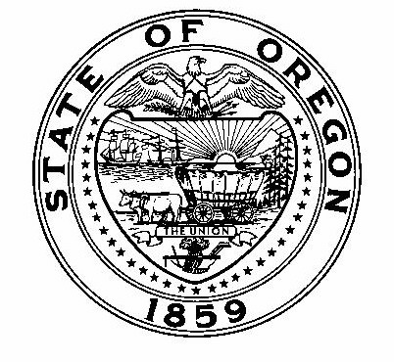
Theodore R. Kulongoski, Governor

Oregon
Department of Human Services
Public Health Division
800 NE Oregon Street
Portland, OR 97232-2162
Phone (971) 673-1020
TTY (971) 673-0372
Fax (971) 673-0994

M E M O

Date: April 4, 2011

To: County and Tribal Tobacco Prevention Program Coordinators
County Healthy Communities Implementation Program Coordinators

From: Healthy Communities/TPEP Community Program Liaisons

Re: QUARTERLY PROGRESS REPORT REMINDER

Due: APRIL 22, 2011

Quarterly Progress Report Instructions (January 1, 2011 through March 31, 2011)
Report your progress toward completing planned activities during the quarter, adding onto your previous quarterly report. The report may be formatted in either narrative or table format, following these guidelines:

- Make your notes on the workplan itself, under or next to each activity. See the format example below.
  - If you are using a workplan format that includes a column for quarterly reporting, put your progress notes there.
- Each quarterly report should build on the report submitted the quarter before. In other words, add new notes beneath or next to the progress notes from last quarter.
- There should be notes for every planned activity for the quarter in the workplan, whether or not they took place exactly as planned.
- Your progress notes should include:
- The quarter you are reporting on
- For activities that were conducted as planned, simply provide the actual Start and End dates for each activity for the quarter
- For activities that were not conducted as planned, describe why and how the activities were conducted differently, including any changes in your Start and End dates

Please clearly mark all forms with the county name and report date.

Optional: Feel free to include any additional information, such as media clips or pictures of events.

Quarterly Report Format Example:

- Coordination and Collaboration
We will continue our work with the Superintendent and Administrative Assistant at the school district. As necessary, we will bring in more partners from the community, staff and/or students to add to this workgroup to make recommendations to the School Board. Planned Start/End Dates: September 2010 – December 2010.
First Quarter Progress: Actual Start Date was September 2010. Actual End Date: N/A. This activity will continue through December 2010.
Second Quarter Progress: Actual End Date: N/A. Workgroup has been formed and two meetings were held during the quarter; this activity will continue through January 2011 to allow more time for the workgroup to finish preparing recommendations for the Board.

Email or mail the entire report to your Community Programs Liaison:

Sabrina Freewynn sabrina.l.freewynn@state.or.us
Tara Gedman tara.e.gedman@state.or.us
Jacqueline Villnave jacqueline.m.villnave@state.or.us
April Rautio april.l.rautio@state.or.us
Becky Wright becky.m.wright@state.or.us

Thank you for all your efforts for healthy communities throughout Oregon!

