OREGON PUBLIC HEALTH DIVISION  Health Promotion & Chronic Disease Prevention Section | 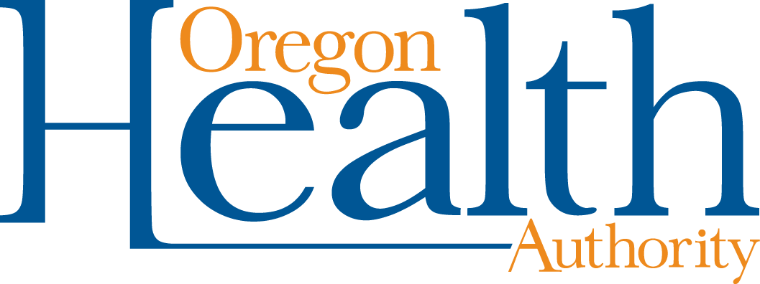

800 NE Oregon St, Ste 730
Portland, OR 97232
Voice (971) 673-0984
Fax: (971) 673-0994
TTY (971) 673-0372

Date: April 6, 2012

To: Tribal Tobacco Prevention Program Coordinators

From: Community Program Liaisons

Re: QUARTERLY REPORT REQUEST

Due: April 20, 2012

Quarterly Progress Report Instructions (January 1, 2012 through March 31, 2012)
Report your progress toward completing planned activities during the quarter. The report may be formatted in either narrative or table format, following these guidelines:

- Make your notes on the workplan itself, under or next to each activity.
  - If you are using a workplan format that includes a column for quarterly reporting, put your progress notes there.
- There should be notes for every planned activity for the quarter in the workplan, whether or not they took place exactly as planned.
- Your progress notes should include:
- The quarter you are reporting on
- For activities that were conducted as planned, simply provide the actual Start and End dates for each activity for the quarter
- For activities that were not conducted as planned, describe why and how the activities were conducted differently, including any changes in your Start and End dates

Please clearly mark all forms with the tribe name and report date.

Optional: Feel free to include any additional information, such as media clips or pictures of events.

Email or mail the entire report to your Community Programs Liaison:

Sabrina Freewynn sabrina.l.freewynn@state.or.us
Tara Gedman tara.e.gedman@state.or.us
April Rautio april.l.rautio@state.or.us
Tia Skerbeck christia.d.skerbeck@state.or.us
Rebecca Pawlak rebecca.l.pawlak@state.or.us

Thank you for all your efforts for healthy communities throughout Oregon!

