OREGON PUBLIC HEALTH DIVISION  Health Promotion & Chronic Disease Prevention Section | 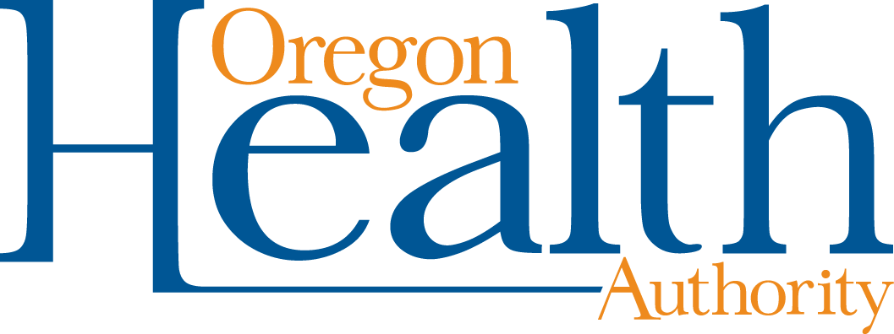

800 NE Oregon St, Ste 730
Portland, OR 97232
Voice (971) 673-0984
Fax: (971) 673-0994
TTY (971) 673-0372

Date: September 19, 2012

To: Tribal Tobacco Prevention Program Coordinators

From: Community Program Liaisons

Re: QUARTERLY REPORT REQUEST

Due: October 26, 2012

Quarterly Progress Report Instructions (July 1, 2012 through September 30, 2012)
Report your progress toward completing planned activities during the quarter. The report may be formatted in either narrative or bullet points, following these guidelines:

- Make your notes on the workplan itself, in the line reserved for quarterly reporting (titled “Fist Quarter Report: Due October 26, 2012”).
- No report is needed for “M”.
- For “POWER,” include notes for activities, milestones reached, partners engaged to complete the work, and media coverage achieved.
  - For activities that were not conducted as planned, describe why and how the activities were or will be conducted differently.
- For “Reporting and Evaluation” include information on activities to disseminate program findings and results.
- Provide copies of any policies passed during the quarter

Please clearly mark all forms with the tribe name and report date.

Optional: Feel free to include any additional information, such as media clips or pictures of events.

Email or mail the entire report to your Community Programs Liaison:

Sabrina Freewynn sabrina.l.freewynn@state.or.us
Tara Gedman tara.e.gedman@state.or.us
April Rautio april.l.rautio@state.or.us
Tia Skerbeck christia.d.skerbeck@state.or.us
Andrew Epstein andrew.d.epstein@state.or.us
Leah Fisher leah.m.fisher@state.or.us

Thank you for all your efforts for healthy communities throughout Oregon!

