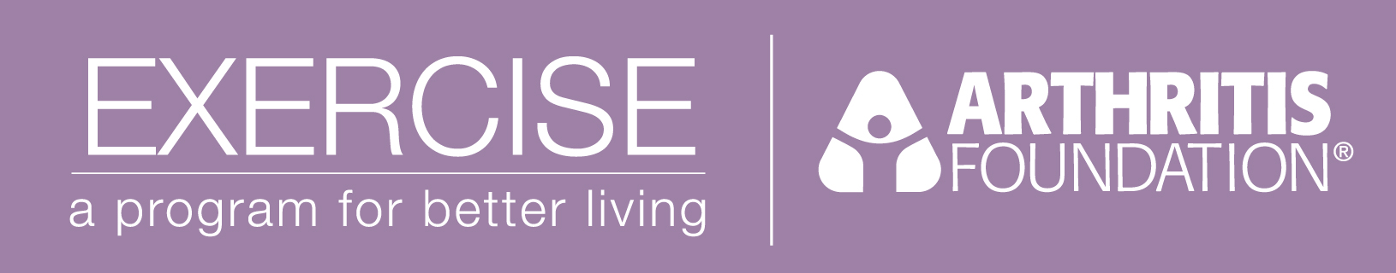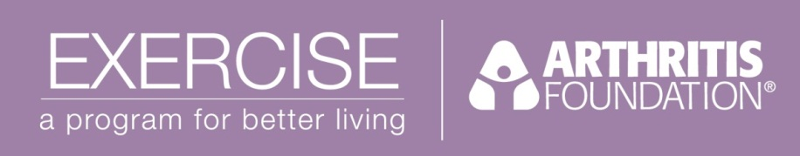

Arthritis Foundation Exercise Program

**Instructor Training Workshop**



### S:\AF Logos & forms\aflogo_color.jpgDescription: AF_ExerDescription: Comprecare Foundation Logo

**April 13, 2013 from 8:00 a.m. - 5:00 p.m.**

Salem Family YMCA

685 Court St. NE, Salem, OR 97301

**Requirements**

* Pre-Training Module to be completed prior to the workshop.
* **Commit to teaching at least one class series per year** (must teach six weeks within six months of training to become certified)
* **Have an affiliation with a facility** that can host the Arthritis Foundation program and has signed a Co-Sponsorship Agreement
* **CPR Certification**
* Other desirable characteristics include personal or professional experience working with people with arthritis or disabilities; interest in working with groups; and interest in health, exercise and a proactive approach to health management.

**Workshop Fee: $25**

Workshop fee does not include lodging or travel expenses.

**Registration Deadline**

April 4, 2013

**Completed Registration form and Co-Sponsorship Agreement are necessary for consideration to attend the workshop.** Please request or submit forms to:

Arthritis Foundation, Attn: Cindy Bishop

9700 SW Capitol Hwy, Ste 160, Portland, OR 97219

cbishop@arthritis.org or fax: (503) 245-5691

**Program Implementation Process**

1. Have your facility sign the Co-Sponsorship Agreement

2. Attend a one day instructor training and agree to follow all program guidelines.

3. Teach the class for six weeks, within six month of training.

4. Apply for Instructor Certification (certification lasts 3 years).

5. Enjoy your class!

**Please ask if you have questions! Cindy Bishop (503) 245-5695**

**Why Offer the Arthritis Foundation Exercise Program?**

**Program Quality**

Arthritis Foundation Programs:

* Are evidence-based, with research-proven effectiveness and safety
* Include nationally standardized exercises
* Are developed and updated by experts to meet the specific needs of people with arthritis
* Help people take control of arthritis. In participants’ words, they are: “life-changing,” “helped me walk again,” and “helped me feel better physically and mentally”

**Great Marketing Opportunity**

* The Arthritis Foundation is a trusted resource, and its name lends credibility
* Arthritis Foundation programs provide a value added service to your constituents
* Partnership with the Arthritis Foundation increases visibility for your site through co-marketing opportunities, promotional flyers, phone referrals and listings on our website
* Classes open to the community provide a greater potential for increased membership and utilization

**Instructor Benefits**

* Affordable training provides a valued three year certification
* Instructional materials are easy to use
* Training provides an opportunity to earn contact hours for possible continuing education credit