OREGON PUBLIC HEALTH DIVISION  Health Promotion & Chronic Disease Prevention Section | 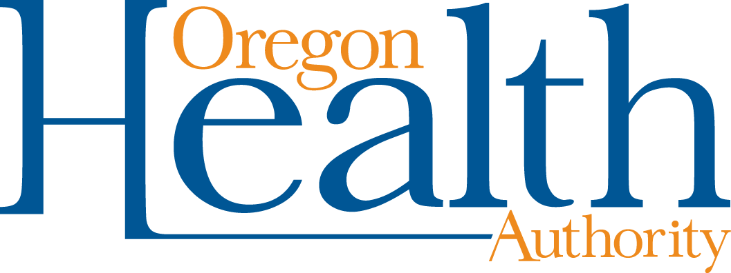

800 NE Oregon St, Ste 730
Portland, OR 97232
Voice (971) 673-0984
Fax: (971) 673-0994
TTY (971) 673-0372

Date: March 22, 2013

To: Tribal Tobacco Prevention Program Coordinators

From: Community Program Liaisons

Re: QUARTERLY REPORT REQUEST

Due: April 26, 2013

Quarterly Progress Report Instructions (January 1 through March 31, 2013)
Report your progress toward completing planned activities during the quarter. The report may be formatted in either narrative or bullet points, following these guidelines:

- Make your notes on the workplan itself, in the line reserved for quarterly reporting (titled “Third Quarter Report”).
- No report is needed for “M”.
- For “POWER,” include notes for activities, milestones reached, partners engaged to complete the work, and media coverage achieved.
  - For activities that were not conducted as planned, describe why and how the activities were or will be conducted differently.
- For “Reporting and Evaluation” include information on activities to disseminate program findings and results.
- Provide copies of any policies passed during the quarter

Please clearly mark all forms with the tribe name and report date.

Optional: Feel free to include any additional information, such as media clips or pictures of events.

Email or mail the entire report to your Community Programs Liaison:

Sabrina Freewynn sabrina.l.freewynn@state.or.us
Tara Gedman tara.e.gedman@state.or.us
April Hasson april.r.hasson@state.or.us
Terresa White terresa.l.white@state.or.us
Andrew Epstein andrew.d.epstein@state.or.us
Leah Fisher leah.m.fisher@state.or.us

Thank you for all your efforts for healthy communities throughout Oregon!

