OREGON PUBLIC HEALTH DIVISION  Health Promotion & Chronic Disease Prevention Section | 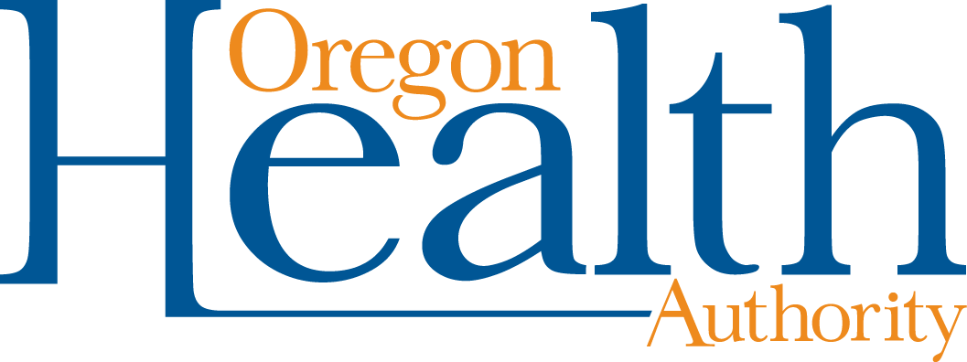

800 NE Oregon St, Ste 730
Portland, OR 97232
Voice (971) 673-0984
Fax: (971) 673-0994
TTY (971) 673-0372

Date: June 6, 2013

To: Tribal Tobacco Prevention Program Coordinators

From: Community Program Liaisons

Re: QUARTERLY REPORT REQUEST

Due: July 26, 2013

Six-Month Narrative Report Instructions (January 1, 2013 through June 30, 2013)
Please write a 1-2 page cover letter describing highlights from the last six months, using the following questions as a guide:
- Describe the key successes or outcomes over the last six months as you have made progress on your workplan objectives.
- Describe any new ‘champions,’ stakeholders, or partnerships that are developing as a result of your efforts.
- Describe any barriers or challenges to working on each of your objectives, and how you addressed them (lessons learned).
- Describe next steps for your objectives.
- Describe any questions, concerns, technical assistance needs, or resources that you need from OHA/HPCDP.

Quarterly Progress Report Instructions (April 1, 2013 through June 30, 2013)
Report your progress toward completing planned activities during the quarter. The report may be formatted in either narrative or bullet points, following these guidelines:

- Make your notes on the workplan itself, in the line reserved for quarterly reporting (titled “Fourth Quarter Report: Due July 26, 2013”).
- No report is needed for “M”.
- For “POWER,” include notes for activities, milestones reached, partners engaged to complete the work, and media coverage achieved.
  - For activities that were not conducted as planned, describe why and how the activities were or will be conducted differently.
- For “Reporting and Evaluation” include information on activities to disseminate program findings and results.
- Provide copies of any policies passed during the quarter

Please clearly mark all forms with the tribe name and report date.

Optional: Feel free to include any additional information, such as media clips or pictures of events.

Email or mail the entire report to your Community Programs Liaison:

Tara Gedman tara.e.gedman@state.or.us
April Hasson april.r.hasson@state.or.us
Terresa White terresa.l.white@state.or.us
Andrew Epstein andrew.d.epstein@state.or.us
Leah Fisher leah.m.fisher@state.or.us

Thank you for all your efforts for healthy communities throughout Oregon!

