Smokefree Oregon State Parks and Recreation
Background: Governor Kitzhaber signed the Tobacco-free State Properties Executive Order in August 2012. Most state agencies successfully implemented the Order in January 2013.
The Order encourages the Oregon Parks and Recreation Commission “to adopt policies by December 31, 2014 that limit or restrict the use of tobacco products at state parks and recreation areas to address wellness issues, and to reduce the risk of forest fires.”
The Order “in no way limits the authority of state agencies to further limit or restrict the use of tobacco products in state agency buildings or on state agency grounds."
Proposed Rule Changes: The Oregon Parks and Recreation Department (OPRD) Executive Committee determined OAR changes were necessary for implementing the Order. OPRD proposed the following OAR changes to the Parks and Recreation Commission in November:
DIVISION 10 - GENERAL STATE PARK RULES
The following activities are specifically prohibited at park properties, and a person may not engage in …
Smoking of tobacco products in any parks property with the following exceptions:
- In personal vehicles and camping units;
- In designated campsites in developed overnight camping areas;
- Where permitted by the park manager for traditional ceremonies in accordance with the American Indian Religious Freedom Act.
Considerations
- OPRD is going above and beyond the Governor’s Order. OPRD leadership wants to demonstrate their commitment to protecting and preserving state parks.
- At the request of natural resources agencies, HPCDP convened an Open Lands committee to discuss strategies for implementing the Order in open/public lands. The Dept. of Forestry and Dept. of Fish & Wildlife agreed to mirror the approach of OPRD.
- OPRD’s system for implementing DIVISION 10 policy is through Ranger enforcement and citation. OPRD is recommending a period of education and communication without formal citations. OPRD will eventually use their citation system to enforce the policy.

Rules Advisory Committee
Partly due to TPEP’s Smokefree Oregon campaign, the Surfrider Foundation advocated that the Parks and Recreation Commission include ocean shores in rulemaking. OPRD convened an advisory committee to discuss this and other recommendations - HPCDP was invited to sit on the advisory committee for rule making.
As a group, the committee recommended that the:
- Parks and Recreation Commission open up rulemaking for ocean shores, and
- ORPD develop and implement a communication plan. Note: a communications plan is already begin developed; the advisory committee proposed messaging and dissemination strategies.
What can TPEP grantees do to support OPRD?
OPRD has encouraged stakeholders to submit formal comment on the rule changes through the public commenting process (deadline January 17, 2014). The following are HPCDP’s recommendations:
- Phase-in policy implementation for overnight campsites in overnight camping areas
- Open DIVISION 21 rulemaking for ocean shore recreation areas
- For both ocean shores and parks, define ‘tobacco products’ to include smokeless tobacco as well as specify all cigarettes, cigars, electronic-cigarettes, and hookah.
Grantees can voice their support of ORPD’s leadership in tobacco prevention and education, as well as make recommendations by:
- Submitting public comment on behalf of your organization
- Attend and participate in public hearings
See below for information regarding ORPD’s public commenting opportunities.
- Grantees can also submit letters to the editor or editorials to local newspapers; use this opportunity to leverage local smokefree park initiatives; share local stories; identify and support community champions in submitting comment/attending hearings and response to local media.
Contact your liaison with questions.

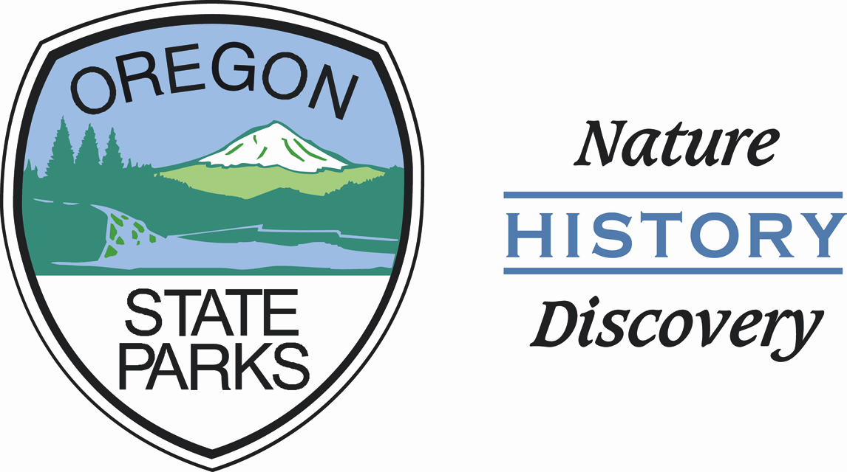
News Release
Oregon Parks and Recreation Dept.
FOR IMMEDIATE RELEASE
December 19, 2013
Media Contact:
Richard Walkoski, Communication Specialist
richard.walkoski@state.or.us
503-986-0748 (direct)
OPRD seeks comments on rules that would restrict outdoor smoking in Oregon State Parks
The Oregon Parks and Recreation Department (OPRD) is seeking public comment on proposed rule changes that would control smoking in outdoor areas of Oregon State Parks. The proposed changes, which can be found at http://tinyurl.com/stateparksmoking , are designed in part to reduce litter and protect natural resources in Oregon’s state parks. Smoking is already prohibited in public buildings in the parks. The draft rule change proposes to limit smoking to personal vehicles, tents, and RVs, plus campsites in developed overnight camping areas. The current proposal does not apply to the ocean shore which is managed by OPRD.
Public hearings have been scheduled during January at the following locations:
Date | Location
1/7/2014 | Josephine Community Library, 200 NW C Street, Grants Pass OR
1/9/2014 | Champoeg State Heritage Area, Visitor Center, 8239 Champoeg Road NE, St. Paul OR
1/14/2014 | Bend Park and Recreation Office, Riverbend Room, 799 SW Columbia Street, Bend OR
1/16/2014 | Newport Recreation Center, 225 Avery St SE, Newport OR
All public hearings begin at 7:00 PM and those wishing to make a comment must register with the hearings officer by 7:30 PM. Comments may also be e-mailed to oprd.publiccomment@state.or.us and written comments may be sent to Richard Walkoski, Oregon Parks and Recreation Department, 725 Summer St. NE, Suite C, Salem Or 97301. Public comments will be accepted until 5:00 PM on January 17, 2014. If passed, the rule would become effective March 1, 2014, but state park staff wouldn’t start enforcing it until January 2015, and instead spend 2014 educating visitors about the change.

