Date | From Where? | What bucket?  (does this fit into The Real Cost, Youth, Addiction, or Join the SF Community)? | So what?  (Why care? What’s intriguing? How does this further the discussion?) | Now What?  (What’s the call to action: Support, Recognize, Talk, Learn) | Post
Fri 4/4 | http://www.lung.org/stop-smoking/tobacco-control-advocacy/reports-resources/cessation-economic-benefits/states/oregon.html | The Real Cost | Cigarettes are much more devastating economically than represented by their cost. | Wouldn’t you rather spend that somewhere else? http://www.youtube.com/watch?v=H6F3HCgl8pM | 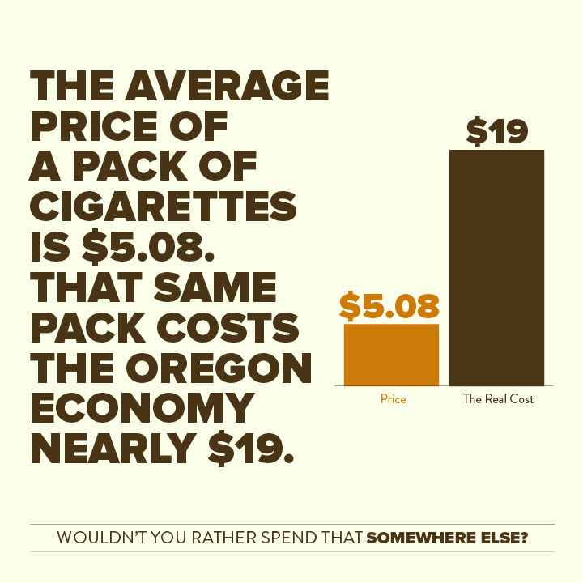
Mon 4/7 |  | Addiction | Most people don’t realize their health plan offers cessation tools. | Join the Smokefree Community today! Call your insurance provider to find out what your cessation benefits are and start quitting today. | 
Tues 4/8 | http://www.surgeongeneral.gov/library/reports/preventing-youth-tobacco-use/exec-summary.pdf | Youth | A milestone age that provides a positive goal for teenagers. 88 percent of smokers used tobacco by age 18. | What’s for sale in your neighborhood? http://www.youtube.com/watch?v=lHcZeHziQi8 | 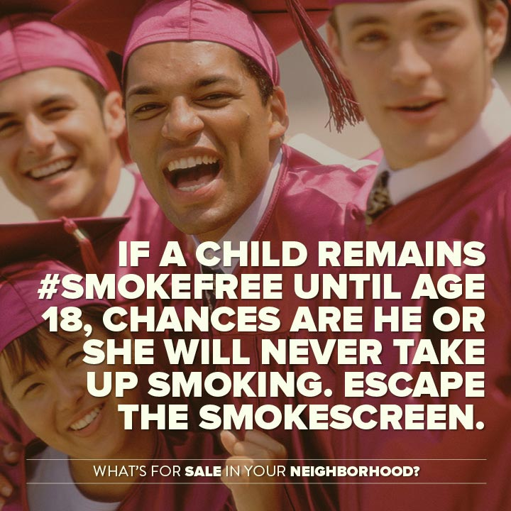
Wed 4/9 | http://www.cbnb.us/news-events/news/coastal-news/7927-cigarette-butts-on-oregons-beaches-june-26.html | Environmental | The most littered item in the world contains deadly chemicals. | Read more about the environmental impact of cigarettes: http://tobaccocontrol.bmj.com/content/20/Suppl_1/i1.full.pdf+html | 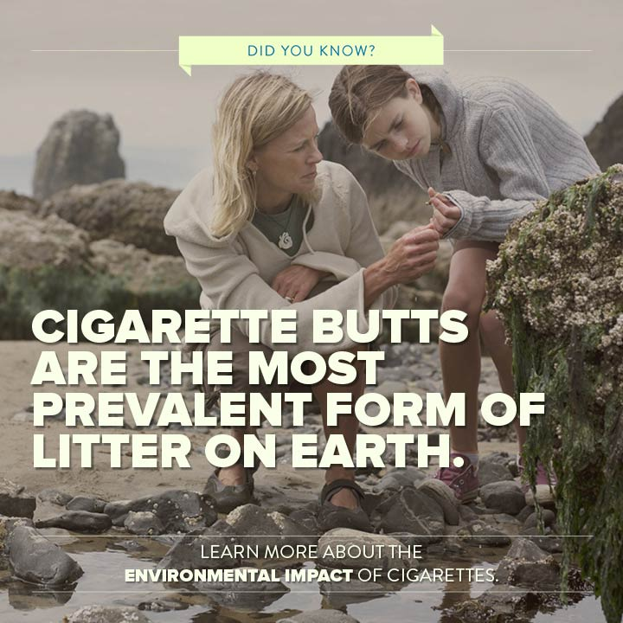
Thurs 4/10 | http://public.health.oregon.gov/preventionwellness/tobaccoprevention/documents/medicaidburden.pdf | Join the SF Community | Oregonians are making strides to cut tobacco use but there’s still a lot of work to be done. | What other locations would you like to see #smokefree? | 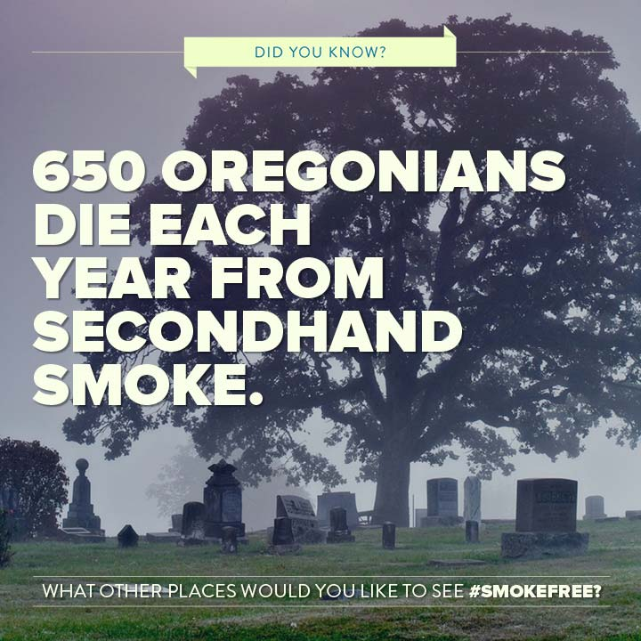
Fri 4/11 | http://well.blogs.nytimes.com/2014/01/27/helping-smokers-quit-or-not-start-in-the-first-place/?_php=true&_type=blogs&_php=true&_type=blogs&_php=true&_type=blogs&_php=true&_type=blogs&_php=true&_type=blogs&_php=true&_type=blogs&ref=smokingandtobacco&_r=5&module=ArrowsNav&contentCollection=Health&action=keypress&region=FixedLeft&pgtype=Blogs | Youth | E-cigarettes are available to children and getting them addicted to nicotine. | What’s for sale in your community? http://www.cdc.gov/media/releases/2013/p0905-ecigarette-use.html | 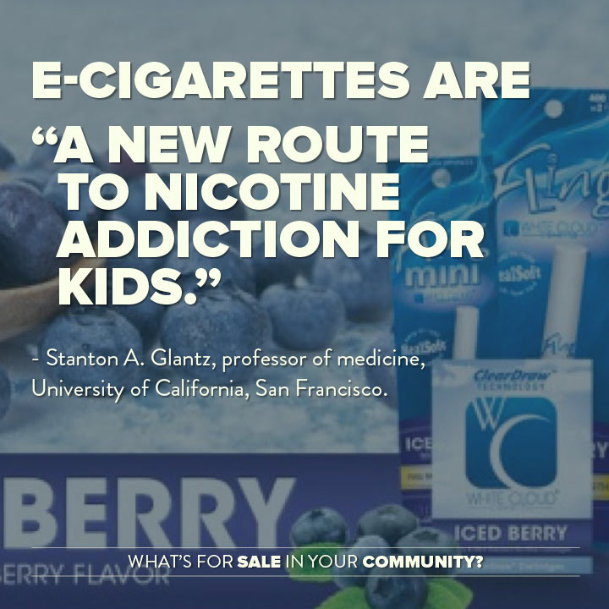
Mon 4/14 | http://www.surgeongeneral.gov/library/reports/50-years-of-progress/exec-summary.pdf | Addiction | Diabetes is a dangerous disease that receives a lot of attention. This is a new fact from Surgeon General 2014. | We’re here to help you on your quitting journey. Call 1-800-quit-now for help and learn more about health effects of smoking in the Surgeon General’s Report: http://www.surgeongeneral.gov/library/reports/50-years-of-progress/exec-summary.pdf | 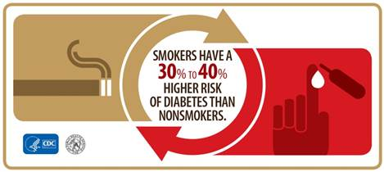
Tues 4/15 | http://www.mailtribune.com/apps/pbcs.dll/article?AID=/20140321/NEWS/403210322 | Join the SF Community |  | What other places would you like to see smokefree? | 
Wed 4/16 |  | Youth | E-cigarettes are marketed to youth. | What’s for sale in your community? | 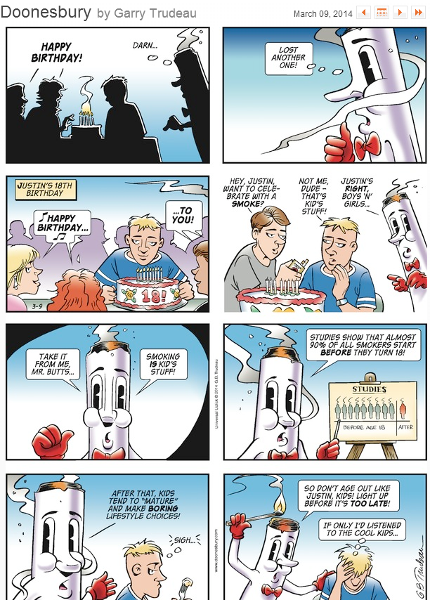
Thurs 4/17 | http://www.lung.org/assets/documents/publications/lung-disease-data/lgbt-report.pdf | Addiction | Specific methods of Big Tobacco’s subversive efforts. | Learn more about Big Tobacco’s targeting in the LGBT community:  http://www.lung.org/assets/documents/publications/lung-disease-data/lgbt-report.pdf | 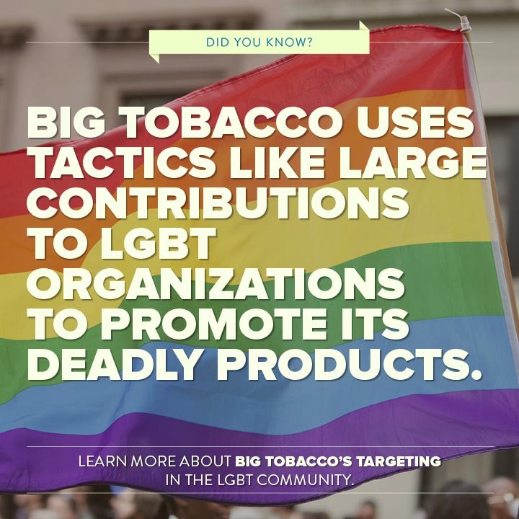
Fri 4/18 | http://www.surgeongeneral.gov/library/reports/preventing-youth-tobacco-use/exec-summary.pdf | Youth | Big Tobacco’s subversive methods of reaching children. | What’s for sale in your community?  http://www.surgeongeneral.gov/library/reports/preventing-youth-tobacco-use/exec-summary.pdf | 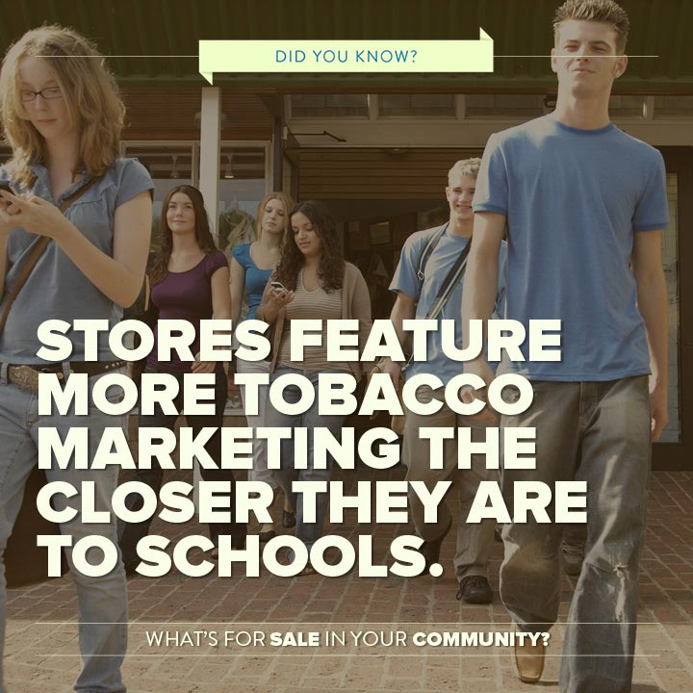
Mon 4/21 | http://www.surgeongeneral.gov/library/reports/50-years-of-progress/exec-summary.pdf | Addiction | The juxtaposition shows the enormous impact of tobacco. | Let’s end this epidemic. Call 1-800-quit-now for help. | 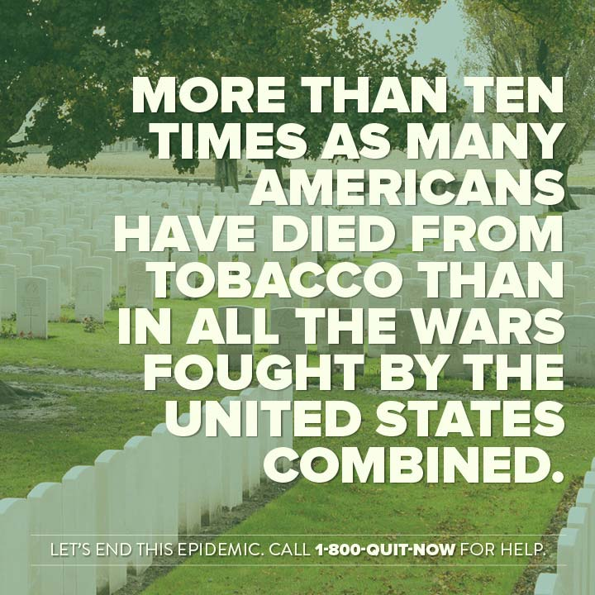
Tues 4/22 (Earth Day) | http://www.cdc.gov/tobacco/calendar/apr/earth_day/  http://www.legacyforhealth.org/our-issues/cigarettes-and-the-environment/help-us-stop-toxic-litter | Environmental | The most littered item in the world contains deadly chemicals. | Join an organization that is working to clean up cigarette butt litter in your community. http://www.solv.org/  http://www.surfrider.org/campaigns/entry/hold-on-to-your-butt | 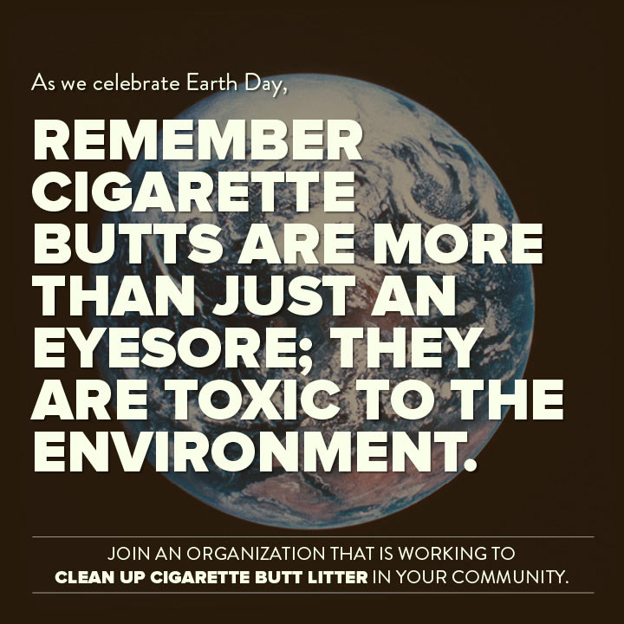
Wed 4/23 | http://public.health.oregon.gov/BirthDeathCertificates/Surveys/AdultBehaviorRisk/brfssresults/09/Documents/tobaccouse.pdf  http://www.surgeongeneral.gov/library/reports/preventing-youth-tobacco-use/exec-summary.pdf | Join the SF Community/Youth | Convenience stores are the battleground for youth and adult cigarette sales and advertising. | Find out what’s for sale in your community at smokefreeoregon.com or read more in the Surgeon General’s Report http://www.surgeongeneral.gov/library/reports/preventing-youth-tobacco-use/exec-summary.pdf | 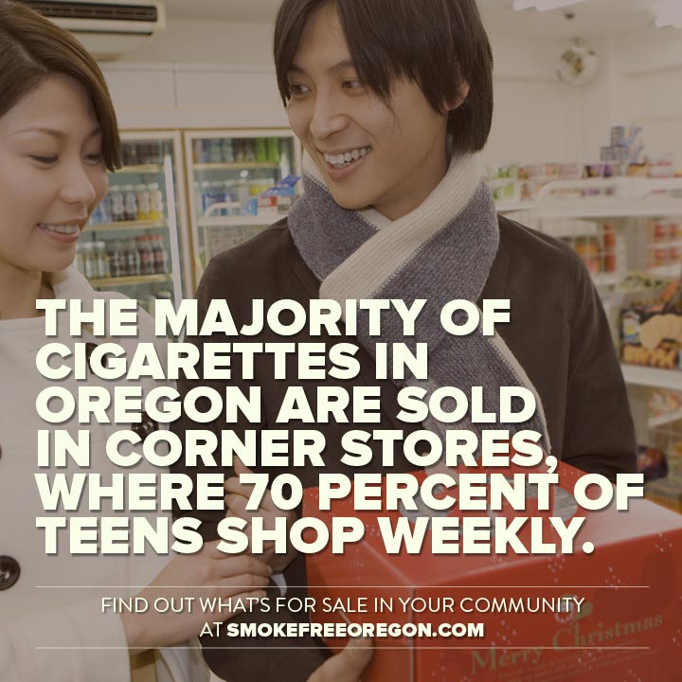
Thurs 4/24 | http://1.usa.gov/1ccP23M | Addiction | American Indians have the largest prevalence of smoking among population groups. | What’s for sale in your community? | In the linked podcast, Dr. Patricia Nez Henderson, vice president, Black Hills Center for American Indian Health, discusses the importance of educating tribal people that cigarettes are not traditional. She and other tribal support centers are working to end commercial tobacco use among American Indians.  http://1.usa.gov/1ccP23M  
Fri 4/25 | OHT, 2013 | Youth | Big tobacco’s subversive methods reach children. | What’s for sale in your community?  https://public.health.oregon.gov/BirthDeathCertificates/Surveys/OregonHealthyTeens/Documents/2013/2013_OHT_State_Report.pdf | 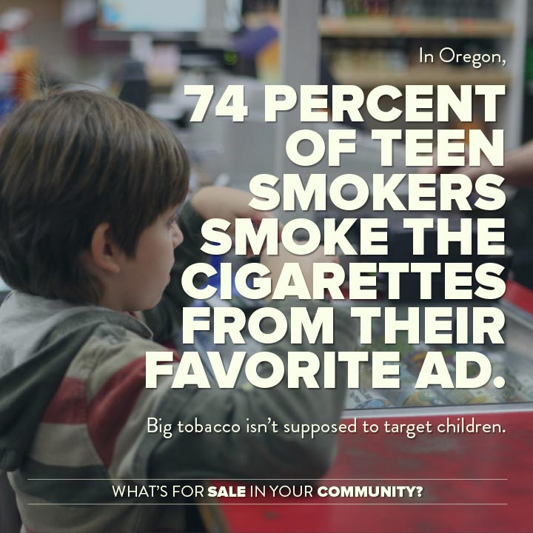
Mon 4/28 | http://public.health.oregon.gov/BirthDeathCertificates/Surveys/AdultBehaviorRisk/brfssresults/09/Documents/tobaccouse.pdf | Addiction | Some uplifting news for those looking to quit. | Call 1-800-QUIT-NOW to join them. | 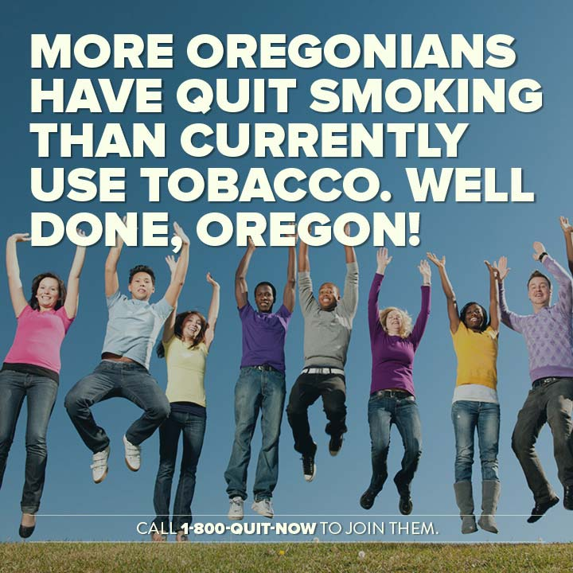
Tues 4/29 | http://www.legacyforhealth.org/our-issues/cigarettes-and-the-environment/help-us-stop-toxic-litter/?o=3571# | Environmental | The most littered item in the world contains deadly chemicals. | Read more about the environmental impact of cigarettes: https://www.youtube.com/watch?v=FfXgmHihfWk&list=UULTcqjxNhju_E9eq_uO_wrg | 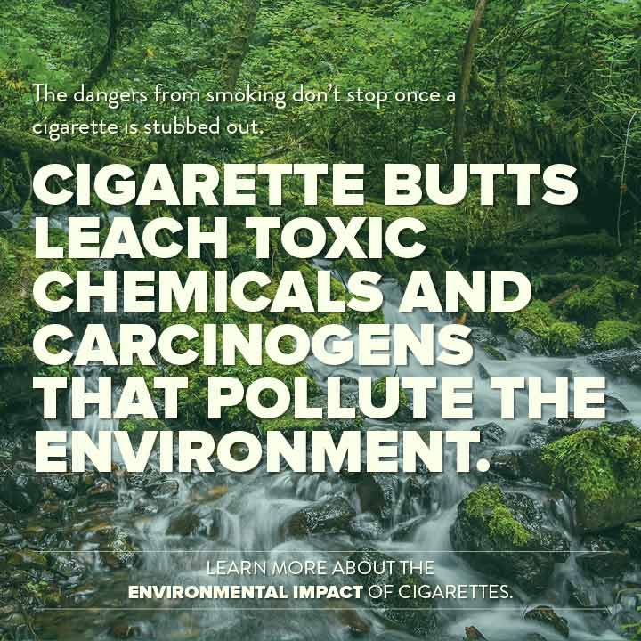
Wed 4/30 | http://global.tobaccofreekids.org/en/industry_watch/marketing/youre_the_target | Youth | Tobacco companies are targeting our children with images that appeal to our them. | If you’re unsure about how Big Tobacco targets kids, take a look at some of the marketing techniques they are using around the globe. http://global.tobaccofreekids.org/en/industry_watch/marketing/youre_the_target | 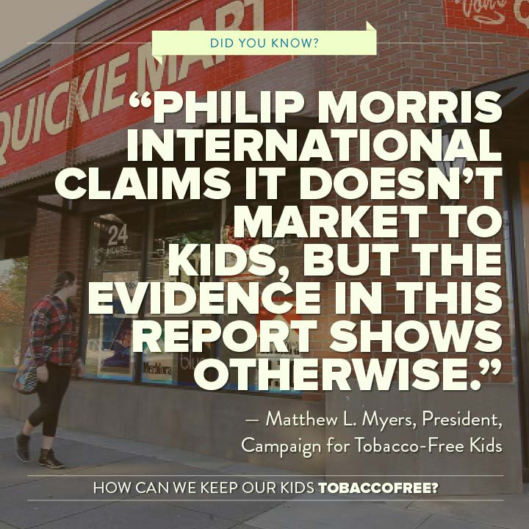
TO KEEP FOR MAY | http://www.tobaccofreekids.org/research/factsheets/pdf/0363.pdf | Youth | Smokeless doesn’t mean harmless. | Learn more about how smokeless doesn’t mean harmless: http://www.tobaccofreekids.org/research/factsheets/pdf/0363.pdf | 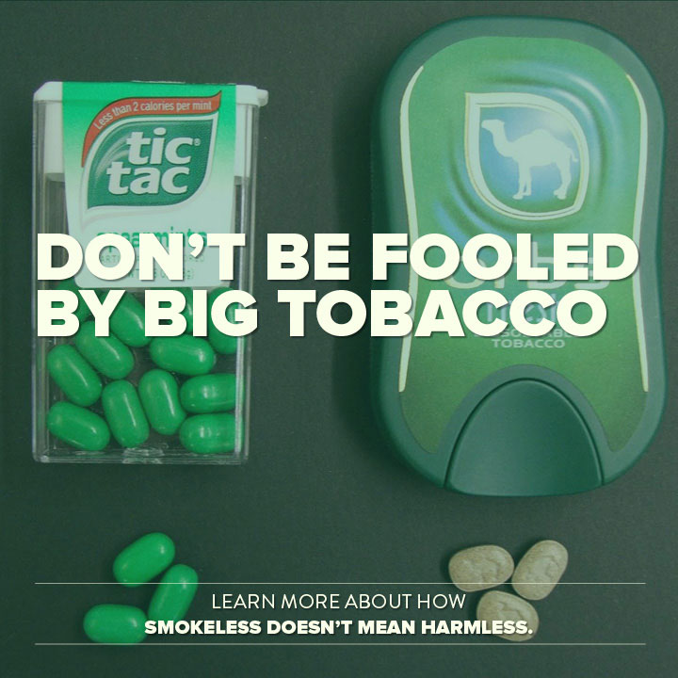
TO KEEP FOR MAY | http://www.surgeongeneral.gov/library/reports/preventing-youth-tobacco-use/exec-summary.pdf | Youth | Kids don’t tend to think about the long-term health effects of smoking. | What’s for sale in your community?  http://www.youtube.com/watch?v=lHcZeHziQi8 | 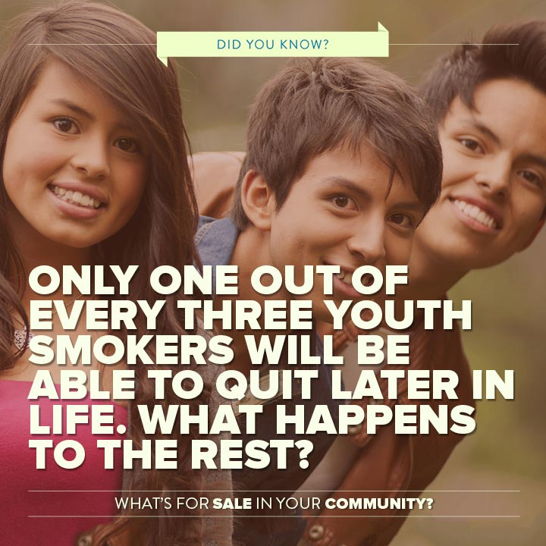
TO KEEP FOR MAY | http://public.health.oregon.gov/BirthDeathCertificates/Surveys/AdultBehaviorRisk/brfssresults/09/Documents/tobaccouse.pdf | Addiction | Proof of a community fighting disparities. | Find out more about smoking disparities in the African American community at http://www.naatpn.org  https://public.health.oregon.gov/DiseasesConditions/ChronicDisease/Documents/table_5_race_oversample_2010-2011.pdf | 