OREGON PUBLIC HEALTH DIVISION  Health Promotion & Chronic Disease Prevention Section | 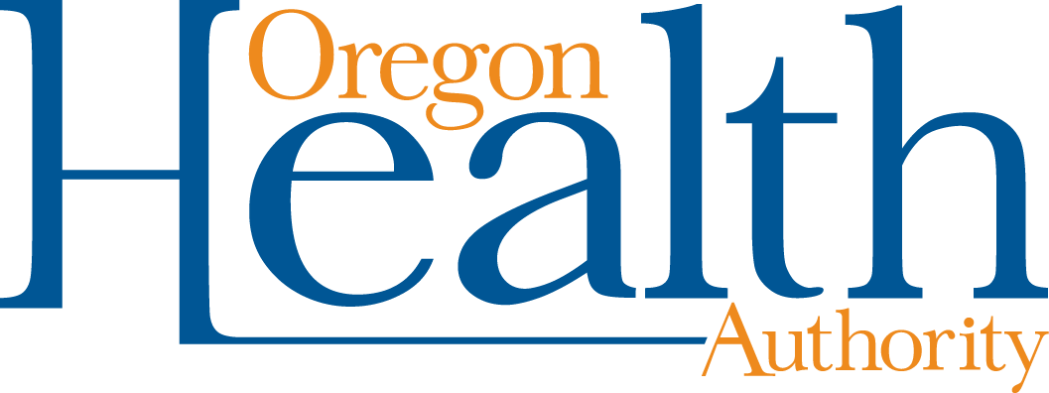

800 NE Oregon St, Ste 730
Portland, OR 97232
Voice (971) 673-0984
Fax: (971) 673-0994
TTY (971) 673-0372

Date: May 22, 2014

To: Tribal Tobacco Prevention Program Coordinators

From: Community Program Liaisons

Re: REPORTING PERIOD THREE

It is time once again for reporting on TPEP and Healthy Communities grants. We are looking forward to hearing about the excellent work you have been doing and the challenges you face. We use the information gathered for tracking, but also for decisions on training content, resources, and state-wide strategy. Your voice contributes to our collective conversation.

Please contact your liaison to schedule a time to conduct your reporting interview. The report will cover the period of March 1, 2014 through June 30, 2014. The interviews should be conducted during June. You can expect the interview to take approximately one hour.

This reporting period will build on your two previous reports from the year so the same form is used. Your liaison will complete the form during the interview and send the summary to you for your review and edits. If you would like to make notes, pre-fill portions of the report or gather documents prior to the call, feel free to do so.

If you have any questions and to schedule your interview, please contact your Community Programs Liaison:

Tara Weston tara.e.weston@state.or.us 971-673-1047
Andrew Epstein andrew.d.epstein@state.or.us 971-673-2379
Leah Fisher leah.m.fisher@state.or.us 971-673-1039
Jenica Palmer Jenica.palmer@state.or.us 971-673-1117
Terresa White terresa.l.white@state.or.us 971-673-0984
Tamara Burkovskaia tamara.v.burkovskaia@state.or.us 971-673-1085

Thank you for all your efforts for healthy communities throughout Oregon!

