*Significant health disparities, such as higher asthma prevalence and worse asthma outcomes, burden tribal communities. Strong evidence indicates that many chronic health conditions, such as asthma, that disproportionately affect tribes, among others, are caused and exacerbated by exposures to environmental pollutants in homes. Further evidence indicates that investment in home environmental health and safety improvements offer a powerful potential strategy for improving community health and sustainability. At the national level, new incentives within the Affordable Care Act, Medicaid’s increasing focus on disease prevention, and other health policy innovations have created “a moment of opportunity” to expand funding for and delivery of in-home interventions that address environmental health risks. The purpose of the EPA Tribal Summit is to explore the possibilities for tribal communities to take advantage of this opportunity to create sustainable funding and effective in-home intervention programs that will improve tribal asthma, in-home safety and community sustainability.*

Summit Intent

**Key Messages**

* In-home asthma interventions can serve as a catalyst for enhancing health-care delivery systems and improving chronic disease outcomes generally within tribal populations.
* Pursuing the immediate opportunity for expanded reimbursement does not require that we know all the answers about what to fund and how to deliver programming, but success does require that we bring the right people together to begin planning and executing on a joint strategy.
* This Summit will be the first of what we expect to be many conversations on what to advocate for and how to implement effective in-home interventions in tribal communities. Over time, we expect to engage more and more stakeholders in the conversation and work.
* Capitalize on current healthcare landscape and develop a 5-year plan for action aimed at improving asthma outcomes for children (0–18) among tribal populations in Washington, Oregon and Idaho *by driving reimbursement for, and delivery of, in-home interventions.*
* Form initial leadership group in health, housing and environment sectors to help drive a coordinated action plan forward.
* Develop an approach and timeline for expanding the group of tribal stakeholders working together to increase reimbursement for and delivery of in-home environmental assessments and interventions.
* Identify opportunities to spread reimbursement strategies to tribes across R10 and nationwide.

**Objectives for September 26th**

* Issue a strong and clear call to action: Get agreement around a bold goal that represents a collective vision for what tribal communities can achieve through a concerted effort to drive reimbursement for and delivery of high quality in-home interventions.
* Identify and address system components that are necessary in addition to in-home interventions to deliver, support, fund, and maximize the potential benefits of in-home interventions in tribal communities.
* Generate commitments among participants to advance the plan for action and broaden the stakeholder group, as well as set pacing milestones for tracking and ensuring the group’s progress on its bold goal   
  (e.g., upcoming regional and local events including the November Washington State Asthma Summit, 2015 HUD reimbursement summit).

Who Needs to Be in the Room for This First of Many Conversations?

Bring together 40–50 health, housing and environment stakeholders in the Northwest to refine, improve and commit to the plan for action:

* Tribal leaders, including individuals who: (1) can support and elevate the perceived importance of efforts to secure reimbursement for in-home interventions, (2) are responsible for or strongly influence the way healthcare delivery is managed in tribal communities, and (3) manage housing.
* Health, housing and environmental program representatives working within tribal communities, including: (1) clinic managers, (2) nurses who manage community health representatives working in the home, (3) in-home intervention providers, (4) family leaders, (5) environmental program directors or staff, and (6) housing authority leadership.
* 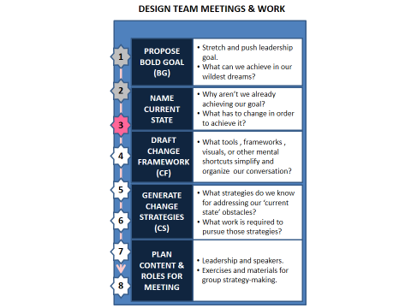Stakeholders responsible for making policy decisions about and financing health care delivery within tribal communities at the local, state and regional levels.

Meeting Design Approach

* An interdisciplinary planning team (Design Team)—comprising regional representation from the Indian Health Service, Departments of Housing and Urban Development and Health and Human Services, Environmental Protection Agency, Washington Governor’s Interagency Council on Health Disparities, Tribal Healthy Homes Network and the Yellowhawk Tribal Health Center—is actively working to lay the groundwork for a successful summit.
* The Summit’s Design Team will serve as ambassadors, regularly communicating with stakeholders prior to the September event, and will develop materials to help present potential ideas/solutions at the start of the Summit to ensure that the broader group is poised for a very action-oriented discussion from the minute the Summit begins.
* At the Summit, participants will build onto the Design Team’s initial dialogue and materials to finalize the bold goal and develop a realistic strategy to achieve it.

**Measures for Success—Tracking Summit Objectives**

The Design Team will develop metrics to determine whether the event’s desired outcomes are met, including:

* Decision-making power in the room—How successful we are at recruiting the people who can take action to advocate for healthcare policy change and promote in-home interventions in tribal communities into this conversation.
* Level of engagement—How many people/organizations represented at the Summit agree to lead future efforts.
* Level of commitment to strategy implementation—How many commitments to take action to secure reimbursement for in-home interventions are generated at the Summit.
* Plan for maintaining momentum and ensuring forward progress—How many local and regional events are identified where we can broaden the stakeholder group committed to this work and pace and advance action to ensure that we make rapid progress.