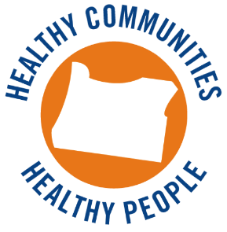**Health Promotion and Chronic Disease Prevention**

**Grantee In-Person Trainings 2015-2016**

### 

**Building and Supporting Effective Self-Management Referral Systems**

**December 1, 2015**

**Eugene, Oregon – Valley River Inn**

**AGENDA**

9:00 Welcome: Introductions, Agenda Review, and Opening Ice Breaker

9:15 Understanding Cultural Differences between Public Health and Health Systems  
*Cultural assessment activity & sharing of insights*

10:15-10:30 Break

10:30 Planning Effective Self-Management Referral Systems  
 *Closed loop referral processes  
 Developing a shared future state vision*

12:00 Working lunch

1:00 Quality Improvement (QI) in Health Systems  
 *Overview of QI tools for systems development & improvement  
 QI case studies & practice session*

2:30-3:00 Physical Activity Break

3:00 Communication Styles and Strategies  
*Work session: talking points for differing communication styles*

4:15 Wrap-up: 3-2-1 Reflections

4:30 End of Day