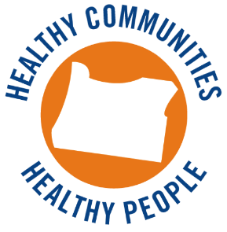**Health Promotion and Chronic Disease Prevention**

**Grantee In-Person Trainings 2015-2016**

**POLICY, SYSTEMS, AND ENVIRONMENTAL CHANGE IN TRIBAL COMMUNITIES**

**May 12, 2016**

**North Bend, Oregon – Coquille Plankhouse**

9:00 Welcome: Introductions, Expectations, and Opening

9:30 Morning Session

10:15 Break

10:30 Morning Session (continued)

12:00 Working Lunch

1:00 Cessation Systems Change

1:30 Afternoon Session

2:30 Physical Activity Break

3:00 Afternoon Session (continued)

4:15 Wrap-up and refer to online Evaluation

4:30 Closing

