**WISDOM WARRIOR TRAINING**

*Empowering individuals to help themselves and others!*

AUGUST 22nd – 26th, 2016

8:30 – 4:00 pm

**Tamástslikt Cultural Institute**

*Breakfast, Lunch and Snack Provided*

This **FREE** Train the trainer training is good for:

Community Volunteers, Elder Advocates, Diabetes Prevention staff, Fitness Trainers, Social Services staff, Clinic staff, Title VI staff, Caregivers

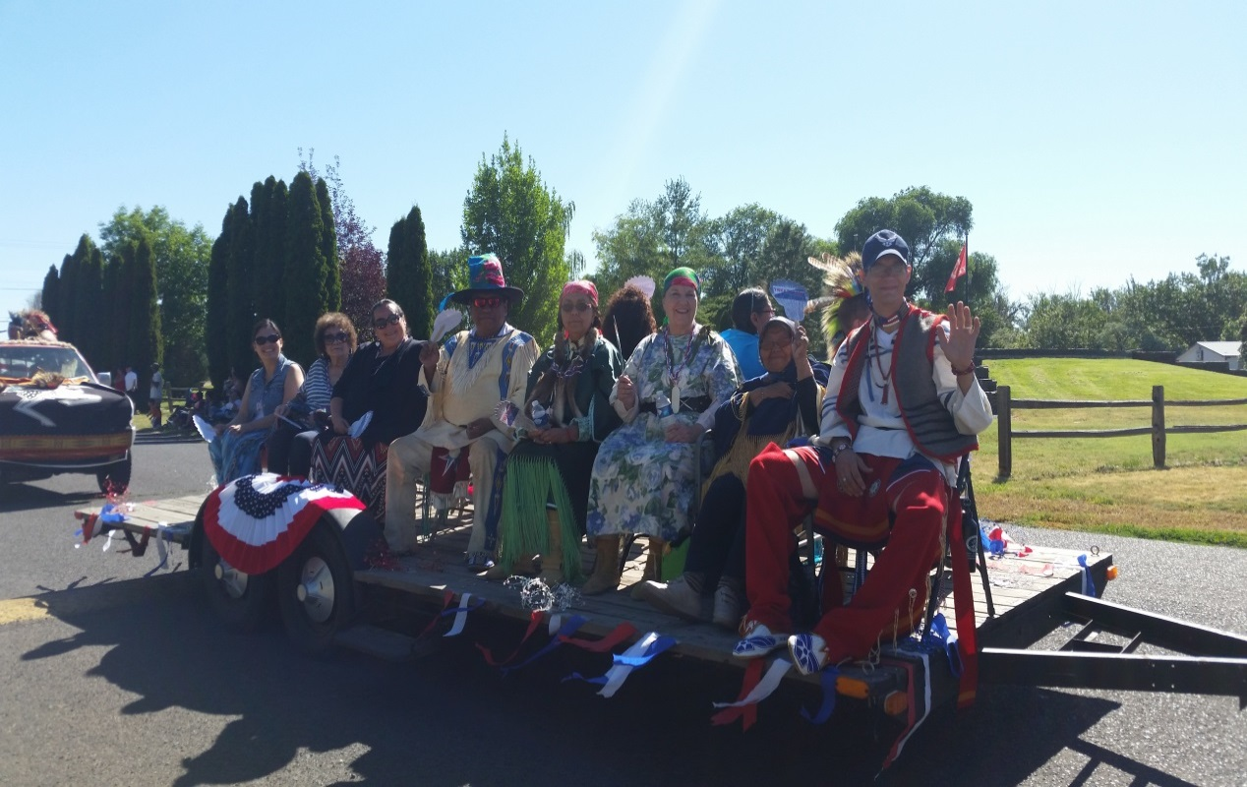**Wisdom Warriors Promotes:**

**Spiritual Connection Partnerships**

**Self-Care Nutrition**

**Exercise Longevity**

**Individual Goal Setting**

**Benefits of Managing Chronic Diseases**

* **Better ability to participate in family and community activities.**
* **Ability to advocate for self.**
* **Fewer hospitalizations and emergency room visits.**
* **Better partnerships with health care providers.**
* 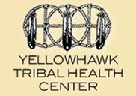**Better management of fatigue, shortness of breath, physical function, pain, stress, depression and difficult emotions.**

**For more information and registration, please contact:**

Dionne Bronson, [DionneBronson@yellowhawk.org](mailto:DionneBronson@yellowhawk.org), 541-429-4922.

Gloria Williams, [GloriaWilliams@yellowhawk.org](mailto:GloriaWilliams@yellowhawk.org), 541-278-7559.