**REGISTRATION**

Name:

Organization:

Address:

City/State/Zip:

Phone:

Email:

**Return Registration no later than August 15th, 2016:**

*Mail to:* Yellowhawk Tribal Health, Dionne Bronson,

PO Box 160, Pendleton, OR 97801

*Fax to:* (541) 278-7571

*Email:* dionnebronson@yellowhawk.org

**Conference Site:** The training will be held in the Theatre Room at Tamástslikt Cultural Institute, 47106 Wildhorse Blvd., Pendleton, Oregon 97801

**Lodging: Wildhorse Resort & Casino, 800.654.9453**

Room rates begin at $95.36 per night and are the expense of the participants. To reserve a room, please contact the hotel directly and mention Wisdom Warriors room block. Ten lodging scholarships are available by emailing [DionneBronson@yellowhawk.org](mailto:DionneBronson@yellowhawk.org).

**Training Days:** Monday, August, 22nd - Friday August 26th

8:30 am – 4:00 pm

**Meals:** Lunch & snacks will be provided each day. Travel, room and all other meals will be the responsibility of the participant.

**Training Attendance:** Attendance at all sessions is necessary to ensure participant certification as a Lay Leader of Stanford University Chronic Disease Self Management.

**For more information contact:**

Dionne Bronson, [Dionnebronson@yellowhawk.org](mailto:Dionnebronson@yellowhawk.org) 541.429.4922

Gloria Williams, [Gloriawilliams@yellowhawk.org](mailto:Gloriawilliams@yellowhawk.org) 541.278.7559

**Wisdom Warriors**

**Lay Leader Training**

**August 22nd- 26th 2016**

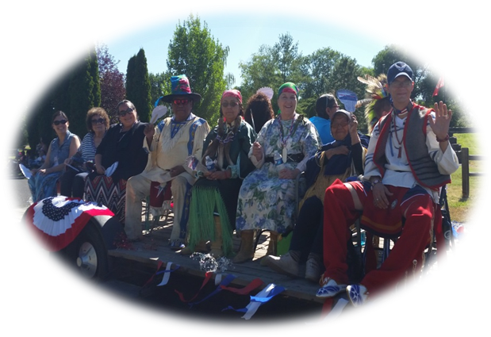

**Tamástslikt Cultural Institute**

**Pendleton, Oregon**

**Theatre Room**

Yellowhawk Tribal Health Center

Community Health Department

PO Box 160

Pendleton, Oregon 97801

(541) 278-7559

Over 500 Tribal members have joined the Wisdom Warriors program in Washington State! Northwest Regional Council is delighted to report that the number of Wisdom Warriors is growing quickly. We welcome tribal communities to train staff and volunteers to provide this program in your community. This program is designed to leave participants healthy, connected to each other and active in the community. Wisdom Warriors make healthier choices, learn to manage chronic disease and some may conquer heart disease and diabetes!

A commonly heard buzz-word today is “Evidence-based.” In short, this means that a system or program has been proven effective through studies published in professional journals. Several evidence-based models have been identified to be effective in keeping older adults healthy but the Stanford University Chronic Disease Self-Management Program (CDSMP) is likely the most widely used. Using CDSMP as a starting point, some Tribes in the Pacific Northwest have begun a health promotion program for their Elders and community members with chronic conditions.

Pacific Northwest Tribes, together with the Northwest Regional Council, an Area Agency on Aging, are taking CDSMP one step further through a program called Wisdom Warriors. Those who complete the course receive a fringed deerskin bag at a graduation celebration. They then meet monthly to revisit the techniques they learned in the workshops and apply them to health promotion areas: good nutrition, exercise, cultural/spiritual activities, intergenerational experiences, health management activities, and screening and prevention. Tribal and community experts provide discussion groups about the monthly topic and Elders make “Action Plans” for the month in the monthly focus area. Elders who complete their plan earn a bead to put on the fringe of their bag and at the end of the year, a charm to hold the beads on the fringe.

**Potential Wisdom Warriors Leaders**

* Elders Program Staff
* Health Clinic/Diabetes Prevention Staff
* Social Services Staff
* Cultural/Wellness Program Staff
* Community Volunteers
* Elders

**Traits of a Good Wisdom Warrior Trainer**

* I am available to attend the entire training
* I believe that people have the right to receive information and to make their own decisions
* I see myself as a facilitator for people who want to self-manage their chronic conditions
* I am comfortable speaking to a group
* I am comfortable with role playing and constructive feedback
* I prefer interactive trainings to “sit and listen” types of trainings
* I care about the health and wellness of my community
* I would like to see more traditional values included in health programs
* I believe Native Culture is essential to health and wellness

