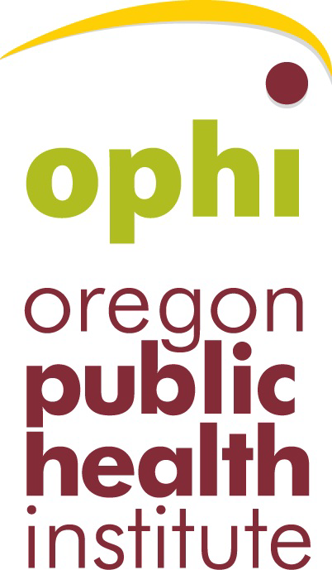
2016 HEAL Small Grants Reporting Guidelines
Oregon Public Health Institute
310 SW Fourth Avenue, Suite 900
Portland, OR 97204
Attn: Karli Thorstenson
Phone: 503-227-5502 ext. 223· Fax: 503-954-1405 · Email: Karli@ophi.org

Important dates:
Final project report and documentation is due October 13, 2017
Grant funds that have not been expended must be returned to OPHI by October 13, 2017

Final project report narrative:
(5 page limit):

- What were the main project activities and successes?
- How did this project increase access to healthy food or physical activity options in your city? Did your project have outcomes beyond increasing healthy food or physical activity options (e.g. increased sense of community, increased foot traffic leading to increased revenue to local businesses)? How did the city measure these outcomes?
- Did the project help mitigate health inequities? If so, please describe how the project achieved this goal.
- How many people have been served by this project so far? How many people do you expect this project will serve in its first year? In the next five years?
- How will the project be maintained after grant funds have been expended?
- What role did volunteers and community organizations play in this project?
- What obstacles did your community encounter during this project? How did your community address them?
- Did your city’s experience with this HEAL policy implementation project make it more likely that your city will undertake other HEAL policy implementation projects? Why?
- Did you request changes to the project budget? If so, how did the changes improve this project?
- Include a final budget with actual expenditures and actual in-kind donations

Other elements that can be included in final project report:

- Please help us tell the story of your community by submitting quotes or memorable stories from people who have participated in project implementation or who have benefitted from the project, as well as photographs documenting the project.

Please return unexpended project funds to Oregon Public Health Institute by October 13, 2017.
If you have any questions, please contact:
Karli Thorstenson
Karli@ophi.org
503-227-5502 ext. 223

