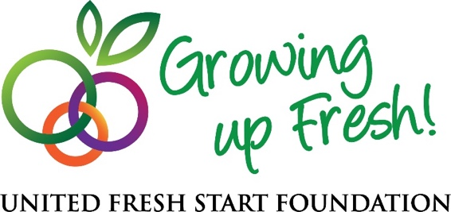

**NEWS RELEASE   
For Immediate Release, March 2, 2017**

***Contact:*** Mary Coppola   
[mcoppola@unitedfresh.org](mailto:mcoppola@unitedfresh.org)   
202-303-3425

**United Fresh Start Foundation Now Accepting Applications**

**For New Community Grants Program***Program Expands Foundation’s Mission to Increase Access to Fresh Produce*

Washington, D.C. (March 2, 2017) – The United Fresh Start Foundation is now accepting applications for its new Community Grants Program, established to help advance the organization’s mission to increase children’s access to fresh fruit and vegetables. The Community Grants Program extends the foundation’s work beyond the school day, with the goal to provide children in communities across the country with access to fresh fruit and vegetables afterschool, on weekends, during summer breaks and in other creative venues.

Local community organizations and groups that share the United Fresh Start Foundation’s mission are encouraged to apply. Not-for-profit organizations focused on child nutrition, food access and creating healthy communities through increased access to fresh produce, can download the grant application [here](http://www.unitedfreshstart.org/what-we-do/community-grants-program/). Applications are due by Monday, April 20, 2017.

“As we rollout this new program, we are looking forward to engaging like-minded stakeholders and innovative community organizations that support our shared interests in increasing children’s access to fresh produce,” said United Fresh President and CEO Tom Stenzel. “There’s a lot of great work being done in communities across the country to address food insecurity, the childhood obesity epidemic, and to educate children about where their food comes from and the importance of eating fresh fruits and vegetables for better health. Our Foundation is committed to helping our youngest generation develop lifelong healthy habits early-on by ensuring that access is not a barrier.”

The Community Grants Program will provide $25,000 in grants in 2017, with a maximum grant of $2,500. The foundation’s goal is to support as many community programs as possible, so grants may also be awarded in smaller amounts. Grant recipients will be notified by June 15, 2017 if they have been selected. Recipients must complete their work within one year of receiving grant funds, and will be required to submit post-grant feedback and evaluation.

For questions about the Community Grants Program, contact Andrew Marshall, Director of Foundation Programs & Partnerships at [amarshall@unitedfresh.org](mailto:amarshall@unitedfresh.org) or (202) 303-3407.

###

**About the United Fresh Start Foundation**

The United Fresh Start Foundation is a 501(c)(3) not-for-profit organization focused exclusively on increasing children’s access to fresh fruits and vegetables. Affiliated with the United Fresh Produce Association, the Foundation is committed to helping today’s children achieve the public health goal to make half their plate fruits and vegetables in order to live longer and healthier lives. The Foundation works to create an environment where kids have easy access to high-quality, great-tasting and affordable fresh fruits and vegetables, ensuring kids everywhere are *Growing Up Fresh*.