Date | Theme Bucket | Post Copy | Link | Visual
Monday 5/1 | Cessation | Ready to quit? Give us a call 1-800-QUIT-NOW or visit www.quitnow.net/oregon/ | http://bit.ly/2nlqnmN | NA
Wednesday 5/3 | Disparities | Fact: Big Tobacco advertises up to 10 times more in African American neighborhoods than in other neighborhoods. #StopProfiling | http://bit.ly/2nfz3JQ | NA
Thursday 5/4 | Events and Key Dates | #tbt May the 4th be with you, Smokefree Oregon style. #MayThe4thBeWithYou | http://bit.ly/2oaKjHx | NA
Friday 5/5 | Partner Post | The higher the price, the less likely we are to pick up a pack. Something Big Tobacco has caught on to. | http://bit.ly/2mxWAny | NA
Monday 5/8 | Cessation | Bill found out the hard way that diabetes and cigarettes can be a life-threatening combination. Hear Bill's story. | http://bit.ly/2nFuj2B | NA
Wednesday 5/10 | Tobacco Retail Environment | Even though you can't get flavored cigarettes anymore, you can get lots of flavored tobacco products. And, kids are using them more than ever. | http://bit.ly/1Lnfcwa | 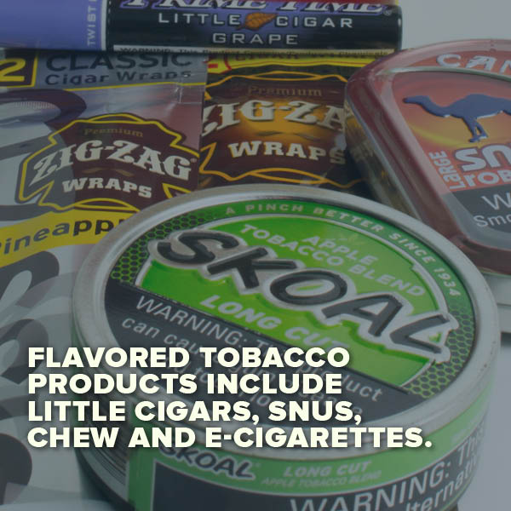
Thursday 5/11 | Environment | Learn about other smokefree places in our community and how you can get involved: | http://bit.ly/2orIvtE | 
Friday 5/12 | Deschutes County Post | Former teacher, current community hero. | NA | 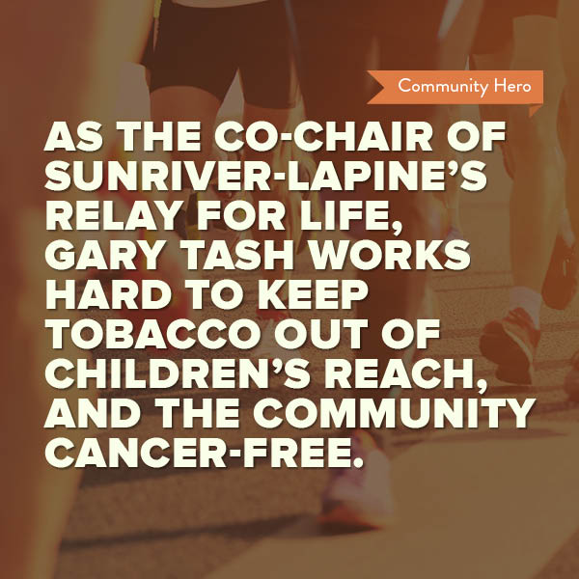
Monday 5/15 | Cessation | @TheRealCost's new campaign is talking to teens. It definitely grabbed our attention. | http://bit.ly/2ow9bIH | NA
Wednesday 5/17 | Partner Post | “It shows that responsible behavior by a pharmacy has public health benefits for the whole population.” | http://bit.ly/2odNRJf | NA
Thursday 5/18 | Real Cost | Fact: There is no risk-free level of exposure to secondhand smoke. | http://bit.ly/2nrLfaA | 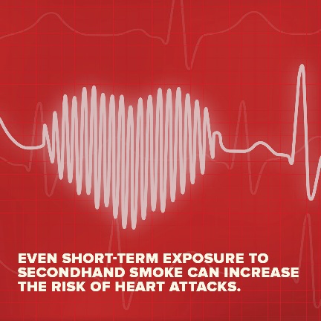
Friday 5/19 | Partner Post | Nothing natural about it. | http://bit.ly/2lnqsqU | NA
Monday 5/22 | Cessation | Motivation Monday. Call 1-800-QUIT-NOW or visit www.quitnow.net/oregon/ | http://bit.ly/2nu6PwU | NA
Wednesday 5/24 | Deschutes County post | Hats off to the Central Oregon Intergovernmental Council for their tobacco free policies which create a healthier environment for all visitors and employees! @theCOIC @Oregongovernor @CCO Oregon | NA | Photo to be provided at the Press Event in Bend on the 24th.
Thursday 5/25 | Events and Key Dates/Real cost | Thursday thoughts brought to us by National Arthritis Awareness Month. #ArthritisMonth | NA | 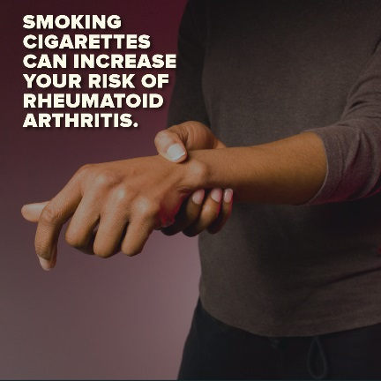
Friday 5/26 | Real Cost | How much do you really know about the dangers of second-hand smoke? Take this quiz and find out. | http://bit.ly/2ne7LCg | 
Monday 5/29 | Cessation | "It's not worth your health...think about your family and think about your life." — Julia | http://bit.ly/2nQW0Gw | NA-Video
Wednesday 3/31 | Tobacco retail environment | Nearly 90 percent of people who smoke start before age 18. | http://bit.ly/1Lnfcwa | 

