**Notice of Posting of RFGP 4495:   
Sustainable Relationships for Community Health**

Dear Vendor or Other Interested Person:

Please be advised that a new Oregon Health Authority Request for Grant Proposals, RFGP 4495: Sustainable Relationships for Community Health, has been posted on the Oregon Procurement Information Network (ORPIN) located at this site: <https://orpin.oregon.gov/>.

The ORPIN Opportunity number for this RFGP is #**OHA-4495-17**.

In RFGP 4495, the State of Oregon, Oregon Health Authority (OHA), requests Proposals from qualified Proposers to participate in an OHA, Public Health Division learning collaborative to develop Sustainable Relationships for Community Health (SRCH). Through the SRCH initiative, leaders from Local Public Health Authorities, Coordinated Care Organizations, and others involved with delivering evidence-based self-management interventions and services will collaborate to prevent and improve chronic conditions and improve community-clinical linkages.

The RFGP is now posted and can be accessed through the Oregon Procurement Information Network (ORPIN) website: <http://orpin.oregon.gov/open.dll/welcome>.

To view the opportunity on ORPIN and then download what is needed to submit a Proposal, you must follow these steps:

1. Enter <https://orpin.oregon.gov> in your internet browser and if you are not registered for ORPIN, click the “Supplier Registration” link and complete your registration.
2. Login to your ORPIN account.
3. From the ORPIN Welcome screen, click “My Documents” search by Document Number for “OHA-4495-17” as shown below.

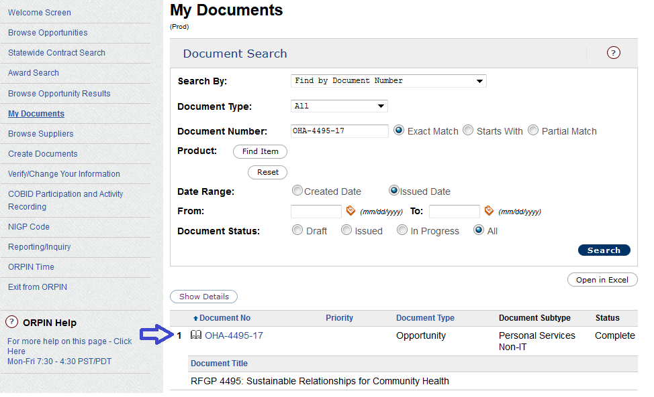

1. Click on the OHA-4495-17 link from the above screen.
2. From the Opportunity #OHA-4495-17 screen, click the “Express/View Interest” button on the left column of that Opportunity as shown below.

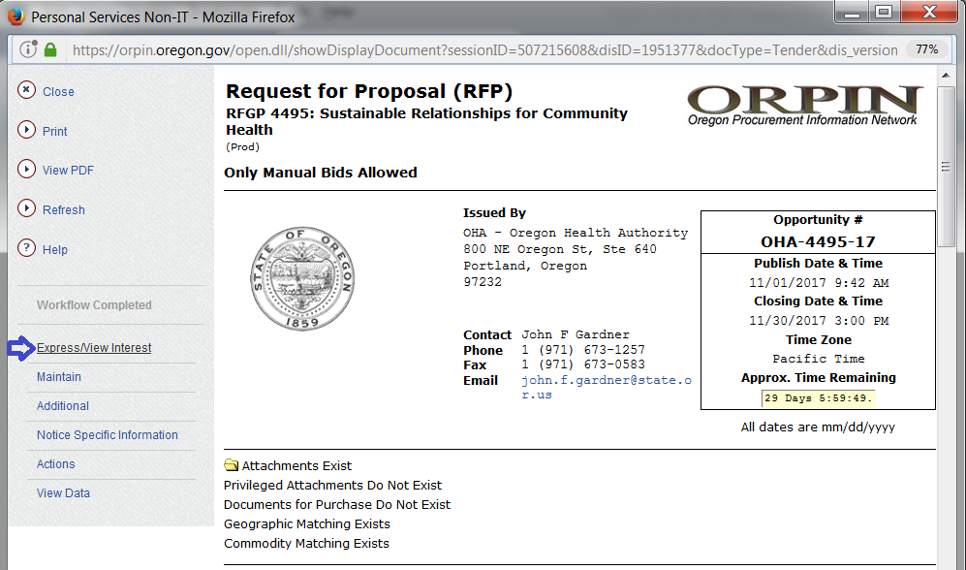

1. Download the file attachments to that Opportunity from the “Attachments Exist” folder” as shown below.

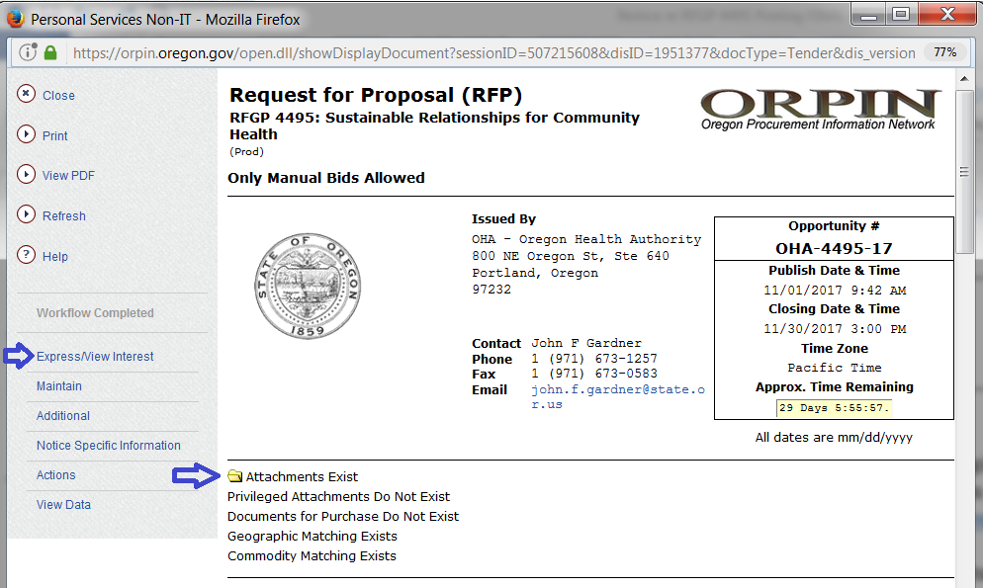

This website provides answers to common questions regarding ORPIN registration and use of ORPIN: <http://www.oregon.gov/DAS/Procurement/Pages/ORPIN.aspx>.

As stated above, once you are logged in to ORPIN and have Opportunity #OHA-4495-17 open, you will need to click the “Express / View Interest” in the left column in order to download / view the RFGP and its attachment(s). The RFGP describes the Opportunity and contains the Proposal requirements which must be followed by all Proposers and required forms.

The official RFGP and attachments for this solicitation are posted on ORPIN under the "Attachments exist" folder.  All official questions and answers, and addenda revising RFGP requirements will be posted on ORPIN.

For questions about using or registering on ORPIN,  or downloading this opportunity, please call the ORPIN Help Desk at (**503) 373-1774** or send an email to [**info.orpin@oregon.gov**](mailto:info.orpin@oregon.gov).

**Please send all questions about RFGP #4495 to John F. Gardner,the Sole Point of Contact (SPC) for this RFGP, via email to:** [**john.f.gardner@state.or.us**](mailto:john.f.gardner@state.or.us)**.**

Thank you very much.

John F. Gardner, Contract Specialist

Department of Human Services

Office of Contracts and Procurement

800 NE Oregon Street, Suite 640

Portland, OR 97232

Email: [john.f.gardner@state.or.us](mailto:john.f.gardner@state.or.us)

Phone: 971-673-1257 / Fax: 971-673-0583