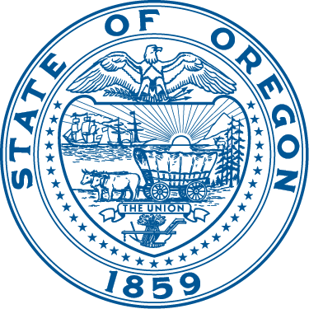 | OREGON PUBLIC HEALTH DIVISION  Health Promotion & Chronic Disease Prevention Section | 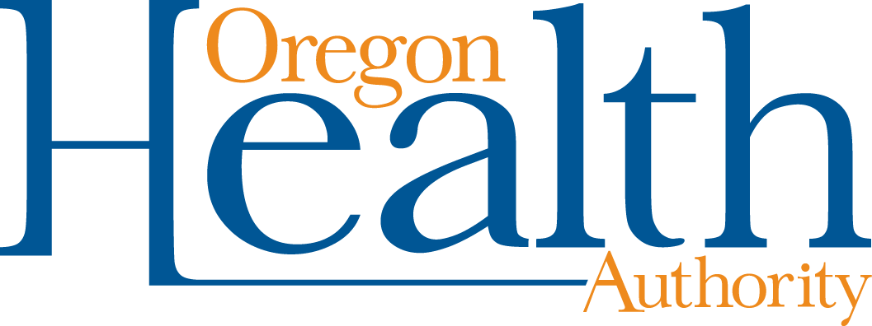
 | Kate Brown, Governor

Quick Facts and Frequently Asked Questions
Introducing Oregon’s Student Health Survey

What is the purpose of the Student Health Survey (SHS)?
Healthy kids learn better. Schools that have students who are happy, healthy and avoid risky behaviors are more likely to be successful in school. And we know that youth are less likely to engage in risky behaviors when they are connected to parents, family, school and the community.

Youth surveys help state and local agencies that provide adolescent programs and services know what prevention efforts are working and which need improvement. State and local agencies depend on youth data to assess youth needs, develop comprehensive plans and prevention programs, solicit funding, and measure outcomes. The SHS will be an important tool that schools, communities, state and local agencies can all use in coordinated efforts to help students achieve their full potential.

When will the new Student Health Survey Launch?
The survey will launch in 2020. Month and/or season of implementation is yet to be determined.

What will the Student Health Survey measure?
The SHS will cover a wide range of topics, including:
- Student mobility--how often youth move or change schools
- Commitment to school including school performance, school attendance, and how important they think school is for their future
- Opportunities for participation in class and other school activities
- Meaningful relationships with teachers, school staff and other students
- Witnessing or perpetrating harassment, bullying or fighting in the school environment
- Antisocial behavior such as carrying weapons, selling drugs, or being drunk at school
- Sexual health
- Positive youth development
- Psychological stress, depression and suicide ideation
- Problem gambling and substance use (primarily alcohol, tobacco and drug use, accessibility, perceived risk of harm and parent attitudes about use)
- How youth get access to alcohol, tobacco and marijuana, along with current and lifetime use of these substances
- Height, weight, body image and unhealthy eating behaviors
- And more…

Some topics and questions may be considered sensitive. Our goal is to reduce health risk behaviors among Oregon youth. The only way to determine if adolescents are at risk in these areas is to ask questions about these behaviors. Questions on the survey will be age-appropriate and presented in a straightforward and sensitive manner.

What grades and schools will participate?
All Oregon public schools with students in grades six, eight, and 11 will be invited to participate.

Will you make sure the questions are the same from the Oregon Healthy Teens (OHT) or Student Wellness (SWS) so comparisons can be made?
For the SHS we plan to ask the same or similar questions to what has been asked in the past on OHT and SWS. However, the methodology for the SHS will be different and comparisons across surveys are not recommended.

Will you maintain the opportunity for tribes to identify their tribal affiliation, as in the SWS?
Yes!

Has there been any discussion about making the surveys mandatory?
No, not currently.

Will we get to preview the questions?
Our goal is to have a draft survey available in the Spring of 2019.

Do the sexual health questions have an opt-out option? Some schools in my area refuse to take it because of these types of questions.
Participation in the survey is voluntary. Students will know that they can opt out of answering any questions which they feel uncomfortable answering. Schools cannot modify the survey or choose which content is on the survey.

Can local health departments act as liaisons with school districts / leadership, answering questions about data, validity, tie-in to school performance, etc.? Perhaps even help administer the surveys?
Yes, local public health authorities (LPHAs), tribes and community-based organizations (CBOs) focused on youth prevention can contact their local superintendents and principals to offer assistance with respect to the importance, interpretation, and use of the data. School administrators will receive school and district level data and might not know that they have valuable expertise locally. OHA will communicate with school districts that local expertise is available. LPHAs, tribes and CBOs may also assist school districts in school recruitment and planning for the survey. LPHAs, tribes and CBOs should contact school administrators to find out what their needs are with respect to survey recruitment and coordination.

What are the plans to consult with Local Public Health Departments, tribes, and other community partners about their uses, important content and concerns in regard to youth data?
We are providing several opportunities for engagement with grantees:
- December 2018: Conversations with Health Promotion and Chronic Disease Prevention Staff
- January 2019: Web survey
- February 2019: Report back and share findings from engagement

What plans does OHA have to help connect schools with local public health as a resource for interpreting and using the data?
OHA is working with its survey contractor on communications and resources for schools and school districts so that they can better understand and use their data. Local public health authorities, tribes and community-based organizations focused on youth alcohol, tobacco and other drug prevention will be highlighted in these resources as critical partners in providing analysis and program support.

How can I get more information?
Contact the Health Promotion and Chronic Disease Prevention Section Surveillance and Evaluation Team
Phone: 971-673-0984 or email: hpcdp.surveillance@dhsoha.state.or.us

