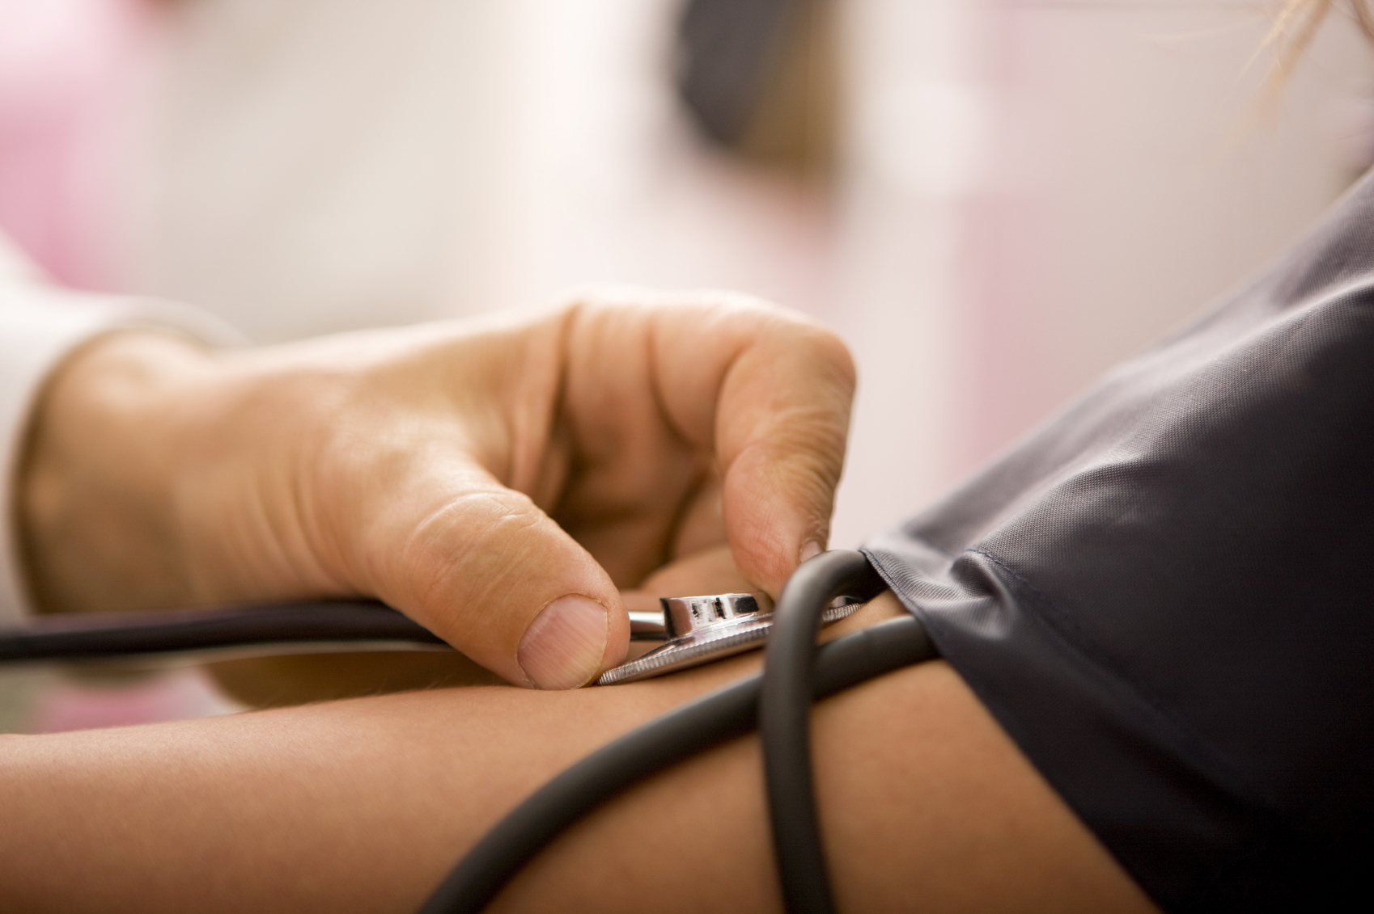  - May 15, 2019  Identifying Undiagnosed Hypertension  Train-the-trainer  Did you know that there could be as much as a 13% difference in expected versus observed (diagnosed) hypertension among your patient population (Ciemins, Ritchey, Joshi, et al., 2018)?  In partnership with the Oregon Health Authority, Comagine Health is providing a train-the-trainer workshop to address identification of undiagnosed hypertension. The focus of this train-the-trainer is preparing staff trainers to work with their organizations to develop policies and procedures for identifying undiagnosed hypertension.  Learn more and register at http://bit.ly/UNDX-HTN  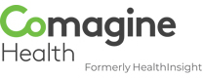 | Identify opportunities to find undiagnosed hypertensive patients  ____  Establish a process for screening and diagnosing identified patients  ____  (Re)train staff on appropriate blood pressure measurement technique  ____  Implement a plan to connect newly diagnosed hypertensive patients to self-management supports  St. Charles Madras Hospital —  Metolius Room  470 NE A St.,  Madras, OR 97741  Wednesday, May 15  Noon – 4:30 p.m.
www.comagine.org

