**Ban on Sale of Flavored Vape Products in Oregon**

**Social Posts for Use by Local Public Health Authorities**

**October 14, 2019**

NOTE: Unless noted, all posts are text only.

Oregon’s temporary ban on the sale of flavored vape products takes effect 10/15/19. The ban, by Governor Brown’s Executive Order, addresses the youth vape epidemic and cases of illness and death from vape-related lung injury. For information, including how to quit, visit [healthoregon.org/vaping](http://www.healthoregon.org/vaping).

Oregon’s temporary ban on the sale of flavored vape products takes effect 10/15/19. Retailers must stop selling all flavored vape products. OHA and OLCC will be conducting “secret shopper” inspections to ensure compliance. Thanks to Oregon retailers for helping to protect youth and others in our state. [healthoregon.org/vaping](http://www.healthoregon.org/vaping)

Now that sales of flavored vape products are temporarily banned in Oregon, it’s a great time to quit —not just during the ban but for good. Oregon’s Quit Line offers free, confidential, 24/7 counseling plus medicated gum and patches. 1-800-QUIT-NOW

*Image to use with* ***Facebook*** *Post (to use, right-click on the image below and “Save As Picture…”)*

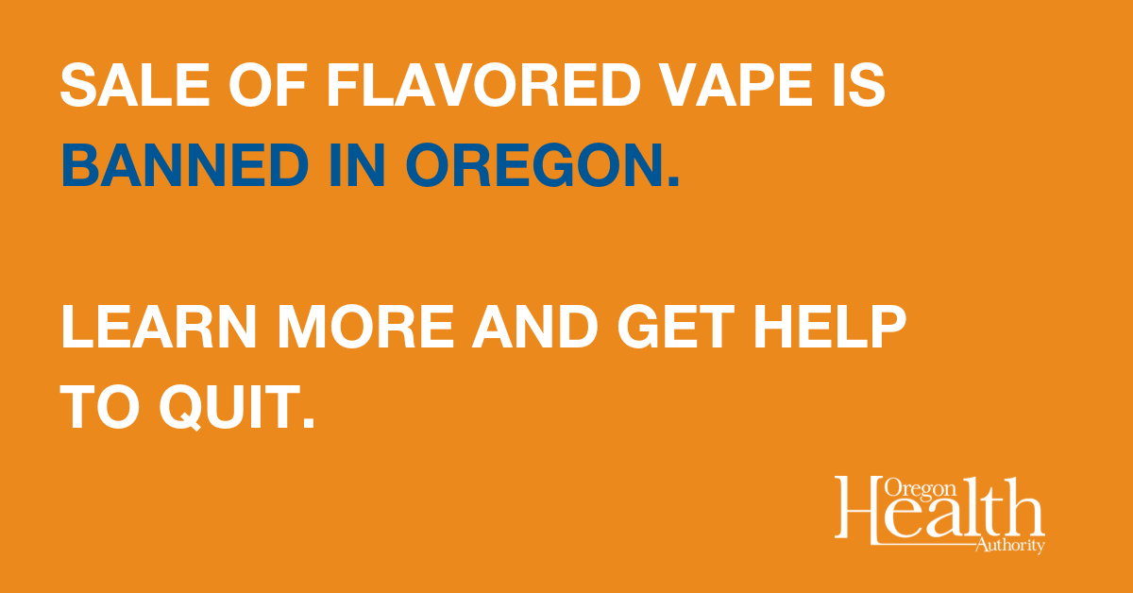

*Image to use with* ***Twitter*** *Post (to use, right-click on the image below and “Save As Picture…”)*

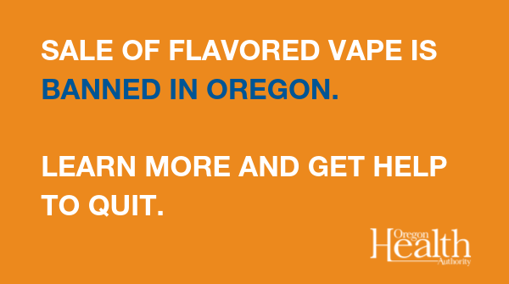

Parents, educators and others who care for young people: Now that sales of flavored vape products are temporarily banned in Oregon, it’s a great time to talk to youth about quitting —not just during the ban but for good. This is Quitting is a free, confidential texting program for young people who vape. Text DITCHJUUL to 88709 or visit<http://www.thisisquitting.com/>..

The temporary ban on flavored vape products protects people immediately. But we needstronger action that will protect youth and adults from these dangerous products for the long-term. Here in (county/tribe), we’re working on (insert policy priorities).

The temporary ban on flavored vape products protects people immediately. But we need stronger action that will protect youth and adults from these dangerous products for the long-term. Governor Brown tasked OHA and OLCC to develop legislative proposals and called on the FDA to regulate flavored vaping products.

Health care providers: Please talk to your patients about quitting vape immediately. The new ban on sales of flavored vape products is a perfect motivation. Tips at <http://www.thisisquitting.com/>. Please report any suspected cases of vape-related lung injury by calling (insert local reporting number).