**Dry Stone Masonry “Hands On” Workshop** Oregon Landscape Contractors Board Approved Continuing Education 16 Technical Hours Credit

**Learn to build dry stone walls using traditional techniques meeting internationally accepted standards**.

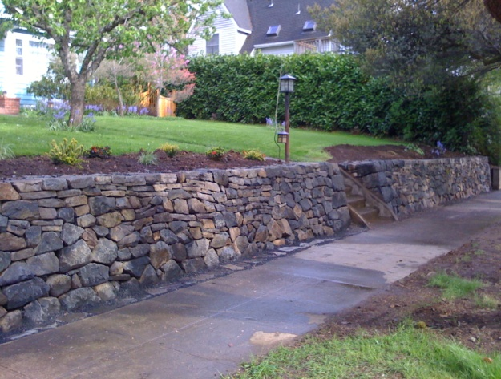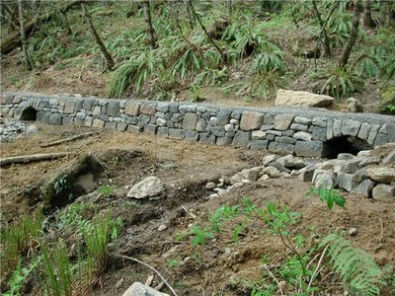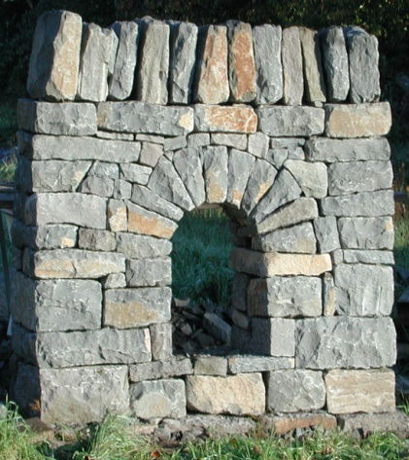

All basic aspects of traditional dry stone wall building from ground prep, frames, foundation stones, wall stones, tie stones, packing, cover stones & capstones will be covered as we completely build a wall.

|  |
| --- |
| Two offerings of the same 2-day workshop  January 26-27, 2011 January 29-30, 2011 |

Qualified Dry Stone Walling Association (DSWA) of Great Britain Instructors

Alan Ash Sean Adcock

Eugene, OR Wales, United Kingdom

*One of the few U.S. DSWA instructors *DSWA master craftsman and examiner *Dry Stone Conservancy (Kentucky) *Winner of close to 30 walling competitions

certified (and placed in almost another 50!) *Has been teaching stonemasonry *One of the world’s leading authorities

classes for over a decade on Dry Stone Walling *Owner Ash Stone Masonry * Co-author of the revised BTCV book *One of the few NW stonemasons building ***Dry Stone Walling***

public works Dry Stone Masonry projects *Author of over 30 articles on walling

**Cost: $200.00**

Cost includes lunch, coffee and drinks

**Workshop Location: 625 Howard Ave. Eugene OR 97404**

|  |
| --- |
| **To Register or get more information**  **Email:** [**alan@thestonemason.com**](mailto:alan@thestonemason.com) **phone 541 688 0899** |

**Ash Stone Masonry www.thestonemason.com Oregon CCB# 126558**