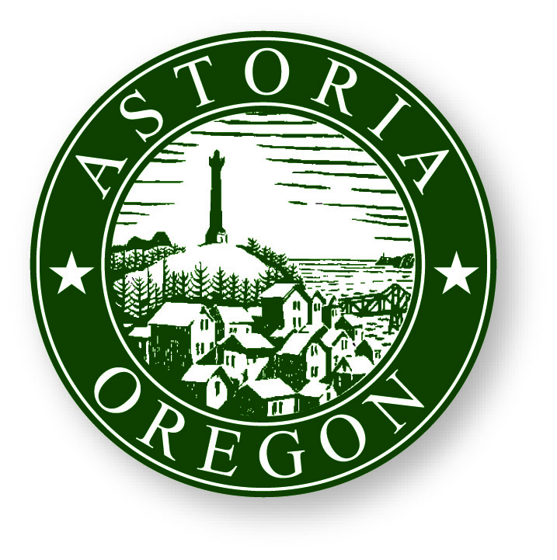

DATE: 7/31/2026

TO: MEDIA

FROM: SHERRI WILLIAMS
COMMUNITY DEVELOPMENT DEPARTMENT

RE: PUBLIC SERVICE ANNOUNCEMENT

HISTORIC PRESERVATION FAIR

The City of Astoria Community Development Department in conjunction with the State Historic Preservation Office will hold a FREE community-wide Historic Preservation Fair on Saturday, April 9, 2011 from 9:30 am to 2:00 pm at Fort George Brewery and Public House’s brewing facility located in the old Lovell Building on the corner of 14th & Duane Streets. The event is free and open to the public. The Fair will include an exhibit area and scheduled presentations. Hourly speakers will address subjects such as weatherization of older homes, re-use of historic doors and trim work, architectural styles, kitchen make overs in historic homes, Bicentennial history of Astoria, and how to work through City and State permits and incentive programs. Exhibitors will have information about salvage materials, how to handle and dispose of hazardous materials, where to find historic photos, what products are locally available for historic projects, and much, much more!

For information, contact Brett Estes, Community Development Director at 503-338-5183 or bestes@astoria.or.us.

