Invitation to Regional HIV and Aging Learning Collaborative
February 10, 2023

The Care and Wellbeing Center (CWC) is a regional training and technical assistance unit for HIV and Aging services, housed in the Training and Health Equity Collaborative (THE Collaborative) at the University of California, San Francisco (UCSF). We are inviting HIV service organizations to join our free Intersectional Learning Collaborative (LC).

What are the benefits?
- Access to program development support and skill building curated for your needs
- Access to our network of HIV and Aging service organizations, with programs ranging from clinical services to community building to client education and empowerment
- Access to flexible options for virtual and in-person learning and networking
- Our peer-to-peer Learning Collaborative sessions led by subject matter experts
- Our Slack online collaboration platform containing even more networking opportunities, resources, events, and trainings
- All of these services are free!

How does our Learning Collaborative facilitate learning?

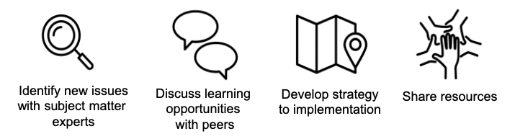

Who should join?
The Care & Wellbeing Center Learning Collaborative is open to all HIV organizations and programs that provide care & wellbeing services that prioritize and/or support people over 50 living with HIV in the Western U.S.

We define the Western U.S. to includes the following 13 states: Arizona, Colorado, Idaho, New Mexico, Montana, Utah, Nevada, Wyoming and the Pacific division that includes Alaska, California, Hawai‘i, Oregon, and Washington.

Our Learning Collaborative expectations are summarized below:

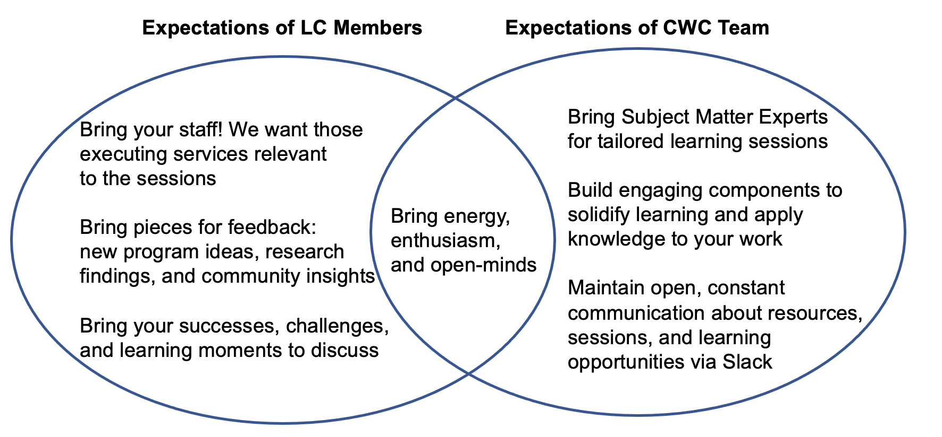

Our Learning Collaborative schedule for 2023 is:
Topic | Date, Time
Women's Health, HIV, and Aging Panel | March 14, 10:00 AM - 12:00 PM
Later Life Planning for People Aging with HIV | May 3, 10:00 AM - 12:00 PM
Strengths in HIV and Aging Roundtable | July 20, 1:00 PM - 3:00 PM
HIV and Aging Conference | September 18th and 19th
How to Tap In: Peers and Volunteers | November 7, 1:00 PM - 3:00 PM

Please access our Resource Guide (https://traininghealthequity.org/care-and-wellbeing-center-resource-guide/) to review previous Learning Collaborative sessions and associated implementation tools.

If you are interested in participating in our future Learning Collaboratives, please fill out this interest form: (https://ucsf.co1.qualtrics.com/jfe/form/SV_ddtKzCZalvaeqlE)

For additional questions about our services, please contact our Project Manager,
JB Del Rosario at janbing.delrosario@ucsf.edu.

Want to keep up with our HIV and Aging training and technical assistance services?
Subscribe to our newsletter or follow our social media accounts using the links below!
Click here to subscribe to our newsletter.
Click here to access our Facebook page.
Click here to access our Twitter page.
Click here to access our LinkedIn page.

