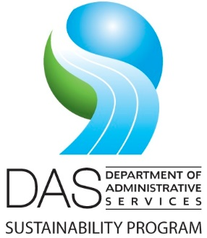**Proposed 2020-2021 Agency Plan Review Schedule: Oregon Sustainability Board**

|  |  |  |
| --- | --- | --- |
| Date | Proposed Location | Presenting Agencies |
| 2020 | | |
| March 13 (complete) | Salem, OR | Lottery  DLCD |
| June 12 | Gresham, OR | OHA/PHD  DCBS |
| September 10-11 | Central Point, OR | ODA |
| December 4 | Salem, OR | ODOE  OHCS  OPRD |
| 2021 (dates and locations TBD) | | |
| Quarter 1 |  | DSL  DOC |
| Quarter 2 |  | DAS  Business Oregon |
| Quarter 3 |  | ODOT |
| Quarter 4 |  | ODF  PUC |