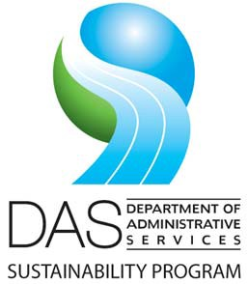**AGENDA**

**Interagency Sustainability Coordinators Network**

**Meeting Date:** Tuesday, October 13, 2019

**Time:** 1:30 to 2:30 pm

[Join Microsoft Teams Meeting](https://teams.microsoft.com/l/meetup-join/19%3ameeting_NTAxMTRmNzctODRhOC00MTllLWFkMDQtZTAyMTgxYjMzMWJk%40thread.v2/0?context=%7b%22Tid%22%3a%22aa3f6932-fa7c-47b4-a0ce-a598cad161cf%22%2c%22Oid%22%3a%222cda8cc4-98f3-4f44-829e-186f404471c2%22%7d)

[+1 503-446-4951](tel:+1%20503-446-4951,,387782805# )

Conference ID: 387 782 805#

|  |  |  |  |
| --- | --- | --- | --- |
| **ITEM** | **PRESENTER** | **TIME** | **ACTION/NOTES** |
| **Welcome** | | | |
| Welcome and introductions | All | 1:30 - 1:40 | Convene group, introductions, review agenda. |
| DAS Sustainability Program updates:   1. Climate planning project for agencies 2. DAS sustainable procurement program updates: equipment standards and current statute 3. Sustainability library 4. DAS EO 20-04 report summary 5. Sustainability Board work plan 6. Plug load consultant study 7. EV charging and infrastructure updates | Dave Wortman, DAS | 1:40 - 2:10 | Learn about the latest statewide policies, projects and resources available to your agency. |
| Popcorn discussion: sustainability, COVID and your agency | All | 2:10-2:25 | Open discussion about challenges, opportunities and resources you may need |
| Closing questions, comments? | All | 2:25-2:30 | Wrap up and adjourn |
| **Wrap up and adjourn** | | | |