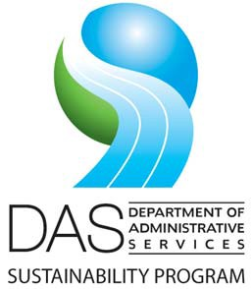**AGENDA**

**Interagency Sustainability Coordinators Network (ISCN)**

**Meeting Date:** Tuesday, June 13, 2023

**Time:** 1:00 to 2:15 pm

**Microsoft Teams**

|  |  |  |  |
| --- | --- | --- | --- |
| **ITEM** | **PRESENTER** | **TIME** | **ACTION/NOTES** |
| **Welcome** | | | |
| Welcome, introductions to new members, recap of ISCN purpose | All | 1:00-1:15 | Convene group, introductions, review agenda. |
| DAS Program updates: web site, Sustainability Plan Guidelines, Sustainability Board, Executive Orders, legislation on state buildings, statewide policy compliance, newsletters, resource guides  Enterprise Sustainability Report | Dave Wortman, DAS | 1:15-1:35 | Miscellaneous updates. |
| Climate action planning- status of agency reporting  ODIEM group: DAS/ODOE collaboration for state agency energy management | Steven Markham, DAS | 1:35-1:55 | Support for agencies on energy and climate action planning. |
| Agency Roundtable: share your successes, challenges, support needs from DAS | Dave Wortman, DAS | 1:55-2:15 | Popcorn style sharing from agencies. |
| Adjourn | 2:15 | | |
|  | | | |

# Next meeting: Tuesday, August 8, 1:00 pm, Teams